

SEPTEMBER 2013
PP 2012

Pres Says:

Thanks to all of you who have responded to your renewals. You are SUPER! And a big thanks to those of you who have dedicated funds to our projects. It is wonderful to know that people such as yourselves really want and appreciate the programs that are provided for you.

Our biggest upcoming event is a Thank You to BJ Ford for her many years of leadership in the Society. She is still on our Board so we will still have her expertise and dedication. The party is at Ludy’s (one of her favorites) on Thursday, September 26 at 6:00 p.m. in the patio. Come early and purchase your own food and join us.

Our Cemetery Tour is next month, Sunday, October 20, from 1-3:30 ish. As you remember we have taken over the Cemetery Tour from the Stroll Through History. It is a fall fundraiser for the Society. This year, we are looking at the epidemics that have occurred in Woodland. This study was prompted by an individual last year who asked about an abundance of grave markers dated around the same time. Doing research at the Yolo County Archives was a fascinating experience. I found out many interesting facts….We had a traveling medicine wagon that came to Woodland and sold his elixirs out of the back of the wagon. We also had deaths from the Spanish Flu that devastated Europe after World War I. Our boys returned home, only to find the flu here in their hometown. I also discovered the persistence of the women in the community who decided that the doctors needed a clean place to operate. They rented a house and opened a ‘hospital’. And did you know that the doctors who brought their patients from Knights Landing, traveled on a road that was shaded with so many trees that the sunlight would not show through? Come find out more information on Sunday, October 20. Cost is $10.00 per person, $20.00 for a family of 4.

Again, we have the talented Chris Dreith who is writing the scripts for these characters. We also have the History Club from Dingle Elementary School who will play their parts as well as the Rotary Club. And this year, I am very excited to have the Yolo County Office of Health as an active partner in this presentation. They will set up a table to give flu immunizations. It promises to be an exciting afternoon.

We always need actors and actresses….If you would like to join us, please call Kathy at 662-2189.

Remember, History Rules!!

Kathy Harryman, President

YOLO COUNTY HISTORICAL SOCIETY
BOARD OF DIRECTORS 2013-2014
President Kathy Harryman 662-0952
Vice Pres Dennis Dingemans 753-5959
Secretary Bob Sommer 756-7553
Treasurer Reva Barzo 867-5800

Directors
Mary Aulman BJ Ford
Roberta Stevenson Enid Williams
Beth Wettergreen Joann Larkey
Jeannette Molson Al Plocher
Pat Campbell Dennis Dahlin

Hattie Happenings
Submitted by MaryLee Thomson

Clues Develop in Puzzling Museum Mystery
By Kate Morss, Volunteer Docent at the Hattie Weber Museum

I've spent years watching my grandmother tackle jigsaw puzzles on her dining room table. Thousands of pieces that look as if they could never fit together slowly merge into one clear picture. At the Hattie Weber Museum of Davis, we have our own unique jigsaw puzzle, displayed piece by piece in our new exhibit "Mystery Photos". Some pieces are of friendly, unidentified faces; some of seemingly unrelated homes and gravestones. With just enough clues to fit them together, the photos are waiting to become a finished puzzle.

Photos that are marked at all suggest they were developed in Missouri. Strange, since all of these photos were found together in Davis--in 1984 in the drawer of a dressing table sold at an International House fundraiser. Several of the photos seem marked with the year they were taken, mostly in the 1920's. Most important, the pictures taken of gravestones feature names and dates. These are our biggest clues, although the last names vary—Swank, Lane, Armstrong.

In one photo, two graves are pictured together. We don't know exactly where these graves are located, but the marker shows Sylvester Swank, 1865-1908, and William W. Swank, 1835-1898. There is an obvious generation gap, and, looking into Census records, we find that they were, indeed, father and son. William W. was one of at least five children born to Jacob and Ruth (Pickenpaugh) Swank. Jacob and Ruth were born in Pennsylvania, but raised their family primarily in Noble County, Ohio. At least one of their sons, Peter, moved to Missouri and is buried there, in Adair County. Two puzzle pieces fit together!

William W. married Martha W. Early. 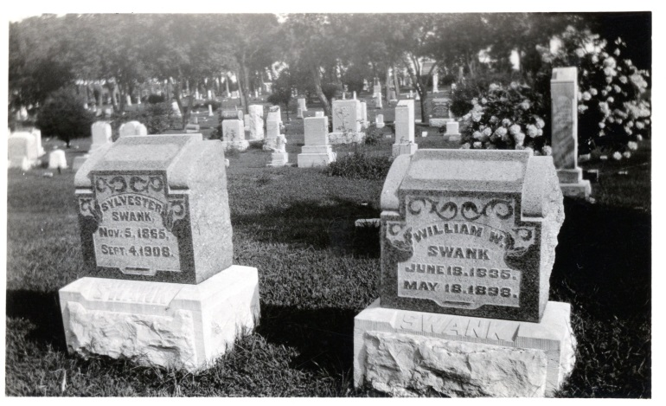

According to Census records, six children were born to the couple: Mary, Jacob, Elvin, Jennie, Sylvester, and William I. Swank. The children were raised in Ohio, likely on a farm. Martha died around 1877 and may be buried in Ohio; she is not with her husband.

After the 1880 Census, the next we hear of William W. and Mary’s son Sylvester is through a newspaper report in the St. Louis Republic in 1903. "Kills Policeman in Station" is the headline on a report that in Kansas City, Missouri, a man named Sylvester Swank, recently released from the St. Joseph's Asylum/Hospital, demanded money from a Sergeant Snow in the police station. When Officer Alexander McKinney came to Snow's aid, Swank shot McKinney and was then overpowered. While this is an unfortunate way to gain fame, it does allow us to place another member of the Swank family in Missouri and to join together more puzzle pieces.

So, how did these pictures from Missouri wind up in California? The likely answer, again, can be found in Census records. William W.'s son and Sylvester's older brother, Elvin Swank, was father to two girls, both born in Missouri. He had married an Illinois-born woman named Emma Lane - a connection to the Lane Grave from the Mystery Photos, no doubt, and another piece of the puzzle fits! By 1900, Elvin had moved his family to Los Angeles, CA. In the 1920's, his daughters would have been young women, perhaps those featured in the Mystery Photos, prerhaps related to them. Eventually, the family settled in Riverside. Elvin, his wife, and their daughter, Effie, are buried there.

Elvin's younger daughter, Ruby Swank, born 1895, married Walter Mooneyham. They had at least one daughter, Laurel M. Mooneyham, possibly born in 1919. The family lived in Riverside, CA. Ruby died there on Dec. 29, 1980. Laurel is listed in the 1930 census as living with her parents. She does not appear in the 1940 census with them. She is our next unconnected puzzle piece.

The Armstrong Grave is also on the edge of our puzzle, not easily fitting in. And the many homes captured on film are still waiting for the positive addresses that will make them a part of the big picture, as are the babies, young families, servicemen and others. But the puzzle is growing and forming before our eyes, and we will perserve. We hope someday to change the title of our exhibit from "Mystery Photos" to "A Puzzle Completed," and to return these treasures to a family member.

❖

Historic Survivor of the Restaurant Wars:
The Chicago Café
By Beth Wettergreen

On a usual blisteringly hot summer afternoon in Woodland, California, an out-of-towner cruising Main Street for a good lunch can still count upon “restaurant row” which features cuisines from Thai to Mexican to Japanese—everything from a quick taco-de-res to a swanky upscale destination with $60 shots of tequila. Restaurants have rotated along this strip year after year, as the town of Woodland has been transformed from the journey’s end of ex-Forty-Niners in the early 1850s, to the equally determined survivors of America’s most recent depression in 2013. But, above all else—The Chicago Café is one of the survivors. What a surprising spot to find a treasure of California history—not just Chinese-American history--in a place like this. The Chicago Café has continuing in business in (almost) the same location for 109 years.

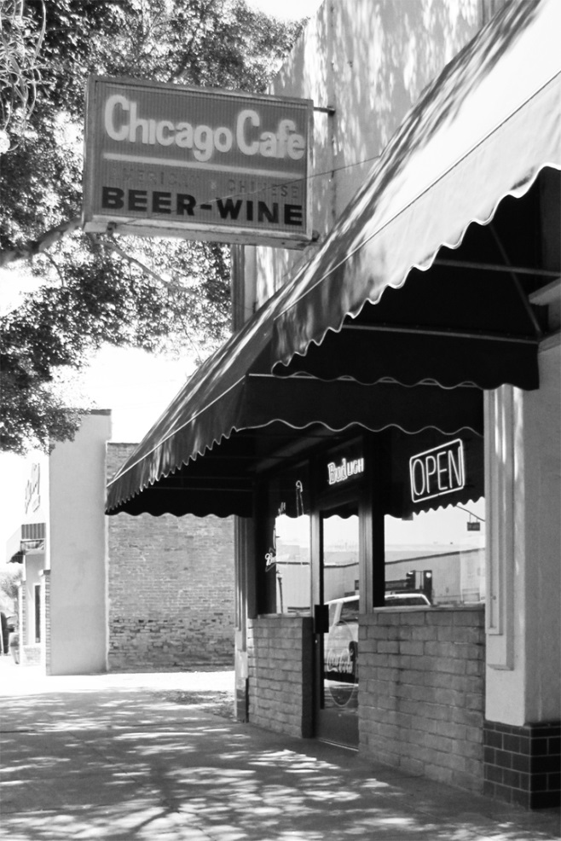

At street level, The Chicago Café has an unassuming appearance. On first approach, the neon sign in the window flashing ”Open” reminds the diner of all of the fly-by-night chop suey parlors that have sprung up along freeway off-ramps from Bakersfield to Weed. In any small town, one could always count on some good chop suey, and, of course, a Coke or a beer to go with it! Indeed, the large letters in second place on the sign proclaim “Beer And Wine”, just as “Air Conditioned” might have been the Café’s main draw in years gone by.
The Chinese and American food served at the Chicago Café is as scrumptious today as it was in 1914, the earliest date that the restaurant was at this site. Dishes like the Chicken-Almond Chow Mein, Peking ribs, or the spectacular hamburger and fries still grace the Café’s menu.

Varying accounts suggest that the cafe has been located at 411 Main Street, Woodland, California, from at least 1915, but was located across the street as early as 1909. Enter the dining room. One side calls to mind an old time lunch counter at Woolworth’s, with rows of stools lined up against an immaculate Formica counter.

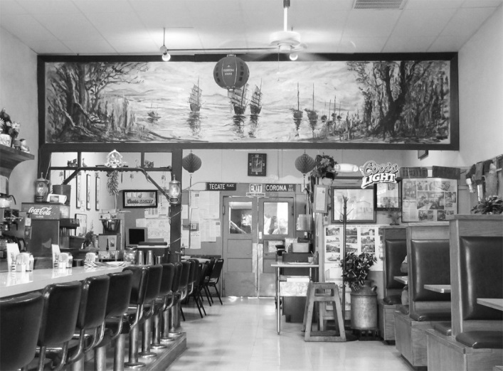

Overlooking the dining room from the back is a 20-foot- long mural of orange-and-gold Chinese junks cruising the China Seas. The story is that the mural was painted “many many years ago”, at the outset, long before the current ownership began in 1949. Another painting by the same long-ago artist –in the small room where the owner does his bookkeeping—shows a Chinese boy standing in a field and holding a rooster. This whimsical portrait harkens back to the simplicity of Chinese rural life in the home country.

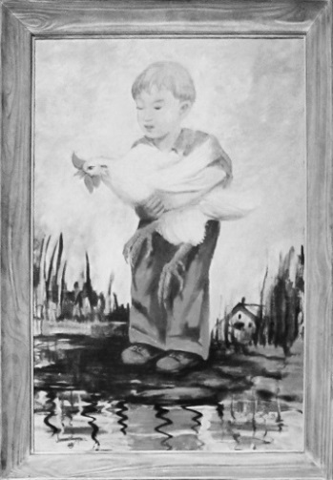

Paul Fong, the hospitable owner of the Chicago Café, is a cheerful man with grey hair and glasses, who has worked here for most of his life, after assuming the Café from his father in 1989.

No one—from Paul Fong to the old- time customers in the restaurant—knows how the restaurant came to be called the Chicago Café, yet one might speculate on the name’s origins. Perhaps one of the Chinese founding fathers in Woodland had spent time in Chicago, which was in the 1880’s and 1890’s considered as America’s foremost city dedicated to modern entrepreneurship. Or, “Chicago Restaurant” might have been a contemporary, all-American-sounding name to draw customers into a restaurant at first located across the street from the current location, inside the lobby of Woodland’s only hotel, which catered to Whites.

What is known about the Chicago Café is that it opened two decades after Chinatown’s peak population in Woodland during the 1880s. As with all Chinese-owned businesses, it was located between Main Street and Dead Cat Alley, an alley with a disreputable impression among the early White settlers. According to Woodland’s still-extant newspaper, the Daily Democrat, the first Chinese male immigrants came mostly from Canton Province, which perhaps accounts for the Chicago Café’s enduring emphasis on Cantonese cooking. “Chinese were employed as cooks, gardeners “ [Daily Democrat]. In fact, the numerous ranches throughout Yolo County usually employed Chinese males as the backbone chefs in their ranch kitchens in the early days. In the budding town of Woodland in the 1880’s and 1890’s, Chinese were subjected to derogatory remarks and open disdain by the more prominent and successful settlers. And at the end of the Nineteenth Century---with the entry point at Angel Island (the Ellis Island of the West) being so restrictive--only Chinese males were admitted, and those few destined for low wage labor jobs only. Several Chinese laundries were located along Dead Cat Alley in Woodland then. According to accounts published in the Daily Democrat , White citizens complained of the sloppy work done by the Chinese launderers, of the smelly quarters, the boiling pots and strung-up shirts and drawers along Dead Cat Alley. It is impossible to determine whether these accusations were genuine, or only examples of the Whites’ prejudice against the presence of the Chinese. (Daily Democrat, December 14, 1984)

The name “Dead Cat Alley” has two disparate theories of its origin. One of them is the rumor that the Chinese incorporated meat salvaged from the many dead cats in the alley as an addition to their culinary specialties. This seems very unlikely, and probably an invention of the White population at the time. A more likely suggestion is that the many dead cats were once live cats who had been attracted to the Chinese quarter because of its abundant supply of kitchen garbage, rats, and mice. An 1890 article in the Daily Democrat noted that Chinese-owned businesses had been “temporarily stopped by a recent order of the [United States] Supreme Court”. This was probably a reference to the Chinese Exclusion Act, which essentially stopped Chinese immigration until the act was repealed in 1943. By the 1920s, the Chinese enclave in Woodland had dwindled and died. By the 1930s, Main Street was lined with movie theaters and department stores whose main clientele were Whites. In 1984, what was considered the last remnant of the Chinese area, a corrugated shed at the back of the Chicago Café, was torn down as part of the renovation of the Woodland Opera House. According to the Daily Democrat, this “archeological dig” yielded several opium pipes and other drug paraphernalia, suggesting a Chinese opium den. But Paul Fong, who was there at the dig, flatly denies this version. “No drugs there.” A cellar was dug out underneath the shed as a place for Chinese to go to get out of the heat. They played cards in the cellar. Readers can hardly imagine the sufferings of Woodlanders before the advent of air conditioning! (Paul Fong, personal interview), (Daily Democrat, December 14, 1984.)
Several accounts of the Café’s first history have been handed down through Paul Fong’s stories and through records of the Yolo County archives. As Paul related, to the east along Main Street was another Chinese restaurant owned by one of Paul’s several “uncles by courtesy”, Charlie Fong. It had the curious name of the Woodland Meat Market; no meat was sold there. Charlie Fong later told Paul’s father, John Fong, that the first location of the Chicago Café was inside the Bryer Hotel, across the street from the Chicago Café’s current location, at the site of the current Hotel Woodland. Woodland city records show that from 1904 to 1907, the site at 411 Court Street was occupied by a couple of photographers, lending credence to the account that the Chicago Café moved to 411 in 1909. At least a decade after a deluxe new hotel (the Hotel Woodland) was erected in place of the Bryer, the Chicago Café was already established as “Woodland’s Oldest Restaurant”.

As if a testimony to the Café’s long heritage, on a far wall at the back of the dining room hangs a framed advertisement from the 1915 Woodland High School’s yearbook, the Ilex. The ad promotes the Chicago Café for its “Chop Suey and Noodles” as well as the all-important contemporary feature, “Air Conditioned”. The Chicago Café is touted as “Woodland’s Oldest Restaurant”, which it was in 1915. (Paul Fong) (Eileen Leung, University of California, Davis)

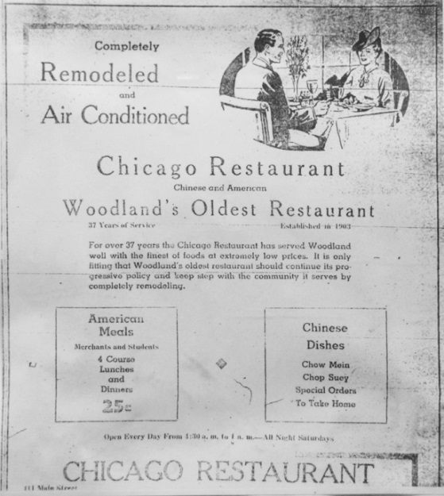
Thirty years passed, with the Chicago Café still dishing out its tasty fare at 411 Main Street. At the same time that Communist China was still struggling, and even while restrictions of Chinese immigration to the U.S. were still problematic, Paul’s father, John Fong, persisted. He immigrated to Woodland in 1949. Because of the immigration laws, Chinese males, even those with families in China, entered the U.S. on temporary visas. The process of obtaining even provisional citizenship was very involved and expensive. These immigrants’ hope was to earn enough money to purchase fake papers from another Chinese who could prove to have American citizenship through birth in the U.S.. In other words, John Fong had to assume a fake identity as another U.S.-born Chinese in order to remain and work in the U.S.. As things turned out, he had to work for 24 years at the Chicago Café (1949-1973), in order to earn enough money to purchase another Chinese male’s papers under a different name and hire a lawyer to plead his case. During these years, Paul’s mother and siblings lived in Hong Kong, and Paul’s father visited them every few years. The requirement of a false identity yielded the term, “Paper Son” which was coined for Chinese of the period. In 1956, an amnesty program was begun whereby those Chinese who had taken someone else’s identity in order to remain in the U.S. were able to “confess” their mistake and take back their own names. In a sad instance of delayed justice, the Chinese Exclusion Act added difficult times for men like John Fong. Such struggles seem hardly conceivable, considering the important contributions that Chinese-Americans have made to California history over many generations (Paul Fong) (Yolo County Archives)
After these hard times, there was a kind of “renaissance” of Chinese restaurants In the 1950s in Woodland. Chinese food had always been popular with everyone, even as new cultures began to migrate to the burgeoning Yolo County population. Throughout the 1950s, John Fong , his friends and his relatives, competed along Main Street in Woodland for the Chinese restaurant market. As Paul learned from his grandfather, Harry (Chinese name Gao) Fong, the original two competitors were Charlie Fong (previously mentioned) and another Chinese chef known as “Cowboy” Fong. (There is no explanation for how “Cowboy” got his moniker, much as there is no explanation of how the Chicago Café got the name of “Chicago”). In 1958, Uncle Charlie Fong beat out “Cowboy” in a bid to open a new Chinese restaurant at the corner of Cottonwood and Main, called Ming’s. It was open for more than 30 years, until it was replaced by the very popular Taco Bell which currently stands at that location. Through all of the restaurant wars, the relatively modest Chicago Café has held its ground. (Paul Fong)

When Paul had finished his apprenticeship at the Chicago Café over a period of 16 years, his father John handed over the restaurant to his son in 1989. Paul Fong is very proud of the menu at the Café, particularly the popular Cantonese-style cuisine. True to the “American and Chinese Food” sign, one can still enjoy the perennial lunchtime favorite, a hamburger and French fries.

At the back of the dining room, at a large table, a gathering of “old timers” wile away the day over coffee, watching the comings and goings. One of them is the grandfather of the Chicago Café’s new, young waitress. The same patrons –some of whom this author recognizes through twenty years of residence in the town—have come here to chat up their buddies. This is a hometown place. The sense of camaraderie about this place--the cross-talk among those who twist around on their stools to spar with their buddies seated in the booths—is a reminder of the comforts of long time friendship. Paul Fong names three secrets to his success with the Chicago Café. First, he was able to buy the building in 1992, so he does not have to pay rent, unlike most of the other restaurants along restaurant row. Second, he credits the restaurant’s authentic Cantonese cooking for repeat customers. And third comes the real reason for his continued success. When asked if he has enjoyed the life he had set out for himself in 1973, Paul Fong states, in a modest tone, “It’s okay if you don’t mind fourteen hours a day.”

The original all-wood refrigerator that has been in the Chicago Café since its opening more than 100 years ago is still on site, and is fully functional, even though it has recently had to been converted from “water cooled” to “air conditioned” due to the recent hikes in metered rates by the City of Woodland. Paul and his wife Nancy, proud owners, are pictured in front the old-time fridge.

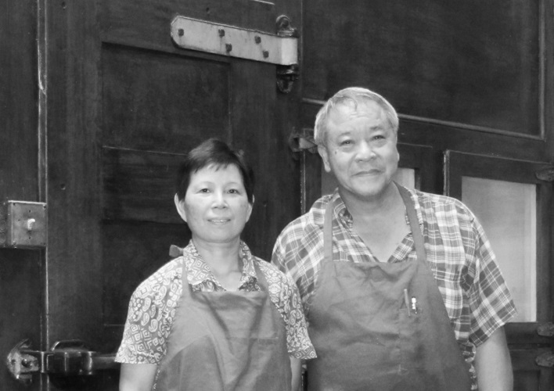

My thanks to Paul Fong of the Chicago Café for all of his kind help.
Amanda Mason of the Yolo County Archives for research assistance, and Dennis Dahlin from the Yolo County Historical Society for his photography.
References
Eileen Leung, University of California, Davis.
Paul Fong, Personal Interviews, July 27 and August 21, 2013
Woodland Daily Democrat, December 14, 1984
Yolo County Archives

❖

Have you checked out our website lately?
www.yolo.net/ychs/

Save the date!!
The fate of the WPA Restroom Bldg in Central Park in Davis is now scheduled to be decided by the Davis City Council on Oct. 8th. Museum volunteers would like to have as many Society members as possible attend to support out pleas to save the building as a Museum Annex. Since consideration of the issue has been delayed several times, it would be wise to check with Director Dennis Dingemans at 530-753-5959 closer to the date.

UPCOMING PROGRAM

Amazing Women of Yolo County
Gibson Museum, Woodland
October 27, 2 P.M.

NEXT MEETING DATE
Members are welcome to attend
Hattie Weber Museum, Davis
Sept. 12, 10 A.M.
Hear more about your Board Members next month….
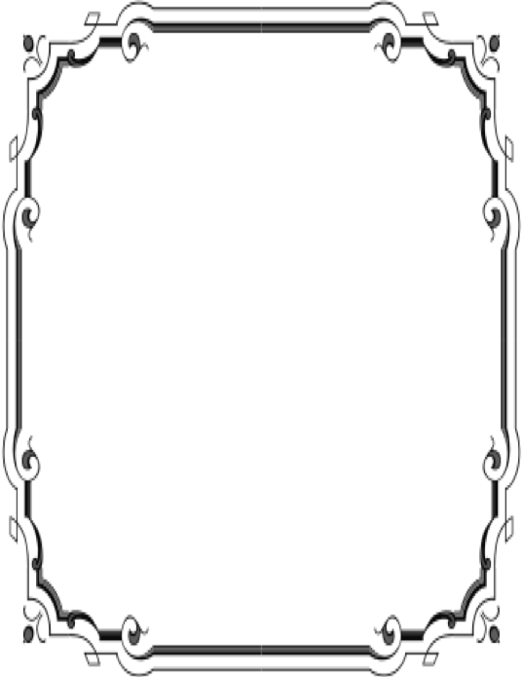
Patrons

Thanks to the following for generously supporting the Society for 2013-2014. You too can be a Patron by donating $100.00 to help us run our projects
- John and Helen Daniels
- John and Kathy Harryman
- Pamela Pearl
- Frank and Virginia
Schwarzgruber
- Stella Dinger
- Robert and Lynn Campbell
- Leroy & BJ Ford

Yolo County Historical Society
P O Box 1447
Woodland, CA 95776

Address Service Requested

Dated Material

Vision Statement The Yolo County Historical Society strives to preserve, protect and acknowledge
the diverse history of Yolo County through education, communication and advocacy

