

SEPTEMBER 2012
PP 2012

PRESIDENT’S MESSAGE

Thank you for renewing your membership in the Society. Your Board of Directors will be meeting the 10th of this month, 7:30 P.M., at the Home Improvement Group which is located in the Woodland Hotel. Entrance on Main Street.
This is be a planning meeting for the coming years. Members of the Society are welcome to attend. We would like to hear from you either by e-mail (bjford@pacbell.net )by phone(662-0952} or face to face. We will be planning our 4th Sunday programs, visiting our already planned October 28th Woodland City Cemetery Tour and the Fashion Follies to be held at the Woodland Opera House on
October 13th.
Our usual meeting time is 7p.m., however, board member, Kathy Harryman and I will be on the Agenda of the Yolo County Fair Board to discuss the moving of the “west stage” away from the front door of the Historic Spring Lake School House during the August Fair. Those of you who so graciously volunteered to staff the school during the Fair know that when a band is playing it is impossible to interact with visitors. Neither you nor the visitor can hear over the music..
And one last reminder, the 24th annual Stroll Through History is Saturday the 8th of September. Many Society members will be staffing the historic Gable Mansion located on First Street. If you have not visited the Mansion previously, this is your opportunity and if you have, seeing this beautifully restored home never gets old. Tickets may be purchased via the Stroll website or on the day of the Stroll at Heritage Plaza (providing they are not sold out).
Peace, BJ Ford, YCHS President

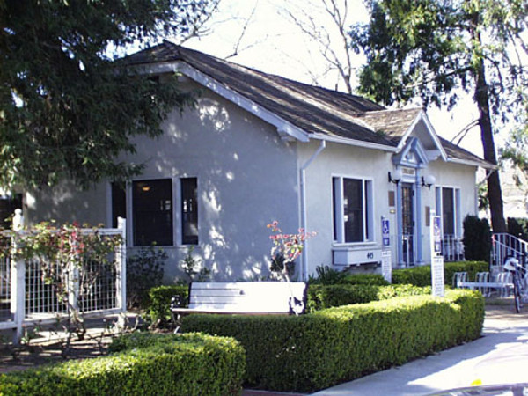

New Exhibit at Hattie Weber Museum
What do a silver seafood fork, pack mule saddle, a wooden roller skate, cowbell from a submerged ranch, gold scale, pictures of early Davisville homes and businesses and a flapper dress trimmed with silver beads have in common?
They are all items in the latest exhibit at the Hattie Weber Museum of Davis. The exhibit, entitled “Hattie’s Attic: Artifacts from our Cupboards” opens next Saturday, August 25, 2012 at the Museum at 445 C Street in Central Park. Also featured is the 1930’s medical bag carried by beloved Dr. Leo A. Cronan. Pictures include a view of the unrestored Dresbach-Hunt-Boyer mansion on 2nd street, “downtown” Davis in 1870 and an early saloon interior. Many of these items have languished on shelves awaiting their chance in the spotlight. The Museum is delighted to give then their due.
Another new item on display is a timeline of Davis history developed by John Lofland showing the decade by decade evolution of our community including a listing of the most influential people of the various eras.
Continuing exhibits include items from the recently demolished Pena house, some of which are for sale to the public.
Museum hours are 10 am to 4 pm Wednesdays and Saturdays, Admission is free. Donations are gratefully accepted. Children are welcome to play in the toy corner while adults view the exhibits.

The Hattie Weber Museum, located at 445 C Street, Davis, Ca. is open to the public on Mon. & Wed. from 10:00 a.m. to 4:00 p.m.

~

Good News from Yolo County Archives
Starting September, the archives reference hours will be on Tuesdays 9 am to 1 pm and Thursdays from 10 am to 4 pm. The Archives are located at 226 Buckeye St. Woodland, Ca.
Questions? Please contact either Analu Josephides (530-666-8025) or Amanda Mason (530-666-8010)
~

NEWSLETTER ARTICLES DEADLINE: Articles for the newsletter will be accepted until the 20th of each month. Please either email B J Ford at: bjford@pacbell.net or mail to the YCHS at P.O. Box 1447 Woodland, CA 95776

~

Searching for a past article from our newsletter? Go to Yolo County Historical Society web address: http://ychs.org/

~

Society publications available for sale at a variety of locations. For more information on book sales, contact Mary Aulman at 666-0743.

~

Gibson Gardners to Host Fall Plant Sale

Early Fall is the perfect time to add new plants to the home garden, suggest the Gibson Gardeners who will host a plant sale on Saturday, September 15th from 10:00 AM to 2:00 PM at the Yolo County Historical Museum, 512 Gibson Road, Woodland.

Offered for sale at reasonable prices will be herbs, succulents, perennial flowers, native plants, lilies, iris, shrubs and trees, plus dried flower bouquets, garden seeds, dried herbs and special gardens and topiaries which make suitable gifts, according to a Museum spokesman.

Donations of plant materials, decorative pots and garden tools are always welcomed by garden volunteers who work in the Museum garden on Tuesday mornings or items may be left in the southwest corner of the grounds.

For more information about the plant sale or the Teddy Bear Tea, which will also be held on September 15th, call 530-666-1045.

Mrs. Gibson’s 2nd Annual Teddy Bear Tea

When: Saturday, September 15, 2012
Where: Gibson House Museum
512 Gibson Road
Woodland CA 95695
Time: 11:30 AM – 1:00 PM
Cost: $25.00 – 1 Adult & 1child
Additional Child: $10.00
Adult: Single Ticket-$17.50
Tickets available:
Museum Office, 512 Gibson Road, Woodland, 530-666-1045
Gifted Penguin, 716 Main Street, Woodland, 530-668-8215
Sweet Potato Pie, 528 Main Street, Woodland, 530-662-8000
Mother & Baby Source, 714 – 2nd St, Davis 530-756-6667
OH, WHAT WE DID IN THE SUMMERTIME, TRA LA
or HOW WE KIDS SURVIVED THOSE HOT VALLEY SUMMERS
Article submitted by Nancy Rice

I loved waking up in the cool summer mornings during vacations from Dingle School. The sunlight came in gently, filtered by tree leaves. The scent of the white climbing roses was in the air. Being a child who loved to read, I could read until the getting up time. That was 7:00, no earlier because I might wake the family up, no later because I might miss breakfast.. I especially remember reading old “Jack and Jill” magazines during that quiet hour. My bedroom was incredible, more so in the summer. It had six windows, three facing east into the back yard and three facing south onto the rose arbor and the side yard.. The room was huge, sixteen by twenty feet. My bed was situated so I felt the delta breezes in the night blowing the built- up valley heat away.
Chores and shopping were done in the morning of course. There was the saying, “Only mad dogs and Englishmen go out in the midday sun,” and we were more sensible than that. Much of our life revolved around coping with the heat and the fact nobody had air conditioning. Some people had swamp coolers. We didn’t, but our house had both wall and ceiling insulation, which did help. I don’t think automobile air conditioners existed then either. Anyway, after breakfast we might go along with Mom when she took Dad to work (in the Hotel Woodland building at 440 Main St.). We would then shop at the Columbia Market across from the office a couple of times a week. Or we might go for produce at Mrs. Benedict’s little truck farm at the end of Lincoln St., a bit west of West St. Every two weeks we went to the library. Of course we would have shut the windows and pulled the shades down before leaving in order to keep the house cool. If we stayed home we might leave the windows and doors open as late as 9:00 a.m. These windows were all opened at 8:00 or 9:00 at night to cool off the house, which would have gotten pretty stuffy in the afternoon. David and I would do our yard chores before the sun was up too high. We did most of the lawn mowing and all of the weeding out the Bermuda grass. I did my ironing in the morning too. I remember the hot steam rising from the ironing board and the fresh, cool air coming in the back door and the kitchen windows. Mom worked the hardest: all cooking was done in the morning unless we barbequed. She did the laundry then and hung the wet clothes out in the back yard. Who had dryers? The sunshine dryer was free and left a great scent on our clothes. Most of the housecleaning was done then too. I remember cleaning my room of course, including rotating the sheets and tucking both of them in with hospital corners once a week. One of my contributions to general house cleaning was crawling among the knobby legs of our gate leg dining table to dust them.
The afternoons were hot, lazy times. In rooms shaded from the sun we read without turning on the light (because of the heat). Sometimes we hung out with neighborhood kids on the front porch and played jacks, Monopoly, checkers, Chinese checkers, or card games like Old Maid, Go Fish, Acey Ducey, rummy, canasta, pinochle, or even poker. Our front porch was shaded, and the cement stayed cool into the afternoon. Sometimes Bonnie Flieschauer and I would hang out, sitting in her crepe myrtle tree a few doors down the block. Before there was a public swim pool in Woodland we rode to the Crowder’s pool in Madison in a bus sponsored by the city recreation department. When I was eight or so Dad joined the Karlton Klub on Elm St so we could use that pool We kids all had to learn to swim then, for the water in the shallow end was four feet deep, maybe more. There was a shady porch for the mothers and two high school male life guards. The deep end was at least eight feet deep. Diving to pick something up off the bottom there was a feat…it was deep enough to feel the water pressing in. The water was unheated, which made it effective for cooling our core temperatures. Friday afternoons were extra fun because the pool had been drained and scrubbed down beginning the night before. There was a fire hydrant at the shallow end of the pool for filling it. At lunchtime the hydrant was turned on full blast. It took about five hours to fill the pool as I remember. When we came we would run on the floor of the pool behind the arc of water from the hydrant and also right through that water, feeling it beat down on us. After there was a foot or two of water in the shallow end we would ride an inner tube in and behind the water stream. When we came there would be water in the deep end to swim in too, really cold water. I identified with newspaper pictures of children in eastern cities enjoying the water from their fire hydrants on hot days: it felt so good, so cool. We had to leave on time to assemble dinner, meaning around 4:30, while it was still hot. It was so hot I remember the parking space pavement, where it was patched with tar, melting enough to sink a coin or poke a stick into. The City Pool on Elm St., aka Gracie Patches Hiddleson Pool, opened in 1948. This pool was open for lessons in the morning and for recreation in the afternoons. I liked going there with the girls, but it was crowded and there was virtually no shade. Since I could take a guest or two to the Karlton Klub, I often did that.
In July and August we drove to Winters or Yuba City or to a tomato field for apricots or peaches or tomatoes for canning. Usually Nada Nichols went with us. The next day or two were really hot, as they were canning and wanted the windows open for ventilation, even in the afternoon. But I remember the particular smell of tomatoes and peaches peeled in hot water lingering in our house.
Summer was the time for visits from the Rawson cousins. Ralph and Alice, and their children Maurine, Bill, and Pat to come up from Richmond and spent a week or two at Dunnigan caring for his aunt’s farm while she vacationed. The kids would stay over a night or two with us and we all had great times. Maurine later remembered my mother as being very lenient, for example letting us play hide and seek in the house, hiding behind clothes in the closet or under beds.
By 5:30 when my father was picked up from work the heat of the day was easing off a little bit. Now my father loved ice cream. He would go a long. long way for ice cream. A special treat was for Dad and us kids to walk from our house at 727 Second St. to the Sanitary Dairy at Sixth and Lincoln to buy a nut roll and walk home with it. These nut rolls were special, vanilla ice cream molded around a core of raspberry or orange sherbet and then rolled in chopped nuts. Yum! The walk was hot but we agreed it was worth it.
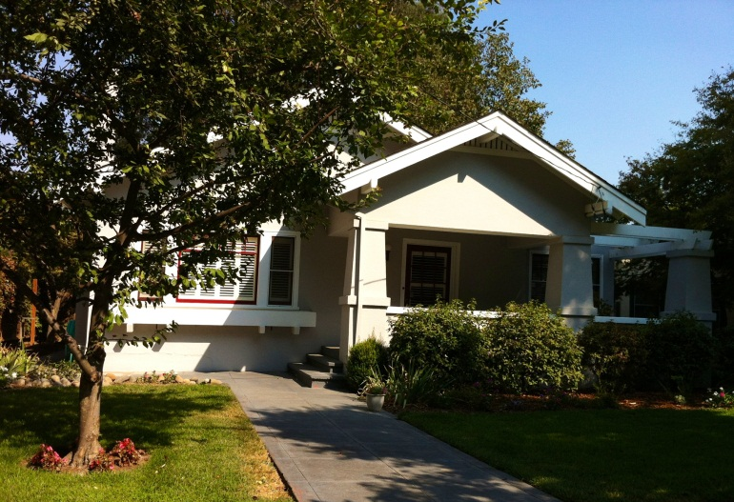
727 Second St as it looks today
Evenings were lovely, warm and mellow. I remember hanging out with kids on Second and Third St. There were so many---Edith Smith, Barbara Candau, Gaylene Nichols, Dotty Parrick, Carol Sue Williams, Carole Monroe, Diana Winters, Joanne Marks, Franklin and Dave Fitz, Steve Foster, Ted Gregg, and more, and then there were the kids my brother‘s age too. Gaylene and Barbara lived a couple of blocks away from the 700 block of Third St. I remember if we played there we would have to come home before dark. We would walk in a group down the middle of the street, under the shade tree arch. Yes once upon a time there was that little traffic on Third St. I remember playing softball on my block with home base in my front yard, the neighbors having moved their cars out of the way. I remember hearing baseball games on the radio---my father followed the Sacramento Solons. One or twice a summer we got tickets to the Solons games through Uncle Bob. At that time he worked for the Buffalo Brewery, and the owners made their unused tickets available for the employees to buy. The tickets were special, for choice seats, box seats, behind and a bit to the left of home base, and only about five rows back. I remember my baseball hero was Walt Dropo, the first baseman. Back in Woodland there were baseball games at the American Legion field. There were City band concerts in City Park that I played in in my middle school grades, and I remember folk dancing, possibly on a family basis, there on the tennis courts. Most evenings would end around 8:30 with a cool bath in the big claw footed bath tub. The tub was long enough that I could pretend to swim in it, and of course I loved making waves. So we kids went to bed clean and cool.
My parents survived also by sending us away. Just kidding…these were high points in my summer. I spent one week every summer with Grandma Bickmore in Sacramento and, starting in the fifth grade, two weeks at Girl Scout Camp at Rucker Lake. Later I would stay in Richmond with cousin Maurine. Being away made me feel so grown up.
This brings me to the point where I have to state that one of the best ways to survive the valley heat was to leave the valley. We did exactly that on our vacations and plus that by camping in the mountains almost every weekend. Saturdays must have been hard on Dad. He worked until 12:30 or 1:00 and came home to load up the car. We had everything ready on the back stoop. He grabbed lunch, eating some of it in the car. When loaded up, we were off. It was important to leave as early as possible because of the heat, and we traveled with the windows open of course. The roads were two lane except for a few four lane sections, and the speed limit was 45 miles per hour. Usually we drove to Sacramento by the River Road and followed up Folsom Blvd to Hwy 50, or we went up from Marysville. We almost never drove to the mountains on Hwy 40, which later became I80. That road was a two lane traffic jam.. My absolute favorite camping site was Wrights Lake, up a mostly one lane dirt road from Fred’s place on Hwy 50. If you met another vehicle there the uphill car had to back up the hill to where passing was possible. Sand Pond, in the Gold Lakes area above Downieville was a favorite too. On these trips we would stay overnight, hike, swim, maybe wait for Dad to take photos, and head home after dinner, when the valley would be cooler. On the way home near Marysville we would have to stop at a fruit stand. On the way up to Hwy 50, especially where Rancho Cordova is now, David and I would lie on the back seat of the car with our feet out the open window to cool off. There was a sign saying 48 miles to Placerville, and we would lie there counting out forty eight telephone poles and then saying, “Are we there yet?” Over and over we did that. I don’t see how Mom and Dad stood us. Well, it was all for family, for being in the mountains, for cooling off, an important part of how we survived and even surmounted our hot valley summers.
~

Don’t forget to mark your calendar for our upcoming fundraisers…….

October 13th - Fashion Follies at the Opera
House

October 28th - “Rogues and Rascals” Cemetery
Tour

Yolo County Historical Society
P.O. Box 1447
Woodland, CA 95776

Address Service Requested

Dated Material

TRIP TO JACK LONDON STATE HISTORIC PARK
CANCELLED
It is with deep regret that we have had to cancel the trip to the Jack London State Park planned for September 20th. There were not enough members interested in this trip to warrant the costs involved. Those who had signed up will be receiving their checks by mail within the week. Those involved in the planning of Society trips to places of historic interest would like to hear from you as to where you would be interested in visiting.
Send you suggestions to the Society’s P.O. Box 1447, Woodland 95776.

Vision Statement The Yolo County Historical Society strives to preserve, protect and acknowledge
the diverse history of Yolo County through education, communication and advocacy

