

AUGUST 2017

PP 2012

Prez Says

Ah July…summer sun, fresh tomatoes and corn, local apricots, peaches and nectarines…rich sweet melons….that’s what makes this county so special. July is also the month of fun and frolic for students….For many it marks the end of their ‘summer’ vacation. I am devoting this newsletter to our schoolhouse.

In other news, The Gibson House Board of Directors has hired a new director. His name is James Glica Hernandez and he is a resident of Woodland. He takes the place of our David Flory who retired for the 2nd, 3rd, time and is traveling between California and Texas. We owe David many thanks for all his years of dedicated service to the Museum. He is responsible for a great many improvement projects that make the Museum a wonderful historical site. Thanks David.

We are equally fortunate to have James Hernandez as our new director. He comes to us with a varied background of experiences. You might recognize him directing the musicians at the Woodland Opera House. That is just one of his many talents. His biography will be in the next newsletter.

The County meeting on the Gibson Museum has been scheduled for Tuesday September 12. The supervisors will look at the 3 year plan submitted by the Museum Board and make a determination. I am encouraging all of our members, if possible, to attend the meeting. It begins at 9:00 at the County Administration Building. third floor. Hopefully there will also be information regarding the future use of the County Courthouse Building.

Again, I want to thank all of you who contacted your supervisors expressing your concerns about the future of the Gibson Museum.

Come see us in the School House at the Yolo County Fair beginning Thursday, August 17 through Saturday August 19. We open at 12:00 and close between 4:30-5:00. If you are interested in helping in the School House, please contact Pat Campbell, at 666-3021 or Campbell5224@sbcglobal.net.
Remember, as always…

History Rules!

Kathy Harryman
President, Yolo County Historical Society

❖

Amazing Yolo County and World War I

As most of you know, the Society is researching the county’s participation in World War One. As always, in that research we come across amazing facts. Here are a few…

- On January 23, 1920, General “Black Jack” Pershing stopped in Woodland on the train on his way to be honored as a guest “of the Golden State’s capital”. “Woodland’s .. school children, who will be assembled there, (the depot) may have the honor of being able to tell posterity that they saw the great American who in reality directed the forces which defeated savagery and Teutonic autocracy for all time” Woodland Daily Democrat
- Woodlander Ella Childers, a Red Cross nurse, shook General “Black Jack” Pershing’s hand in Europe. Woodland Daily Democrat March 5, 1919

If you have any World War One information from your family, please share it with us. We are always looking for personal interest stories especially from our local men and women.

❖

Business Buddies

The following businesses in town have financially supported the Yolo County Historical Society. We would like you to support them and keep your money local. If you know of any to join our support list, contact me. Businesses pay $50.00 per year for advertising.

L & S Printers, Main St.
Zamora Hills Ranch
Larry Shapiro
Bernard & Lynn Gough
Dahlin & Essex Inc.
Alderson Convalescent Hospital

❖

School House Repairs

Willow Springs Schoolhouse is 148 years old and like all ‘old’ things, it is showing it’s age. I wanted to update you on the repairs we have made this year and give you an idea of what needs to be done in the near future.

First of all, there was a new large hole on the front porch this spring. I had already asked the Northern California Construction Training Class which has been housed in the Flower Building to fix the first hole. They have been doing small jobs for us. In looking at the porch, Brian Bartch, the teacher, and I decided we needed to replace all of the boards. They were worn on the edges and showed considerable wear in other areas. We decided to replace the board with 2 x 4’s instead of tongue and groove boards. That way, water, dust, leaves and other debris would fall through the cracks. At the end of June, his class replaced both porches and repaired the railing. The porch was then painted in mid July. The total cost of this repair was $814.45. We paid Brian’s group for materials and gave them a pizza party. (They can’t take money for labor) We still need to finish the painting. I am going to bring in a professional painter and see what he suggests. I will let you know the results.

❖

Stroll Through History

On August 24 from 6-8 pm at the Woodland Public Library’s Leake Room, David Wilkinson and Jim Lapsley will be sharing information about Woodland’s historic housing development. Because Woodland was the county seat, it had a large population growth with varied architectural styles. Jim will discuss the early 1871 build out of the city when various areas were subdivided into lots. David will follow with a discussion on the varied architectural styles of the city. This talk is a precursor to the annual Stroll Through History on Saturday, September 9 beginning at 10:00. The tickets are $25.00 each. There are various tours available: Walking, Bike, and Landmark Building Tours. For an additional fee, there is also an opportunity to take a bus. Tickets can be purchased on line or at the Gifted Penguin.

Our Society provides docents for one of the historic homes during the tour. If you are interested in participating, please call Mardi Bagan at 666-6596 or e mail mbagan14@gmail.com.

Hattie Happenings

This summer hasn’t been exactly sleepy for the volunteers. But, one disappointing piece of news to report is a non-event. In June we learned that no contractor had bid on our project to renovate the 1936/37 “Old Restroom” in Central Park. It wasn’t a big surprise, we knew that we are in the midst of a building boom and our project was pegged to cost less than $45,000. The possible good news, however, is that City Staff believe the way has been cleared to bypass the bidding process and negotiate directly with a qualified contractor, perhaps also dividing the project into separate and “easily doable” parts. The saga that began in 2012 when the concept of gaining a conveniently nearby storage facility occurred to us continues. A thank you goes out to staff for sticking with us through all the delays.

Some more donations have come in from a couple of the prominent German-heritage families who were 19th Century settlers in the Davisville/”Lower Putah” area. We now display some nicely framed photographs and artifacts from the Dietrich, the Becker, and the Schmeiser families. A treasure is Thelma Dietrich’s nicely typed Valedictorian message to her 1929 high school graduation. From Thelma’s medicine cabinet came a trove of 36 items including bottles from Davis pharmacies throughout her 104 years – Campbell, Quessenberry, and Star. Among a box of Thelma’s miscellaneous historical objects was four copies of a rare (and valuable) postcard of the 1916 welcoming arch at 2nd and G. Built for $1,300 with funds raised by the Women’s Improvement Club, this landmark (alas) had just an 8 year life span and less than a half-dozen different images are known to remain.

Responding to the 50th anniversary of “the San Francisco Summer of Love,” the volunteers have pulled from the back of our closets some objects of clothing that date back to that era of neo-Victorian and other strands of hippie fashion. We would welcome additional contributions to display or to add to our collection. The colorful patchwork leather coat that highlights our display has a history that shows how widely diffused were the hip clothing preferences; our volunteer was then teaching in a rural New England school when she bought the coat from a small town department store. Another object, a decorated unbleached muslin shirt, came at the same time from a Los Angeles shop known for catering to the stars (appropriately named “Siderial Time”).

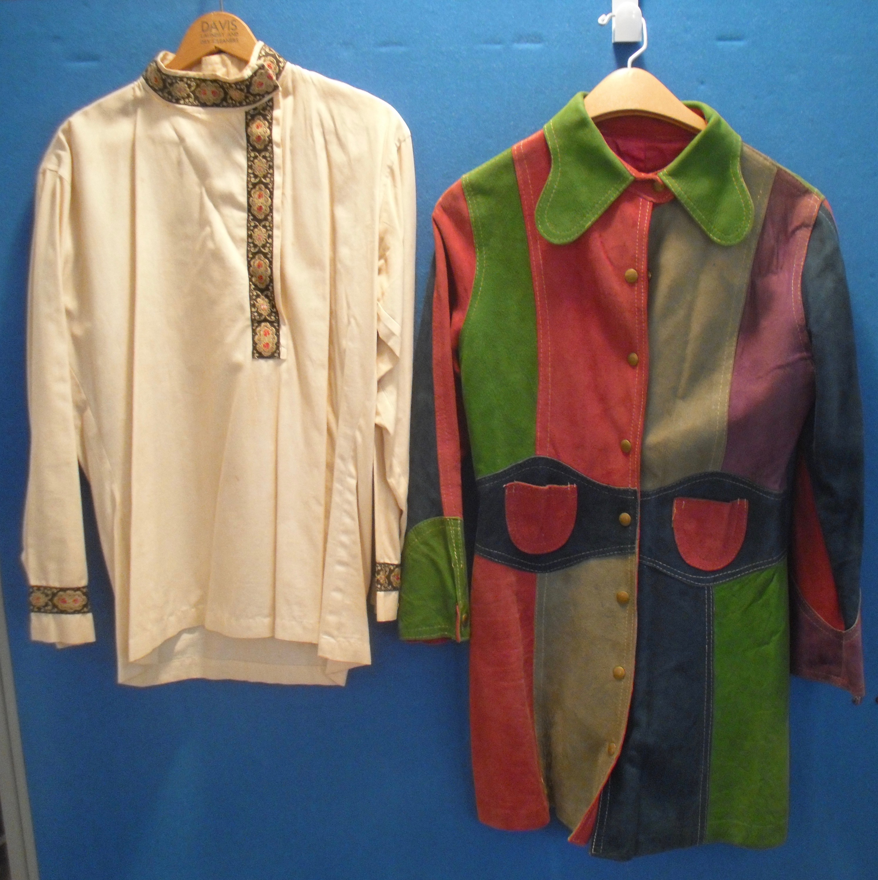

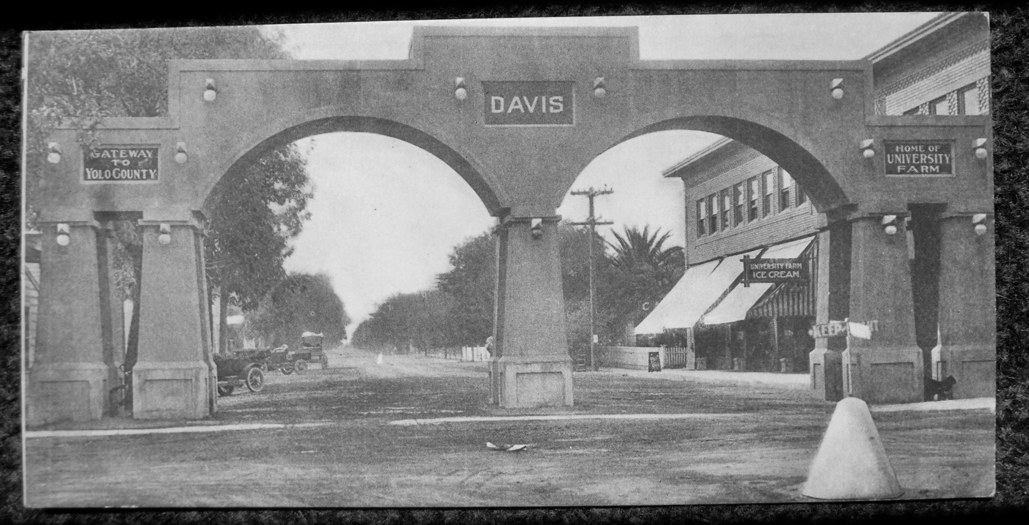

Yolo County Historical Society
P O Box 1447
Woodland, CA 95776

Address Service Requested

Dated Material

Vision Statement The Yolo County Historical Society strives to preserve, protect and acknowledge the diverse history of Yolo County through education, communication and advocacy

