

AUGUST 2016

PP 2012

Prez Says:
The kids are back in school and life begins again. The fair is over and our reduced hours at the schoolhouse were successful. Our numbers have increased considerably. However, when the music begins, we fade away into the night. We will have to make some adjustments for next year, but that is OK. I would like to thank the following who
helped staff the School House: Bob Sommer, Margie Blake, Pat Campbell, Jane Neihaus,
Lydia and Steve Venables, Barbara Durst and Nino, Bill Benton, Karen Lafferty, Pat
Henderson and her husband and John Harryman. You are treasures!

This is that time of year when we renew our membership. Many thanks for those of you
who have already sent in your renewals. If you receive a red dot next to your name, you
are overdue. Please send in your renewals as quickly as possible. Some of our projects
depend on the monies received during this time. If you know of anyone who would like to join our group, please let me know. I will make sure they receive an envelope.

This year, we will need to put some time and money into the schoolhouse. The porch in the front and back need some attention. There is wood rot at the edges of the porches. I will work with the construction unit at the fairgrounds and see if they can repair the porches. I will keep you informed.

Another project that we participate in is the Stroll Through History. We provide docents for one of the houses on the Stroll. This year, Marty Bagan, 666-6596 mbagan14@gmail.com, is our ‘go to’ person. Please call her if you would like to be a
docent.

This newsletter is devoted to Woodland’s Corner Drug Store. They recently won an award from the Native Sons of the Golden West. Lisa and Ed Shelley are sharing with us their history and some great pictures. Thank you the Shelley Family for being an important part of this county for so many years.
Remember, as always….
History Rules!
Kathy Harryman, President

❖

Hattie Happenings
“Surviving A Big Fire in November,1916, Davis
Incorporates Five Months Later”
by the Volunteers at the Hattie Weber Museum

The City of Davis is planning a celebration next year for its 100th anniversary as a City. The Hattie Weber Museum will be participating, and our contribution is conceptualized as having two emphases. Part One will be biographic profiles of the nine “founding fathers” who were elected to serve on the first three City Councils: J.B. Anderson, Sam Becket, Cal Covell, Ed. McBride, B. Brewster, John Jacobson, Warren Pugh, Charles Porter, and A. Anderson. Prominent business owners and a University leader are notable on this list. Part Two will elaborate on a commonly asserted role played by major downtown fires (1906, 1909, and 1916) in persuading voters to
say “yes” to becoming an official City. One recent week the Museum had a chance to make an early contribution to the centennial celebration.
Evelyn George, a Fire Inspector for the Davis Fire Department, has been tasked with preparing a fall City Hall exhibit on the “Big Fire” of November 12, 1916, and the stimulus it provided for creating an official City that could organize a well capitalized Fire Department. She came to the Museum wanting to know if we had maps of the burned (and unburned) parts of the downtown, details about the fire and the fire fighters, and newspaper articles making or reporting the arguments for incorporation. Bingo. An hour later she left the Museum with what she wanted. From our large box of City maps, she selected the Sanborn insurance company maps for 1911 and for 1921. They mapped the footprints of all downtown buildings, including the half dozen relatively small buildings that had burned down on the west side of the northern half of G Street between 2nd and 3rdStreets. From our photograph files she chose a 1907 image showing the half dozen one-story buildings at the epicenter of the fire damage).

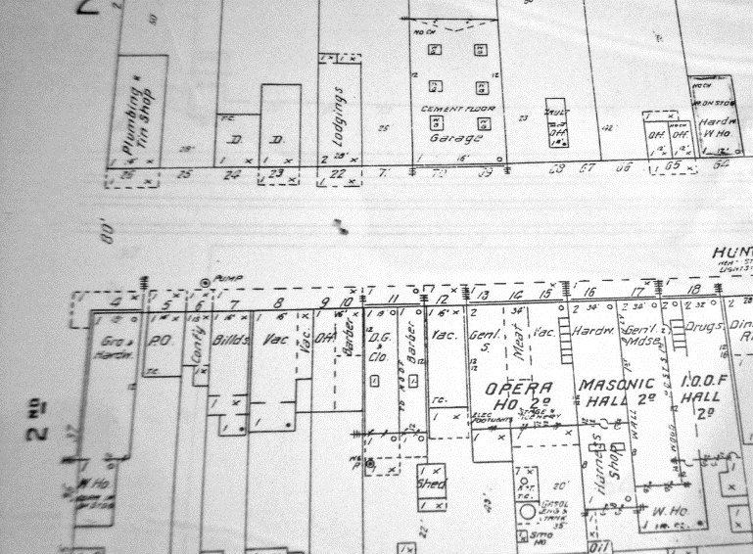

From our subject files she found a collection of Davis Enterprise and Woodland Democrat articles discussing the fire’s role in demonstrating the acute need for trained firefighters and proper equipment. From a copy of John Lofland’s pamphlet on “City Council Elections, 1917 - 2016” she got the names of the downtown residents and downtown businessmen who sought and won positions of leadership for a town ready to get serious about fire prevention. She found a 1957 Enterprise article on the City’s 40th anniversary that included photographs of the “before and after” condition of the fire site. Because those were poorly reproduced, we are looking for better copies of the images which were reported to have come from the Ligget family picture albums. Can anyone help with locating those photographs?

One prominent theme in news stories about the Big Fire and the subsequent election stressed how lucky we were that the whole downtown didn’t burn during that strong north wind event which leveled the western side of the north half of the 200 block of G Street. Credited with saving shops and homes was the very timely arrival (within an hour) of help from Sacramento. From a dozen miles away, via the new Causeway, came fire trucks and via the railroad came a pumper with a sizable water tank. The town’s bucket brigade had worked heroicly, but the serious firefighters and their professional equipment saved the day.

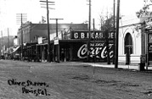

Some representative headlines from the day are
these. "Sacramento Fire Department for the Second Time Comes to the Aid of Needy Yolo County.” “Davis Swept By Fire — Business Block Licked as North Gale Fans the Hungry Flames.” “Lack of Hose Rather than Water Caused Big Loss.” “Mass Meeting of Citizens of Davis Called — Absence of Any Fire Equipment Caused $65,000 Conflagration.” “Long Expected Fire Comes.” “But for Assistance From Sacramento With Fire Engine and Chemical and the Fire train With 65,000 Gallon Water Tank of the Southern Pacific Company, Business District would Have Been Completely Wiped Out."

❖

Business Buddies

The following businesses in town have financially supported the Yolo County Historical Society. We would like you to support them and keep your money local:

L & S Printers, Main St.
Chamberlain Farms
Larry Shapiro
Bernard & Lynne Gough
Corner Drug
L & S Printing
The House Dresser
Dahlin & Essex Inc.
Bill Marble
Michele Giguiere
Tom & Meg Stallard

If you know of any business that would like to join our support list, contact me. Businesses pay $50.00 per year for advertising.

❖

Corner Drug, serving Woodland for over 100 years

Wallace Pond opened the Corner Drug Co at the corner of First and Main Streets in 1897.
Mr. Pond lived at 552 College Street in a house designed by William Henry Carson. He was
married to Genoa Lawson, whose brother W.H. Lawson, is reported to have taught Pond the
apothecary business.

The building itself was originally an elaborately bracketed wooden structure of the Victorian
Italianate style and was constructed before 1886. It was one of the first buildings to be
“modernized” in the 1912 into the Mission Revival style the building maintains today.
There were several owners in addition to Wallace Pond. H.P. Elder was the proprietor in 1903 and F. Von Jochumson was the “chemist” in 1909. F.S. Lawhead & Hume ran the Corner Drug from 1913 to 1926 and in 1929 it was called “Schoen’s Corner Drug Store”.
The building has the name “Physicians Building” on the west side and there were physicians offices in the back half of the building until about 1947 and Dr. Noble, DDS. had his dental office in the front part of the second story. There were 3 apartments behind the dental office. There was an entrance to the physicians offices on the west side of the building near “Dog Gone Alley”. Some of the physicians included Dr Hiram Lawhead and his partner Dr. FredFairchild. Dr. Fairchild was one of the founding physicians of the Woodland Clinic Medical Group which still has offices at 1207 Fairchild Court. There was a fire in the physicians offices and the doctors moved into the office at the south west corner of Lincoln and First Streets.

The “Corner Drug Co.” was incorporated on February 5, 1934 by Mike Crete and Jesse Vickery. That year the store became the first “Walgreen System Store” in California.

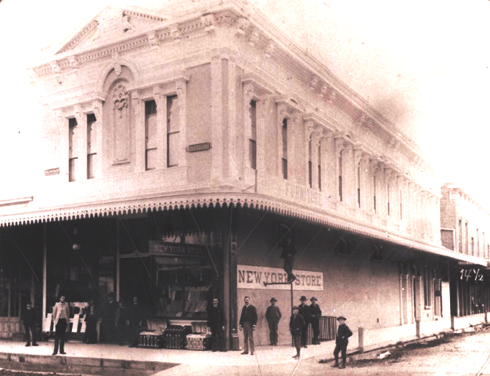

The store sold Walgreen products such as vitamins and pain relievers etc. The large green neon Corner Drug Co sign that remains in place today, was put up when the interior was remodeled after the above mentioned fire. After the fire the pharmacy expanded to take up the entireFloor of the building. Walgreens designed the interior with blond oak fixtures and the linoleum floor of diagonally places black and white tiles. The neon sign was leased from the Federal Sign Company, as it was very expensive at the time to purchase it outright.

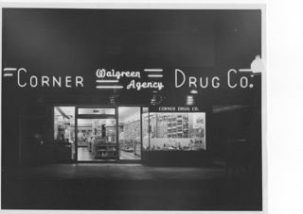

The building itself was owned by the Alge family and was a rental property. Richard Alge’s daughter Bertha (Birdie) Stephens sold the building to the Corner Drug Co. in the early 70’s.The Alge family home is still on First Street and is currently owned by the law offices of Gardner,Janes, Hugo, Nakken and Nolan.
Karl Hanke began working at Corner Drug Co. as a delivery boy. He was 16 years old and
delivered orders on a bicycle prior to having a driver’s license. He worked there until 1943 when he joined the United States Army Air Corps. Upon completing his service, he enrolled at University of California Davis and worked at Corner Drug Co. as time allowed. He then was accepted into Pharmacy at University of California San Francisco. Karl graduated in 1951 and returned to Woodland to work at Corner Drug Co. as a pharmacist.

The store had many employees and was open 365 days per year. The hours were 8am to 9pm.
They carried greeting cards, bulk McFarlane’s candy, warm nuts, cameras, household items
such as alarm clocks, smoking supplies and cigarettes, veterinary medications, games and
toys, writing supplies, off sale liquor and a large fragrance and cosmetics department in addition
to the prescription department.
Howard Gregg and Karl Hanke became partners with Jesse Vickery in 1979. When Howard
died in 1975, Karl bought his shares of stock. Jesse sold the remaining Corner Drug Co. stock
to Karl in 1980.

One of the sales clerks, Eldrid Olsen, and Karl married in 1950. Karl and Eldrid had four
children and their daughter, Lisa (Hanke) Shelley, graduated from University of the Pacific School of Pharmacy in 1979. Lisa went to work at Yolo General Hospital and Corner Drug. Lisa worked a pharmacist and became a partner in 1985. Her husband, Ed came to work as the business manager. Lisa bought the entire business in 1999 and Karl continue to work as a
pharmacist part-time until 2007. Ed and Lisa have 3 children: Sara, Jim, and Kristina. Sara
began working weekends with Lisa when she was 12. She went on to become the third
generation of pharmacists when she graduated from the Thomas J. Long School of Pharmacy
(formerly UOP SOP) in 2008. Sara came back to work at Corner Drug and will soon become
the owner.

We have made many changes over the years in order to continue to compete with large chain
and mail-order pharmacies and still provide personal service to our patients. We still offer
delivery and charge accounts. The interior has been remodeled several times in order to
expand the pharmacy area. We have embraced modern technology in order to help us meet
the demands of the current business environment. We have a Script-Pro Robot that fills about 60% of our prescriptions, which helps free up time for the pharmacy staff to provide personal service. We currently have two Smart cars that deliver medications from 9 am to 6 pm Monday through Friday and from 10 am to 4 pm on Saturday.

We have seen downtown Woodland have its’ “ups and downs” and are excited to see many
buildings being renovated and new businesses join us downtown.

❖

Thanks to the following for generously supporting the Society …………. You too can be a Patron by donating $100.00 to help us run our projects

2015-2016 Patrons

- Robert & Lynn Campbell
- Donald & Pat Campbell
- John & Helen Daniels
- Jonathan & Barbara Durst
- Robert & Judy Simas
- Ron & Marilyn Scholz
- David & Ann Scheuring
- Claire Childers
- Jeff & Starr Barrow
- Michael & Debra Truitt
- Alphe Springer
- Steve & Teri Laugenour
- Richard & Joann Larkey
- Ramon & Karen Urbano
- Thomas Crisp
- Ryan Baum & Alice Wong
- Richard & Evelyne Rominger
- Lynn & Penn Wilen
- Steve & Lydia Venables
- Cleve Baker
- Louis & Jane Niehues
- Charles & Claudia Owens
- Marilyn Kregel
- John & Kathy Harryman
- Roger & Ann Romani
- Patricia Nickell
- Jim & Wilda Shock
- John Hoover
- Dennis Dingemans & Robin Datel
- Don & Carol Ishikawa
- Corner Drug
❖

The Passing of Thelma (Becker) Dietrich, daughter of pioneer Davis families

At age 104 and just days from being 105, she died on August 15th and was buried a week later at Tremont Cemetery in a family plot. Three dozen attended and nearly half of them spoke in praise of her intelligence, her generosity with flowers among other things, her career as office staff for several UCD department, and her talent as a card player and artist. She was active in the Tremont Mite Society for much of her life and was credited with advocating effectively for improved care of the Tremont Church and the adjacent Cemetery which is one of our region’s few still-functioning tradition Church-yard burial grounds. Thelma’s family lived on Second Street in Davis when she was born but the lived three miles south of downtown for most of her youth, on a dairy and crop farm directly across the road from the Rowe family. In retirement she travelled the globe. Her last five decades were in a modest ranch house at 7th and A Street, conveniently adjacent to other long-time Davisites and proximate to the Senior Center where she ate lunch and played cards (poker, pinochle, rummy, and bridge) up to three days a week. A surprise to the designated recipients, her obituary suggests memorial gifts be directed to the Hattie Weber Museum at 445 C Street.

Yolo County Historical Society
P O Box 1447
Woodland, CA 95776

Address Service Requested

Dated Material

Vision Statement The Yolo County Historical Society strives to preserve, protect and acknowledge
the diverse history of Yolo County through education, communication and advocacy

