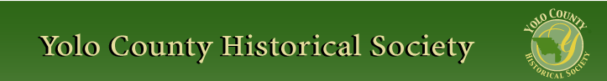

AUGUST 2014
PP 2012

Pres Says:

Here it is the middle of summer. It is time again to renew membership. You should all have received an envelope with a letter from me and a renewal form. Please send it in as soon as possible. Your membership helps us to finance our program and also helps finance our projects. I have added additional categories for specific donations: Hatti Weber/WPA project and Winters History Project. Now you can choose exactly where you want your additional monies to go. If you would like to receive the newsletters via e mail, please call Reva Barzo at 867-5800. Your phone call will save us $1.00 per copy.

For those of you who have already sent your renewal memberships in, thank you. We are processing these as quickly as possible.

Right now, I am working on the programs for the coming year. I am very excited about the possibilities. I will share more with you when I have completed the entire program.

We have three events coming up in the next three months. In August is our Yolo County Fair. We will staff the Spring Lake School House during specific fair hours. Dennis Dingemans is in charge of that program. Please call him at 753-5959 or e mail him at didingemans@ucdavis.edu.

In September we will be in charge of one house during Woodland’s Stroll Through History. If you would like to help with that event, please contact me at 662-2189.

In October we will have our annual Cemetery Tour. This year, we will focus on our military dead. We will have representatives from the Civil War, Spanish American War, World War I, World War II, and Korean War. If you would like to help with this event, please call me at 662-2189.

If you know of anyone who would like to be part of our Society, please let me know. I will send them the information.

Remember, History Rules!
Kathy Harryman

❖

Hattie Happenings: Happy New Year!
By MaryLee Thomson

Fiscal year 2013-2014 ended July 31st at the Hattie Weber Museum. A report of the year’s activities has gone to the Society’s Board for approval.

Highlights include: almost 3,000 visitors from 64 California cities other than Davis, 21 states other than California and 13 countries other than the US. We gave tours to eight different groups of scouts, students and seniors.

The 15 volunteers mounted 12 new exhibits, updated three others and hosted 14 events, including four City “Second Friday ArtAbouts”.

Income exceeded expenses again and we have healthy balances in our general and memorial funds. There is more than enough in our Annex
fund to match the City’s contribution of $14,000 but probably not yet enough to fund the whole project.

Since the major success of saving the WPA building for use as a Museum Annex in January 2004, progress on this project has been stalled. We do not yet have an acceptable architect’s bid for the renovation processes. We do know from a structural engineer’s report that the building is sound.

Our new year started on a festive note as we celebrated Roberta Stevenson’s 95th birthday with a Museum gathering of 50 or so of her closest friends and admirers!

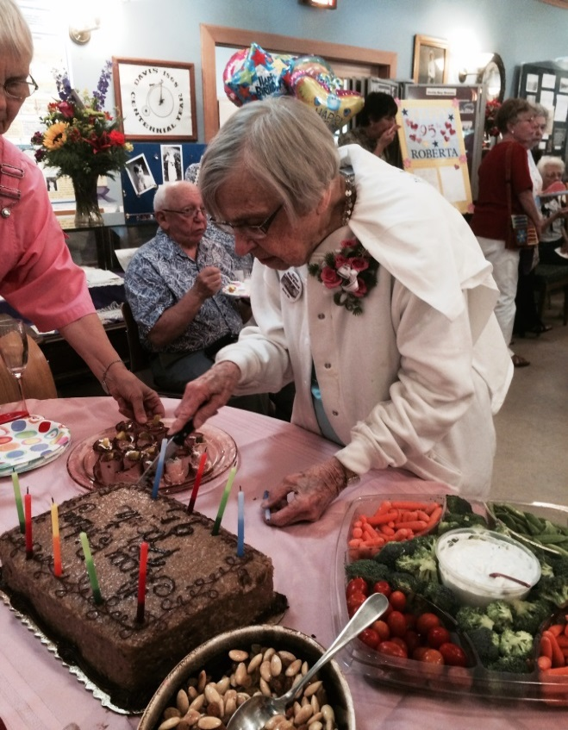

Coming soon is another celebration as we dedicate the 31 new Rose Garden bricks in early September.

Plans are afoot for a new historical resources survey in Davis and the marking of the centennial of the City’s incorporation in 2017. We hope to be part of both efforts.

Our thanks to all who made the year a successful one for the Museum.
Yolo County Fair
By Kathy Harryman

For those of you who have lived in Yolo County for a long time, August heralds the long awaited event, the Yolo County Fair. From Wednesday until Sunday days and evenings during a week in the month of August, activity abounds

If you are a child, the circus -like atmosphere entices you to come and enjoy the rides and play the games. If you are an adult, you probably want to see local art, or the horticulture displays, or the live animals, or the newest items invented to make your life easier. Of course, there are the live animals that you can see and smell. And if you are a senior, you probably want to go to the fair to meet your old friends and chat and have some of your favorite ‘fair’ food. There is always something for everyone.

But what about the early fairs? Were they the same or similar to our fair? According to the Yolo County Fair website, the first fair was held in the late summer of 1893 with horse racing being the main event. Originally held on Race Track Road (presently Kentucky Ave.) between Kentucky and Interstate 5, the fair had a purse of $15,000. Such notables as Senator Leland Stanford ran his famous horses here. There were bicycle races, an art gallery, and women’s equestrian events. The crowds were estimated to be about 1500.

In 1912, the fair changed. Every adult was charged 50 cents to offset the racing prizes. There were 40 prizes given to various winners of contests. Parades through town became a focal point. Even, the “Homelist Man in the Parade” won a prize of $1000 insurance policy for one year. (I am not sure I would want that distinction!) J.A.Murray was hired to film a moving picture parade to be shown at the 1915 Panama Exposition in San Francisco. Yolo County even had a queen. She was Miss Mattelese Fisher who received 25,000 votes to become Queen of the Parade. W.A.Morris of Tilly the Cow fame, was also there showing Riverside Sadie DeKol.

In 1913, H.S. Mattox began to organize an even better fair around the Pacific Coast Grand Circuit Harness Races. He said, “A good county fair is one of the best boasting propositions we know of.”

The current 55-acre fairgrounds site, which was the former “Blowers Ranch,” was purchased by the DAA Board of Directors. The existing buildings included a farm house, horse and cattle barns and a bunk house. Later a stock building was built and the exhibit building was relocated from the previous site.

In 1941, 10,000 people came to celebrate the fair in its new site. The Native Daughters of the Golden West dedicated the fairgrounds “ to loyalty, cooperation, progress and the ideals of American democracy”. There was a massive parade with 225 military corps and several exhibitions including one given by Gloria Jacobs, a 17 year old world champion sharpshooter. Gloria held four national records for women with a .38 caliber pistol. She also won the state championship at the age of 15. Quite a gal!
The Yolo County Fair is the largest and oldest free gate fair in California.

So has the fair changed? There are some changes…horse racing is gone, but what makes the fair a fair is still there. It’s a time for friends to get together, visit the displays, eat ‘fair’ food and enjoy themselves.

See You At the Fair!

http://www.yolocountyfair.net/p/about/147
Daily Democrat Aug. 13, 1991
Mail of Woodland, Feb. 7, 1913
Mail of Woodland, Feb. 18, 1913
The Border Watch, July 30, 1940

Business Buddies

The following businesses in town have financially supported the Yolo County Historical Society. We would like you to support them and keep your money local:

L & S Printers, Main St.
The House Dresser, Main St.
The Gifted Penguin, Main St.
Corner Drug, Main St.
Home Improvement Group, Main St
Dahlin & Essex, Inc., Davis

If you know of any business that would like join our support list, contact me. Businesses pay $50.00 per year for advertising.

❖

School House News

School House was in session this past week with Marilyn Scholz as our schoolmarm. Her class was composed of four prospective future schoolmarms: Carol Beckham, Gerrie Wright, Libby Brooks, and Kate Ball. Big Thank You to Marilyn and the ladies….

❖

Touring Woodland
By Rachel Zur

With the many budget cuts in education through the recession, field trips have become more of a rarity for public schools-- except for the Dingle Elementary History Club which has enjoyed many field trips this year by being in close enough proximity to walk to their destinations. Woodland's Historical gems give youngsters many opportunities to have an exciting field trip with little to no cost to the school. This year the students have been able to
tour the Gibson House, several historical properties belonging to the Stallard family, historic barns and alleys (tour led by Ken Trott),
the Court House and some historic residential properties. While the children deeply enjoyed all of their outings the field trip that inspired the children the most was their tour of the Gable Mansion. Not only were students impressed with its grandeur, but it took much to convince them that it is in fact a residence-- many students were convinced that it was a museum, thinking it was similar to the Gibson House.
After meeting Jeff and Starr Barrow, seeing their warmth and hospitality, the students quickly felt at home in the Gable Mansion. Starr was gracious enough to take the students, in small groups, up and down the elevator and allowed them to see her studio where she works on her stained glass projects. Jeff explained some of what was involved in the many restorations to their home.
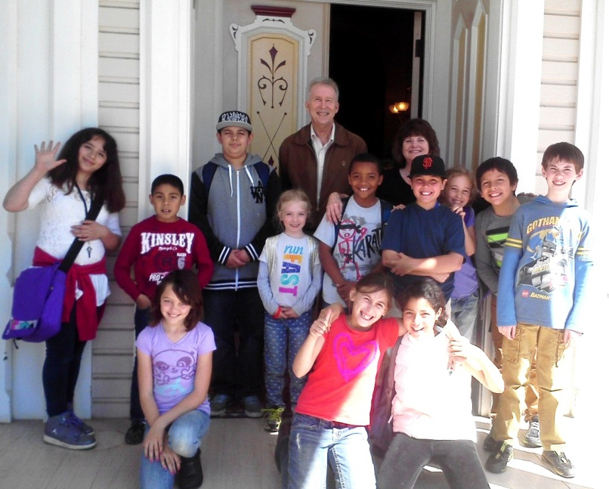

On our walk back to Dingle Elementary, students spoke excitedly about one day renovating a historic home of their own and talked about learning how to make stained glass windows themselves to add to their "future historic home." They also talked about how much they liked Mr. and Mrs. Barrow, how kind they are and how fun the tour was.
It's such a delight to be able to take students on field trips where they are able to truly value their town's rich history-- and so often is the case that the kindness of the people in Woodland leading these tours speaks to our town's bright future. Our club is so thankful to all the many people who opened their doors this year, allowing students to have such wonderful experiences

❖

Memories of the Fair-
The Society’s Lemonade Stand

Below is an excerpt of an item found in the Yolo County Archives prepared by Ada Merhoff and Miriam Miller summarizing the Lemonade Stand at the 1991 County Fair

We Used:
3 ½ cases of lemonade mix … Total 84 gallons
5 jars Lipton instant tea 37 ½ gallons
15 50 lb. bags ice 750 lbs.
30 sleeves of …cups 1650 cups
6 sleeves of hot …cups 300 cups
1 ½ 3 lb. cans of coffee 250 cups
40 packets choc. mix 40 cups

We Need:
Paper napkins

We Have:
Plenty of other counter supplies

We Would Like:
A better faucet that doesn’t blast at us, touch-up paint on the signs, a support for the north counter (it was tipping badly), screws in the metal strip around the edge of the counters where needed

We Think:
Someone should represent us at a fair board meeting to discuss the need we have for activity at the bandstand-even taped music would be nice, would draw people to the area to relax and drink lemonade with their lunches.
People Who Helped Us:
…..Spreckles Sugar, …Safeway….McDonalds

People Who Helped Put Up and Take Down the Stand:
Ed Chally, Bob Pomaroy, Steve Laugenour, Bob Campbell, Dave Lundquist, Dick Larkey, Bob Gordon

The Lemonade Stand would not have worked had Marilyn Kregel’s committee not be so terrific!

Does this bring back memories? This stand was the major fundraiser for the historical society.

❖

RED DOTS

If you have received a red dot next to your name, your membership renewal is due. If you lost the envelope, contact Kathy at 662-2189 for another

❖

If you have a story you would like to share that relates to Yolo County, send it to rbarzo@yahoo.com and we can include it as space is available. Photos are also encouraged! Our members have enjoying reading about the memories that have been shared in the newsletter of late…

❖

Searching for a past article from our newsletter? Go to Yolo County Historical Society web address: http://ychs.org/

Thanks to the following for generously supporting the Society…………. You too can be a Patron by donating $100.00 to help us run our projects

2013-2014 Patrons

- John and Helen Daniels
- John and Kathy Harryman
- Pamela Pearl
- Virginia Schwarzgruber
- Stella Dinger
- Robert and Lynn Campbell
- Leroy & BJ Ford
- Jon & Barbara Durst
- Dennis Dingemans & Robin Datel
- Jeff & Starr Barrow
- Donald & Pat Campbell
- Albert & Lynn Plocher
- Cecilia Kwan
- John Hoover
- The Laugenour Family
- Phyllis Levers
2014-2015 Patrons

- Jeff & Starr Barrow
- Alice Wong & Ryan Baum
- Donald & Pat Campbell
- Michele Giguiere
- Bernard & Lynne Gough
- Betty Van Lew Haines
- Kathy Harryman
- Joan Hogan
- Jim & Donna Peoples
- Roger & Ann Romani
- Lon Springer
- Tom & Meg Stallard
- Valerie Vann
- Lydia Venables
- Marilyn Kregal
- Clair Childers
- Michael King

Yolo County Historical Society
P O Box 1447
Woodland, CA 95776

Address Service Requested

Dated Material

