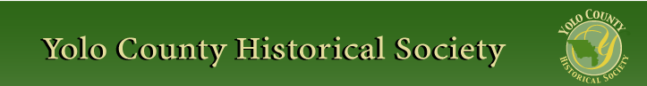

JULY 2016

PP 2012

Prez Says:
The hot days of summer are upon us and for those of you who have lived in the valley for a long time, you know it is that time of year when windows open for the cooling breeze and then are closed for the rest of day. Errands are run in the morning and the afternoon is spent in quiet activities until the cooling breezes off the Delta blow into our homes in the evening.

The Society held its annual meeting at the Woodland Public Library on Thursday evening, June 16. With approximately 40 members in attendance and their guests, the board presented an overview of the year and a future look at projects. We also recognized several non members who have contributed to the development of history in the county. Dallas Tringali and Christine Engel received an award for working with the Society in posting descriptors for the various historical pictures that hang on the walls of the Woodland Community/Senior Center. Rachael Zur also received an award for the establishment of the afterschool History Club at Dingle Elementary School. For the past 5 years Rachael and her students have worked with us during our cemetery tours playing parts designed for children. Her students were also featured this past year in our newsletter. We gave her extra copies so that the students could send their articles to family members outside the area. Again, this just goes to reinforce the concept that history happens when people work together to make it happen. Thank you again for your concern to preserve our historical heritage.

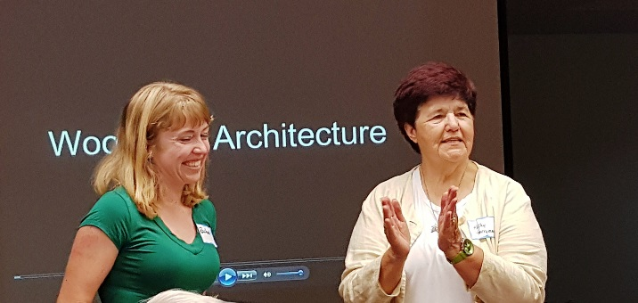
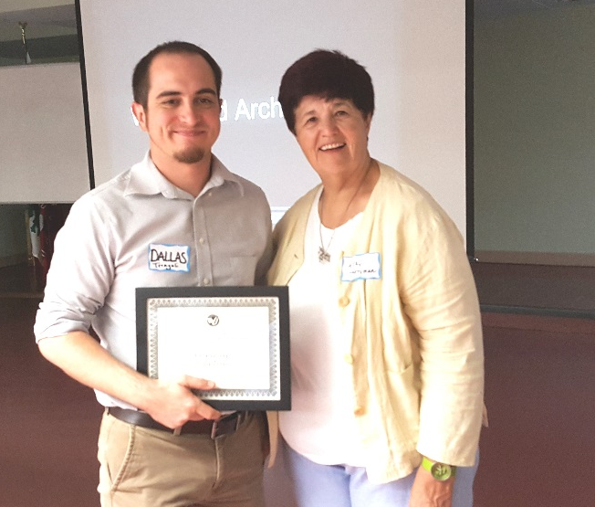

The board officers were also elected and I am happy to announce I will stay in the same position: Kathy Harryman, President, Dennis Dingemann, Vice President, Bob Sommers, Secretary, and Reva Barzo, Treasurer. I will announce the other Board members later on this summer as well as the programs for the coming year.

Our speaker for the evening was David Wilkinson, not only a member, but also an author. He shared with us the many architectural features that are found in the city of Woodland. We also recognized the other authors in our audience: Joanne Larkey, Lynn Golf, Bob Sommer and Dennis Dingemann. What a great group!

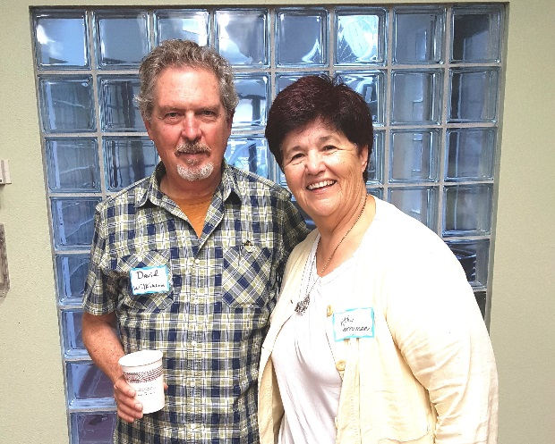
Our next activity is the Yolo County Fair where we open the schoolhouse. If you would like to volunteer for a few hours, we would love to have you. Call me at 662-2189.

Yes, it is that time again….membership dues are due. I have enclosed an envelope with this newsletter (saving postage). Remember, although our dues are only $25.00 per year, your added contributions allow us to fund our projects.

Remember, as always….

History Rules!
Kathy Harryman,
President

❖

Hattie Happenings

Museum Mounts New Exhibits

Three new exhibits are on display at the Hattie Weber Museum at 445 C Street in Central Park.

Putah Creek :Then and Now was the last and largest of the exhibits designed by the Museum's founding Director, Phyllis Haig. About half of the original exhibit is on display in two cases. Artifacts found in the Creek near the A Street Bridge at various times since 1950 include native American grinding stones and Chinese patterned ceramic dishes. Creek wildlife is represented by a stuffed quail and duck. Photographs show scenic views and demonstrate the various uses of the Creek over the years. Especially charming are the photos of picnickers from Davisville enjoying a lazy summer afternoon.

Dressing Up takes us to the roaring nineteen twenties when the booming economy was reflected in elaborate costumes, jewelry and furs. The elaborate evening and wedding dresses in this exhibit belonged to Sylvia Charnow and Violet Gordon and were donated by their daughters. Some of the elaborate beaded jewelry comes from the Schmeizer family. The fox fur wrap, complete with animal heads and paws, is especially fascinating for children.

Davis Transformation is John Lofland's latest book on Davis. Using color photographs and extensive captions, Lofland describes changes in downtown Davis, various neighborhoods, businesses, politics and cultures. Enlarged photographs from the book are displayed on the Museum's central panels.

Central Park Museum Annex Project Update: Back to the Drawing Board

The Hattie Weber Museum volunteers have been working for almost five years to save the 1937 WPA- built Central Park restrooms, restore the exterior and convert the interior to a museum annex for storage and work space. The building is uniquely historical as the only depression era New Deal Works Program Administration project in the City.

In December 2013, the Davis City Council approved an agreement to partner with the Yolo County Historical Society (which operates the Museum) on the project. The City would contribute the cost of the proposed demolition ($14,300 at that point) and the Society would raise the remaining funds needed. Over the next two years, Museum volunteers raised a bit more than $50,000 in individual contributions,, commissioned and paid for an architect's plan, removal of the shade structure around the original building and a structural engineer's report. The building is sound.

As of October 2015, we had raised and delivered our share of the funds the City of Davis estimated were needed to renovate and re-purpose the historic building. The total estimate at the time was $65,000. However, when three construction bids came in in May 2016, the lowest acceptable one was almost $88,000! This is more than 100 times the original $850 construction cost of the building..

At a recent meeting with City staff, it was decided to reject all the May bids and to revise the scope of the project to save costs. Architect Ty Smally is now revising the plans. The Museum volunteers will seek additional funding and contributions of construction materials and the City will be asked to increase its contribution in light of increased costs since the project was approved in 2013. New requests for bids will be issued in the fall when it is hoped contractors will be more available for winter work.

Museum volunteers estimate there will still be a funding shortfall of about $10,000. We are considering ways to raise the necessary funds. Anyone interested in contributing to this effort with funds or ideas is most welcome to visit the Museum at 445 C Street on Wednesdays or Saturdays between 10am and 4pm. We have some new and interesting exhibits also.

❖

Business Buddies

The following businesses in town have financially supported the Yolo County Historical Society. We would like you to support them and keep your money local:

L & S Printers, Main St.
The House Dresser, Main St.
The Gifted Penguin, Main St.
Corner Drug, Main St.
Dahlin & Essex Inc.
Chamberlain Farms
Bill Marble
Michele Giguiere
Bernard & Lynn Gough
Larry Shapiro
Tom & Meg Stallard

If you know of any business that would like to join our support list, contact me. Businesses pay $50.00 per year for advertising.

❖

Palm Mania
By Kathy Harryman

Have you ever wondered why there are so many palm trees in our area? I am not talking about new additions to the landscapes, but the tall palm trees that seem to hover around the large Victorians in town and out in the country. I think it is safe to say that whenever you find one or two or more palm trees, you can bet that there was once a large home there. The fascination with palms led me to research why they were used in such abundance during the Victorian era. What motivated individuals to use trees that were not native to the area in their landscape design?

Palms actually have a symbiotic relationship with the human race. In Ancient Greece, the palm tree was the sacred sign of Apollo. Palm branches became the symbol of victory and were awarded to the winners of battles as well as athletic contests. In Roman times, the palm again was used as a symbol for victory. A lawyer who won his case would decorate his front door with palm branches. The Christians are more familiar with the palm branch because of the celebration of Palm Sunday when Jesus was honored with the waving of branches at his triumphal entry into Jerusalem. Other religions also consider the palm as a symbol of victory and of peace. In Judaism, the palm is used to unite the Jews in the service of God (Festival of Sukkot) and in Islam the palm symbolizes rest and hospitality. So palms have been used as symbols in various cultures throughout history.https://en.wikipedia.org/wiki/Palm_branch_(symbol
But was it the Victorians who brought palms to Yolo County? Actually, it was the Spanish who brought missionaries to the coast of California who brought the palm trees. The priests needed the palms for Palm Sunday. There was a ready ‘market’ for palm trees in California. https://www.sandiegohistory.org/journal/v56.../v56-3trent.
But when one thinks of palm trees, one thinks of a tropical island environment. Well, apparently palms can grow anywhere. Apparently there are 2,500 species of palm trees in the world from the desert to the rainforest. www.mnn.com › Earth Matters › Wilderness & Resources
Because California’s climate is temperate, it was easy to get seeds and small plants. But what if you were in New York or in England? Could you grow palms there? Well, apparently you can and people did…but they built greenhouses. In 1840, Kew Gardens in England built the world’s largest steel and glass greenhouse and amassed an unrivaled palm collection. Jay Gould added a gigantic palm house to his Hudson River estate with over 300 varieties inside. A palm conservatory was on view at the Vienna World Exhibition in 1873. Not to be outdone, the Austrian Emperor Franz Joseph built a huge palm house at the Schonbrunn Palace. It was and is the largest palm garden in Europe. Palm courts were even found on the White Star Cruise Lines. searchresearch1.blogspot.com/2015/05/answer-victorians-and-palms-trees-thing.html

Who knew? Now my questions are answered…the palms signify wealth and luxury. The next time you travel the roads of Yolo County or go shopping downtown, look for the tall palm trees and imagine what is was like when a large structure stood surrounded by flat fields.

Just a short note….in my research I found that the Victorians believed that gardens would decrease drunkenness and improve the manners of the lower classes…the upper classes were encouraged to plant gardens as a means of decreasing social unrest….. Again…who knew? As always, History Rules!

❖

Thanks to the following for generously supporting the Society …………. You too can be a Patron by donating $100.00 to help us run our projects

2015-2016 Patrons

- Robert & Lynn Campbell
- Donald & Pat Campbell
- John & Helen Daniels
- Jonathan & Barbara Durst
- Robert & Judy Simas
- Ron & Marilyn Scholz
- David & Ann Scheuring
- Claire Childers
- Jeff & Starr Barrow
- Michael & Debra Truitt
- Alphe Springer
- Steve & Teri Laugenour
- Richard & Joann Larkey
- Ramon & Karen Urbano
- Thomas Crisp
- Ryan Baum & Alice Wong
- Richard & Evelyne Rominger
- Lynn & Penn Wilen
- Steve & Lydia Venables
- Cleve Baker
- Louis & Jane Niehues
- Charles & Claudia Owens
- Marilyn Kregel
- John & Kathy Harryman
- Roger & Ann Romani
- Patricia Nickell
- Jim & Wilda Shock
- John Hoover
- Dennis Dingemans & Robin Datel
- Don & Carol Ishikawa
❖

1st Annual Gibson House Rummage Sale
Saturday, July 30, 2016
8:00 a.m. – 2:00 p.m.

Looking to get rid of stuff? Rent a space on the grounds of the Gibson House

Sign up at ychmoffice@sbcglobal.net, or visit us at the museum headquarters: 512 Gibson Road: Tuesdays, Thursdays, and Fridays 10:00 a.m. to 3:00 p.m.

Space is limited so reserve yours by July 15th!
Spaces:
$25 for 10x15
$40 for 20x20
Sell your furniture, housewares, toys, books, electronics, office furniture, patio sets, tools, etc.
If you do not want to rent a booth, consider donating your items to the Museum for sale.
These are a few of the thank you letters received by the school marms. We thought you might enjoy reading their comments……
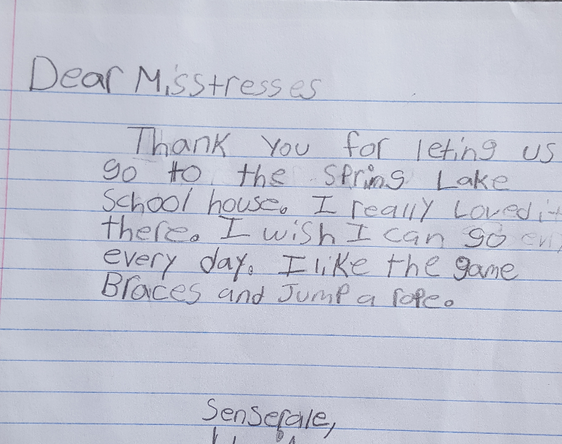

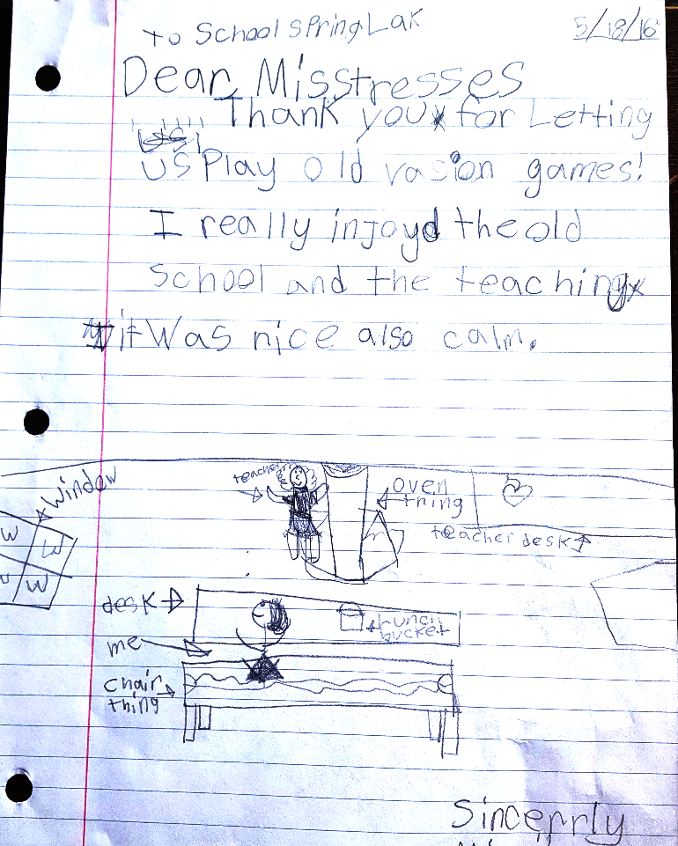

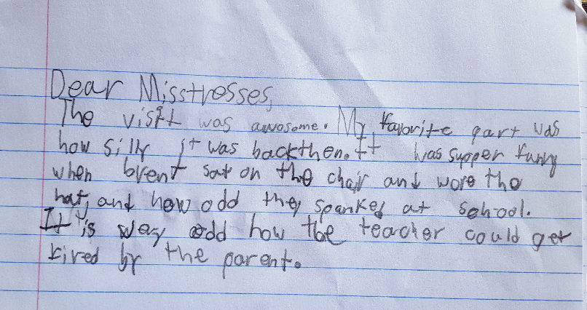

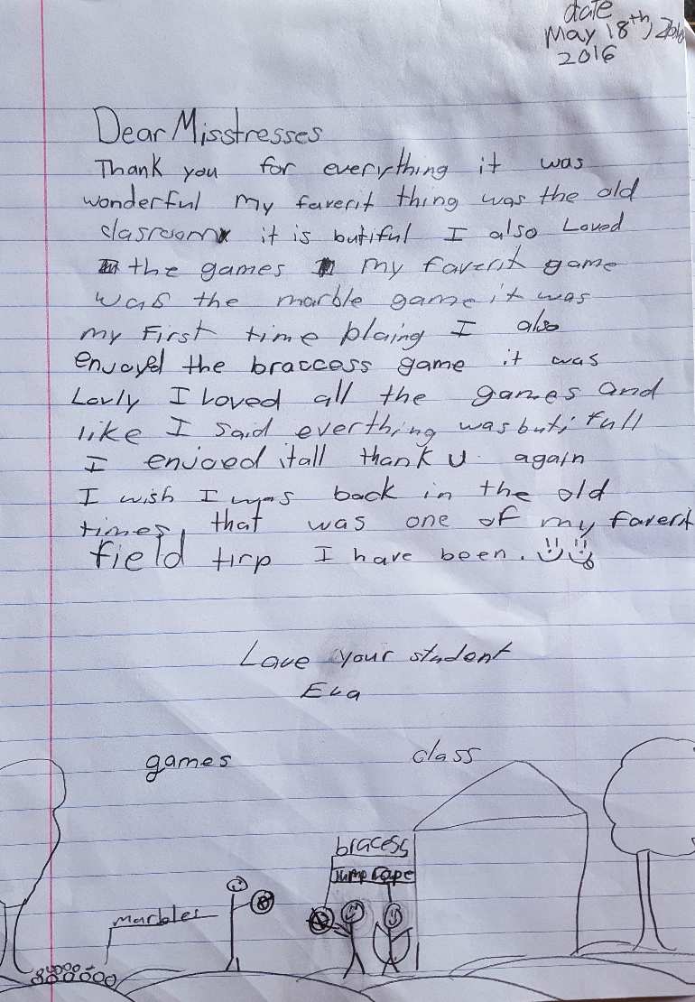

Yolo County Historical Society
P O Box 1447
Woodland, CA 95776

Address Service Requested

Dated Material

Vision Statement The Yolo County Historical Society strives to preserve, protect and acknowledge
the diverse history of Yolo County through education, communication and advocacy

