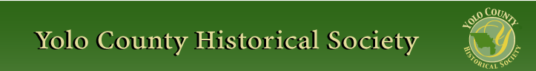

JULY 2013
PP 2012

PRESIDENT’S MESSAGE

Hi. My name is Kathy Harryman and I have been elected as your new President. I am honored to have been chosen as the leader of this very important group of individuals who are committed to preserving history in Yolo County. As a former history teacher, my commitment to preserving and sharing history with others is paramount. I look forward to working with you, the membership, in continuing the strong focus that has been a tradition of this society. If you have any questions and or concerns, please do not hesitate to call or e mail me. Remember my slogan…..History Rules!!!

YOLO COUNTY HISTORICAL SOCIETY
BOARD OF DIRECTORS 2013-2014
President Kathy Harryman 662-0952
Vice Pres Dennis Dingemans 753-5959
Secretary Bob Sommer 756-7553
Treasurer Reva Barzo 867-5800 Directors
Mary Aulman 666-0743
Kathy Harryman 662-2189
Dianne Barsotti 661-1179 Roberta Stevenson 753-5791
Beth Wettergreen 207- 9403
Jeannette Molson 666-7103
Dennis Dahlin
❖

Hattie Happenings
Submitted by MaryLee Thomson

The latest exhibit at the Hattie Weber Museum of Davis is a giant birthday card for the Old North Davis neighborhood which began life in
1913 as the “Bowers Addition” development bordered by current 5th, B and 7th streets and the railroad line near G.
Unlike more modern developments, the Bower Addition offered bare lots and buyers designed and built their own homes. Consequently there are a variety of styles, from log cabins to Victorians and bungalows, as well as sizes in the area. Alleys and sidewalks were features which were not yet universal in the town.
Dennis Dingemens provided some stunning photographs of Old North homes built or transferred there in 1913. He calls them the “Centurions”. He also took pictures of post 1913 builds to demonstrate the vast variety of styles.

Details of the sociology and history of Old North and a walking tour of the area can be found in a book by Davis Historian and area resident John Lofland. Copies are available for purchase at the Museum.
Because the Museum runs on a fiscal year basis we are in the midst of preparing an annual report to the Society and the City of Davis. Stay tuned for details.
Other activities at the Museum include our continuing quest to save the 1927 WPA Central Park building next to the Museum. We have just submitted a revised proposal to city staff which is currently scheduled to be sent to the City Council in September for action.
We are also working on an exhibit featuring nineteenth century homes still standing in Davis. Future exhibits will include a series on various Davis neighborhoods.
Come visit us at 445 C Street in Davis on Wednesdays and Saturdays between 10 am and 4 pm. Children are welcome and can play with
reproductions of antique toys and (carefully) with our old manual typewriters while adults view exhibits.

After a heroic effort, Stella Dinger has succeed in concluding the effort to identify and locate every single document and artifact in the Museum! Kudos to Stella who also provides invaluable services to the Gibson House, Kiwanis Club and Meals on Wheels! She is a treasure!

❖

Winters History Project
Don’t forget to mark your calendar, August 8, 2013, 7 p.m. at the Palms in Winters…see inserted flier in this issue!
For further information, contact 795-2676 or tachoops@sbcglobal.net.

❖

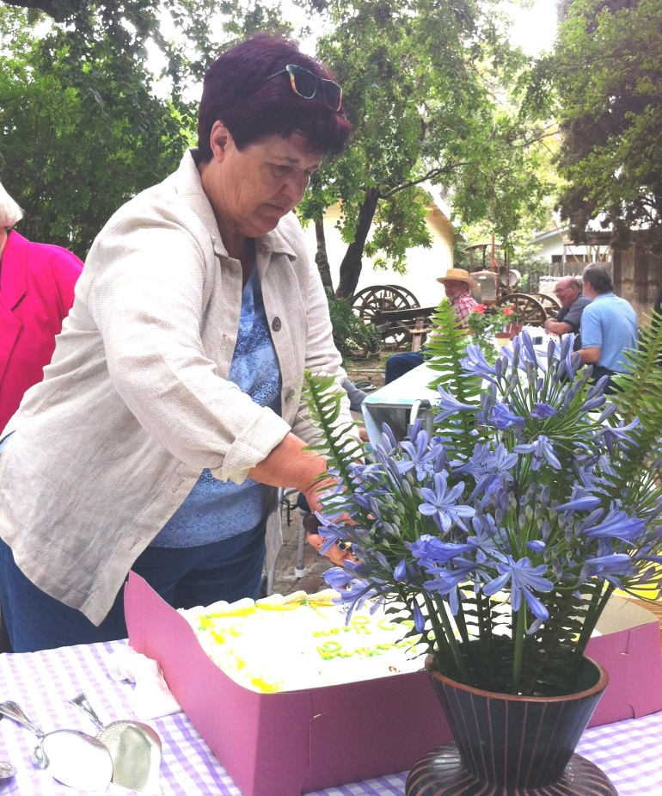

Celebrating 50 years….

Remarks by Joann Leach Larkey
At the 50th Anniversary gathering of the Yolo County Historical Society
Yolo County Historical Museum, June 23, 2013

Earlier Societies honored pioneers: Sacramento Society of California Pioneers (males who arrived in CA before Dec. 31, 1849), 1917 PIONEER Day at Yolo County Fair (Col. William Hatcher, president of Pioneer Association), Old Timers’ celebrations in Capay Valley c. 1915.

In the fall of 1948, citizens from all over Yolo County met at Nance’s Restaurant in Woodland and to organize the first Yolo County Historical Society. The stated goal of the new organization was “to formulate plans for a museum for Yolo County.” Fred Meier of Woodland who had sponsored a museum project for many years was elected chairman. Davis historian Flora McDonald was elected secretary. Committee appointments included Stuart Waite, Program; W. O. Bernhardt, Organization; Dr. R. A. McGinnis, Publicity; and Walter Baker, Museum. As announced in the press releases that are preserved in the McGinnis scrapbooks, the dual purposes of the new society were the construction of a museum on the county fair grounds and the presentation of historical programs every three months.

First meeting was held on October 11, 1948. Construction of a large log building with a covered open area that would house donations, such as the 1849 Bemmerly covered wagon was proposed. In addition, plans for the construction of a larger building in time for the centennial celebration of California statehood (in 1950) were discussed. These buildings don’t seem to have materialized, but instead, the society, in cooperation with the Woodland Parlor, Native Daughters of the Golden West, was able to purchase the 1869 Springlake School house and locate it on the fairgrounds, where it is still serving as a museum. Membership signups were taken during the county fair, as they are today, and the work of preserving Yolo County history proceeded.

Originally no dues were charged, but by March 31, 1949, 12 members had paid $1 each and the society had a balance of $7.00 after a $5 tip was paid to the school janitor where meetings were held. Are any of the sixty-one charter members or their descendants here today? Check out the list of members as of March 31, 1949.

Some way or another, these civic minded people were able to pay $350 for the purchase and relocation of the Springlake School. In addition, many generous citizens donated historic items and photographs, including antique furniture and farm equipment, as well as the beautifully framed pioneer portraits that grace the museum walls today.

Also In 1948, historical society members who belonged to the Woodland Camera Forum set to work photographing some 171 historic sites and buildings throughout the county. Many of these photographs, along with historical descriptions, were published in area newspapers. This valuable collection remains at the Gibson House Museum and is being digitalized for public use at the Yolo County Archives.

Interest in the first Yolo County Historical Society waned in the early 1950s and the organization disbanded. Happily, many of the artifacts donated to that first museum collection eventually found their way to the Yolo County Historical Museum in the late 1970s when the former Gibson House became the county museum. Others stayed at the fairgrounds such as numerous Bemmerly carriages that can be seen annually, while still others, like the Bemmerly covered wagon and the old horse-drawn Woodland streetcar, have been restored and are now displayed at the Heidrick Ag History Center. In short, we owe a great deal to those members of the first historical society.

NOW Fast Forward to early July, 1963, when at
the urging of several members of the Conference of California Historical Societies, a renewed effort to organize a Yolo County Historical Society was made. County Librarian Vivian Douglas led the charge. An initial meeting of invited area representatives was held in the office of D. David Smith, Executive Director of the Woodland Chamber of Commerce. I was invited to represent Davis, and look where it got me – hooked on local history. The meeting was led by Vivian Douglas. Also attending were Louise Stephens of Esparto, a retired teacher wife of county supervisor J. Dudley Stephens; William Geyer of West Sacramento; and Reverend E. E. Zimmerman of Winters, a member of the CCHS.

The decision was made to call a public meeting of interested citizens, to be held on July 23rd in the board room of the Yolo County Supervisors. A positive response at that meeting led to the appointment of a steering committee charged with the responsibility of drafting a constitution and by-laws and planning further meetings. Former Supervisor John Rogers of Davis offered to promote membership signups at the schoolhouse museum during the county fair, an effort that has continued through the years.

Hence, on September 30, 1963, some 50 people gathered in the Community Room of the Guarantee Savings Bank at 500 Main Street in Woodland. A constitution and by-laws were adopted, officers were elected and the current the Yolo County Historical Society was founded. Charter officers included: Mrs. J. Dudley Stephens, president; E. E. Zimmerman, vice president; Joann Leach Larkey, secretary; Stuart B. Waite (a holdover from 1948-49), treasurer; and Dr. J. Richard Blanchard, University Librarian at UC Davis, director. Walter Frame, a Sacramento lawyer and member of the CCHS, was the featured speaker who applauded formation of the Yolo County Historical Society and noted that up to 1963 “not much had been done to preserve Yolo

Yolo County Historical Society
P O Box 1447
Woodland, CA 95776

Address Service Requested

Dated Material

County History.”
More regional directors, including Superior Court Judge William McDermott of Knights
Landing, were subsequently named. Dues were set at the high cost of $2.50 and it was determined that charter memberships would be offered through January 31, 1964. By October 28th the society had a balance of $238.50 and by the end of January the membership was up to 250. Check to see if your family is on the list.
Blanchard spoke about historical resources located in the University Library at the October

meeting. The November meeting was cancelled due to the tragic death of U.S. President John F. Kennedy, a research committee was appointed, a $25 prize was offered to a high school student submitting the best essay on Yolo County History, and plans were underway for more public meetings and tours to historic sites.
Please watch for the next installment of this article in the next newsletter!!

Vision Statement The Yolo County Historical Society strives to preserve, protect and acknowledge
the diverse history of Yolo County through education, communication and advocacy

