PRESIDENT’S MESSAGE

By now you should have received your reminder that dues are due. I encourage you to continue your support of the Society. We have kept our dues the same while other historical organizations have raised theirs for a myriad of reasons.

Your support of the Society helps us to continue to work for the preservation of the historical riches of Yolo County through the publication of books such as the “Hollywood Comes to Woodland” researched and written by historian, David Wilkinson and due to go to the printer in the very near future.

Your support provides the opportunity to present monthly programs for the enjoyment of not only our members but their friends and families.

Your support provides the opportunity for members to enjoy day trips to places of historic interest. This year there were trips to both Colusa and Solano County.

Your support provides the opportunity for members to join in supporting other historic organizations; joining with the Yolo County Historical Museum (the Gibson House) in their annual May Festival.

Your support provides the opportunity for school children to experience a day at the Spring Lake School House as they might have in 1890.

Your support provides the opportunity for the public to enjoy the reenactments at the Woodland City Cemetery during the Stroll Through History.

Your support provides the Society the opportunity to work with the City of Davis in keeping the Hattie Weber Museum as a venue for exhibits depicting the “History and the Heritage of the City of Davis” and the surrounding area.

Your support provides the Society the opportunity to affiliate with the Winters History Project as they develop venues showcasing the diverse history of the community.

Your support provides the Society the opportunity to join with others who are supporting the Friends of the State Theater in Woodland as they encourage the City to choose to preserve the 1937 treasure.

Your support provides the Society the opportunity to support individuals who are interested in our communities and there historical significance such as a recent call from an individual living in Florida interested in the robbery, in Woodland, of the Bank of Italy in 1924. With encouragement, he flew from Florida to Woodland and spent several hours at the County Archives before touring the community. He will be back.

And, your support provides the Society the opportunity to interact with other historical groups throughout the region learning from them as your representatives meet with them every other month in various communities, most recently, July 22nd, at the Heidrick Ag Museum.

Peace,

B.J. Ford, President
Yolo County Historical Society

THE HATTIE WEBER MUSEUM OF DAVIS

Last month, June 2010, marked the end of the first year of operation at the Hattie Weber Museum of Davis by YCHS for the community of Davis. We began a year ago after considerable discussion by the YCHS Board amid well founded fears about the soundness of the Museum financial plans. Those fears, however, failed to materialize, and we ended the year in the black. The happy outcome came about for several reasons, not the least being of which the chosen Director, me, had hip replacement surgery July 13, 2009, and consequently was not around to implement some of the more expensive features of the proposed plan. Instead, the Museum was successfully co-managed by Asst. Director Dennis Dingemans and Exhibit Coordinator Mary Lee Thomson with the assistance of super Docents Virginia Isaacs and Roberta Stephenson.

As we begin a second year, we are hoping to attract a few more volunteers to implement some new features, as well as to allow the main members of our Hattie Weber Team more time to do other things. One of our operating philosophies is that the volunteers gotta have fun. Below is the first paragraph of our most recent blurb, which reflects that philosophy, submitted for printing in the Davis Enterprise.

The Museum Volunteers did what?”

The headline in the Thursday, July 22, 2010 Enterprise read: “Museum thaws century-old Scotch.” As volunteer Director of the Hattie Weber Museum of Davis, my initial assumption whenever I see something about “museum” in the local paper is that it is about the Hattie Weber. And the piece was in a Thursday issue – the day after the Hattie Weber was open for its regular Wednesday hours of 10:00 a.m. – 4:00 p.m. I had not been there for the entire 6 hours that day, so did one or more of the other faithful volunteers have the time to thaw a little nip? If so, which one of our early Davisites donated the Scotch? G. W. Pierce? Cal Covell? Judge Scott? A. Gordon Anderson? Or did it come directly from one of the (many) saloons of the early days of Davisville – like Jakie Greive’s Buena Vista Hotel or the George Weber Saloon?

In addition to explaining that the Scotch was being thawed in New Zealand, not Davis, the blurb went on to speak to out need for more volunteers. It also did some reporting by mentioning the 2100 plus visitors in the past year. We got off to a good start of the second year last Saturday, as we had 55 visitors. Not all of them were as interesting, nor as interested, as the three young women from China but all learned at least something about the history of Davis and the surrounding area. Please join in the fun.

Jim Becket, Director
MEMBERSHIP RENEWAL

As all Society members are aware, the membership year runs from July 1st to June 30th. Starting with the September issue there will be a Red Dot on the label of those who have not paid their membership dues for the 2010 – 2011 year. While you are renewing your membership in the Society, please tell a friend about the many benefits of being a member – this newsletter, general membership meetings, day and overnight tours with discounts to members, and discounts on history books at the time if publication by the Society, etc., etc. The membership envelopes have been mailed.

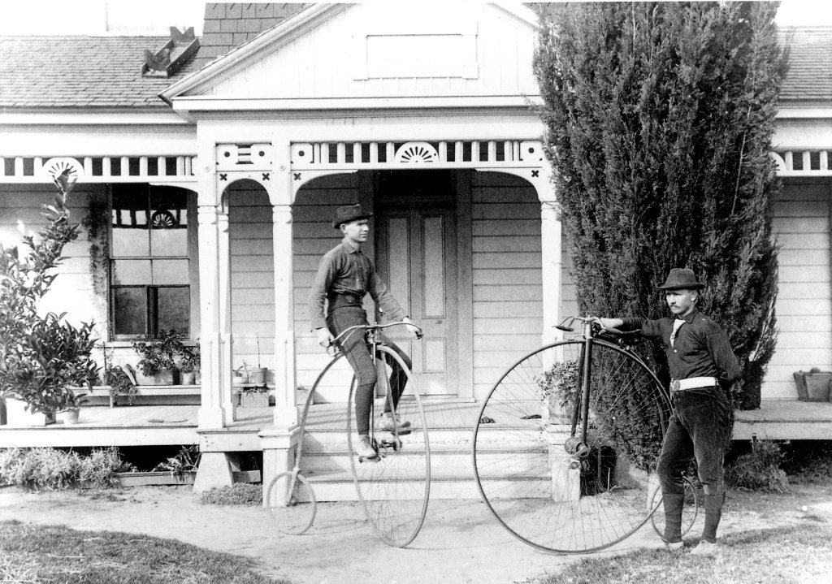

In 1891 these two brothers, Frank and A. B. Wilson, made an historic 251-mile ride from Winters to San Jose via Stockton and back on their "high wheeler" bicycles. They were photographed in front of their family home, which is now located at 415 Main Street in what once was an orchard.

July/August 2010

“Totally” “ag”cited at the 2010 Yolo County Fair”

Wednesday, August 18th to the 22nd

It is that time again. The Spring Lake School House will be open for public viewing. That means that we have to have volunteers who can welcome our visitors. Our School House Coordinator, Kathy Harryman, continues to add, and change a few things, but generally speaking it is just as it was in 1869. Information is available to answer people’s questions and it is always a joy to see a student who has visited during the school year drag parents in to show where he or she sat when their class visited.

We will again be closed on Sunday due to the entertainment which drowns out the ability to have conversations.

We will NOT have a booth in the main building but we will have a tent near the School House where we will have our numerous historic publications for sale. With the need for additional space for student desks, there is no room for our usual display.

Now, here is where you come in. We need volunteers. See the back side of this front page. Fill it out and join us at the Fair or you may telephone Board member, Dennis Dingemans at: 753-5959, or e-mail him at rddd@dcn.davis.ca.us . We thank Dennis for volunteering to help organize our “workers” this year.

