

MAY 2012
PP 2012

34th Annual May Festival

Join your friends on Sunday, May 20th, from 10:00 – 4:00 PM for a wonderful time under the trees at the Historic Gibson House park grounds, 512 Gibson Avenue. Admission is free, but donations are always welcomed.

New this year will be a Discovery Row for young people to experience gold panning, face painting, model railroading and kids games. Over forty vendors are joining us for the Craft Faire. Woodland Noon Rotary BBQ starts at 11:00 AM and the Yolo County Historical Society is having their old fashion bake sale again. Don't miss the Gibson Gardeners plant sale. It is always a huge success, and we are grateful to the garden committee for all their support.

The Tarlesson Family from Guinda is performing dances and songs from Liberia, and Folklorico de la Woodland will be entertaining during the day.

This is one of the largest fundraiser for the Gibson Museum, so please come on out and join us for food, fun and fellowship.

This year the Museum is joining with the Woodland Food Closet so for each can of food you bring, you will receive a ticket for a wonderful selection of prizes.

The Gibson House Museum touring will be from 1:00 - 4:00 PM. A brand new exhibit will be featured, honoring the contributions of the early Chinese workers and families to the various towns of Yolo County.

Gibson House, Yolo County Historical Museum, 512 Gibson Road, Woodland CA
Phone: 530-666-1045
email: ychmoffice@sbcglobal.net
website: www.gibsonhouse.org

~

PRESIDENT’S MESSAGE

Having just come from a “wrap up” meeting of the Directors of the 11 Museums open on Museum Day, April 14th, in Woodland and sponsored by the Society I want to report that it was very successful and that ideas for the future have been discussed and will be acted on.

Elsewhere you will read that both the annual May Festival and the June Picnic have been planned . Both events will take place at the Gibson Museum and will give those of you who have not seen the Chinese Exhibit the opportunity to see the “handy work”of Kathy Harryman.

As is our practive,we do not have monthly programs for our membership in May through August but we will be making plans for programs in the Fall.

A visit to the City of Mariposa is being considered. Because of the many activities which could be planned for this historic community, an overnight trip is now being considered. We have not done an overnight since our trip to Salinas several years ago.

I would appreciate some feedback as to whether you might consider such an “outing”. Cost, etc. to be determined. Please e-mail me at bjford@pacbell.net if you would be interested.

Peace,

BJ Ford, President
530-662-0952
~

Hattie Weber Displays Dictaphone Equipment

If you like alliteration then you will love the Davis Dictaphone Display at the Hattie Weber Museum. Dictaphones were early 20th Century audio recording inventions. Before them, verbal communication could be recorded only by a stenographer using shorthand and typing from the notes. Dictaphones permitted voice recordings to be stored and later replayed for
transcription. If there was any confusion as to the words coming from the speaker, the recording could be replayed, thus ensuring
accuracy. The recording disks could also be
erased and reused.

The Dictaphone equipment at the Hattie Weber was manufactured by the Columbia Gramophone Company of New York, one of the earliest gramophone companies, originating in the United Kingdom. The company later became Columbia Records. Our Dictaphone, cleaner and storage rack were donated by Jim Kitchens, then pastor of the Davis Community Church, in 1993.
The dictaphone’s earliest development occurred at the Volta Laboratory established by Alexander Graham Bell in Washington, DC, in 1881. The name “Dictaphone” was trademarked by the Columbia Gramophone Company in 1907. Columbia soon became the leading manufacturer of Dictaphones. Wax cylinders were used for recording until after WWII. In 1947, Columbia changed to plastic belts.

Magnetic recorders were introduced in the late seventies, making the Dictaphone obsolete.

Nonetheless, Dictaphones have a colorful history. Every U.S. President between 1923(Warren G. Harding/Calvin Coolidge and the early 1960s used a Dictaphone. John F. Kennedy had three, one of which was used to record Lyndon Johnson taking the oath of office on Air Force 1 in Dallas.
In 1927, The New York Telegram recorded the Dempsey-Tunney boxing match by Dictaphone machine, passing the wax cylinders along to rewrite reporters for greater accuracy. The next day at a radio station, an amazed Jack Dempsey listened to the fight replay.

Hollywood actor Charlie Chaplin kept a Dictaphone machine by his bedside and dictated movie ideas into it at night.

The Museum’s Dictaphone machine, with its Bakelite dictating horn is displayed alongside an antique typewriter, adding machine, reel to reel tape recorder and a cash register which registers sales only to $9.99, probably from the old Terminal Hotel Café in downtown Davis.

This article was written by an author who does not wish to be identified. It was edited 0and submitted by Mary Lee Thomson.

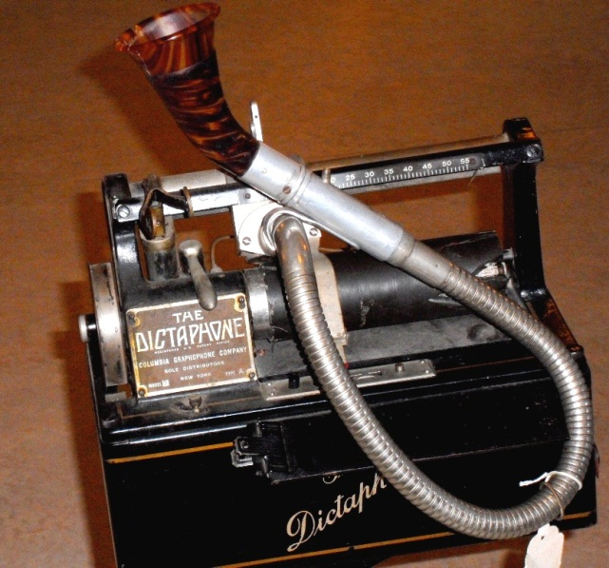

The Hattie Weber Museum, located at 445 C Street, Davis, Ca. is open to the public on Mon. & Wed. from 10:00 a.m. to 4:00 p.m.
~
Wanted - Historical Researchers!!!!
by Kathy Harryman

WE are still seeking members who would like to help research information at the Yolo County Archives for our upcoming fundraiser at the Woodland Cemetery on
October 27. The archives are open to the public only on Tuesday mornings and Thursday afternoons. We have to call to let

them know we are coming. If you are interested, call me at 662-2189 and we can make arrangements to meet.
~
Society publications available for sale at a variety of locations. For more information on book sales, contact Mary Aulman at 666-0743.
~
OLO COUNTY HISTORICAL
SOCIETY
BOARD OF DIRECTORS
President B. J. Ford 662-0952
Vice Pres. Jeannette Molson 666-7103
Secretary Bob Sommer 756-7553
Treasurer Reva Barzo 867-5800
Directors
Mary Aulman 666-0743
Kathy Harryman 662-2189
Dianne Barsotti 661-1179 Roberta Stevenson 753-5791
Jim Becket 756-1418
Beth Wettergreen 207- 9403
Dennis Dingemans 753-5959
~

Searching for a past article from our newsletter? Go to Yolo County Historical Society web address: http://ychs.org/

~
NEWSLETTER ARTICLES DEADLINE: Articles for the newsletter will be accepted until the 20th of each month. Please either email B J Ford at: bjford@pacbell.net or mail to the YCHS at P.O. Box 1447 Woodland, CA 95776

Yolo County Historical Society
P.O. Box 1447
Woodland, CA 95776

Address Service Requested

Dated Material

INVITE A FRIEND TO JOIN
Membership in the Yolo County Historical Society is open to all who wish to join in supporting the research, preservation and designation of the county historical resources, maintaining the Springlake Schoolhouse Museum on the Fairgrounds, and publishing mini-histories of Yolo County communities. Please make check payable to Yolo County Historical Society.

Individual $20 NAME _________________________________
Family $25
Senior 65+ $15 ADDRESS ______________________________
Family 65+ $20
Business $50 CITY __________________ ZIP ____________
Patron $100
Life $300 TELEPHONE ___________________________

EMAIL _________________________________

Vision Statement The Yolo County Historical Society strives to preserve, protect and acknowledge the
diverse history of Yolo County through education, communication, and advocacy

Vision Statement The Yolo County Historical Society strives to preserve, protect and acknowledge the
diverse history of Yolo County through education, communication, and advocacy

