PRESIDENT’S MESSAGE

The Society’s fiscal year is quickly drawing to a close, i.e. June 30th. That means time has passed to elect new officers. But, then as with many non-profit organizations, young people are not getting involved. I wish I had the answer to this dilemma. It seems that you have to get old(er) before you realize the importance of dedication to the mission, or goal, of the many groups that keep communities viable through service - health organizations, and in the case of historical groups, not forgetting where they came from.

You probably get tired of reading in this newsletter that we need to expand our Board of Directors, we need a new President who will instill new energy and new ideas to explore, but it is true. It does not take a $1000 donation to the Society’s coffers to be a Board member.
It does not mean you will have to sell a certain amount of tickets to a fundraiser OR buy them yourself.

What it does mean is that you need to attend monthly board meetings to make decisions, i.e., shall we fund the printing of a book written by a local historian, shall we do a new brochure focusing on Yolo County Museums, shall we continue our School House program, shall we continue our collaboration on the proposed Yolo County Art, History, Cultural Center, shall we continue our partnership with the City of Davis in staffing the Hattie Weber Museum.

I am waiting for your phone call.

BJ Ford,
President

HATTIE WEBER MUSEUM

There’s been a bit of excitement around the Hattie Weber Museum the past couple of weeks. Searching for artifacts in our collection for display at the Gibson House, we discovered a Buffalo Gun. We knew we had the gun (well, the barrel and trigger, the stock is missing), but we weren’t aware of its background. Seems we have a .45 caliber, 23 inch barrel one-shot monster manufactured by Sharps, probably in 1874, and found in Davis during an excavation in 1951 by Gray Rowe, who gave it to us. Dennis Dingemans has been researching it with input from Virginia Isaacs, whose archaeologist son, Paul, is aware of the gun and its discovery. It may be quite rare.

On a more prosaic note, we have closed the brick sales for this year. We sold 37 bricks. They will be laid in the Rose Garden and dedicated on May 8, in honor of specified mothers, grandmothers, and other exceptional women. Members of the Society are cordially invited to attend the dedication at 2 p.m. and the reception which follows.

We celebrated Picnic Day (more soberly than some) with an exhibit of “Picnic Days Past” based on programs from the 60’s and 70’s from John Lofland’s collection which he graciously allowed us to copy, and donations of early Farm building photographs by an anonymous donor.

Coming up on May 22 is the first (of several, we hope) Downtown Davis History Walks to be led by Gerri Adler, longtime Davis resident and businesswoman. Tickets are $10 per person and the group size is limited to 10. Tickets may be purchased through the Hattie Weber (445 C Street, Davis, 95616) or at Gerri’s shop, Lasting Impressions, on 4th Street. They are sure to go fast, so get your orders and payments in early.

Mary Lee Thompson

INDEXES TO OLD YOLO COUNTY NEWSPAPERS

The Childers Index to Old Yolo County Newspapers is available. CDs have just been re-arranged so that the indexes (about five files – divided by newspaper and by decades) are now on one CD. If anyone wants a copy, they can write, or call, Dennis Dingemans (530) 753- 5959) and he will “burn”/make a DC and send it to you. Free for the first dozen or so. These indexes are arranged in the order of the name of the person mentioned in the papers (for each mention of the person, you get the page, column, date, and name of the newspaper). Microfilm copies are available at various libraries and archives – and Childers’ has an introductory essay that tells you where you can get/use each of the papers.

Dennis Dingemans

LOCAL AUTHOR PUBLISHES NEW BOOK ON CENTRAL VALLEY HISTORY

A new book by Ann Foley Scheuring will be available at the Historical Society’s Booth at the May Festival. Titled Valley Empires: Hugh Glenn and Henry Miller in the Shaping of California, the book describes the careers of two extraordinary men who helped put the Central Valley on the world map in the nineteenth century.

Ann and her husband David, long time Yolo County residents, live and farm in the Capay Valley. Ann is making her latest book available to the Society at a reduced price to benefit both the Society and its members. You may purchase Valley Empires from the Society for the special price of $20.00, plus tax.

Hugh Glenn and Henry Miller were known in their lifetimes as the “Wheat King” and the “Cattle King.” While other titans made fortunes in mining and railroads, these two were profoundly influential in shaping the development of rural California. The author has told their stories against the backdrop of struggling times as the great valley evolved from a raw frontier into some of the most productive farmland in the world.

Written to be readable as well as authoritative, the 320-page narrative includes the murder that ended the career of Hugh Glenn, California’s biggest wheat grower and a candidate for governor in a hard-fought election – and how a penniless German immigrant named Henry Miller amassed a million acres, dominated western meat markets, and put his mark on California water law. The book describes the rise in the state’s bonanza wheat trade, the development of transportation, and changes in the cattle industry. It includes 20 illustrations, a bibliography, and an index.

Single copies of Valley Empires can be ordered prepaid from Yolo County Historical Society, PO Box 1447, Woodland, CA 95776, for $20.00 plus $1.75 for tax and $3.50 for shipping ($25.25 by check to YCHS). For more information call Lynn Campbell, (530) 753-4172.

UPCOMING EVENTS

May 16th – May Festival, contact Lynn Campbell if you would like to volunteer for one or two hour shifts selling books and things

August 29th – “Historical Songs of Outlaws, Villains, and Rogues”, co-sponsored by YCHS and Yolo County Museum

32nd ANNUAL
YOLO COUNTY HISTORICAL MUSEUM
MAY FESTIVAL
SUNDAY, MAY 16, 2010
10:00 A.M. - 4:00 P.M.

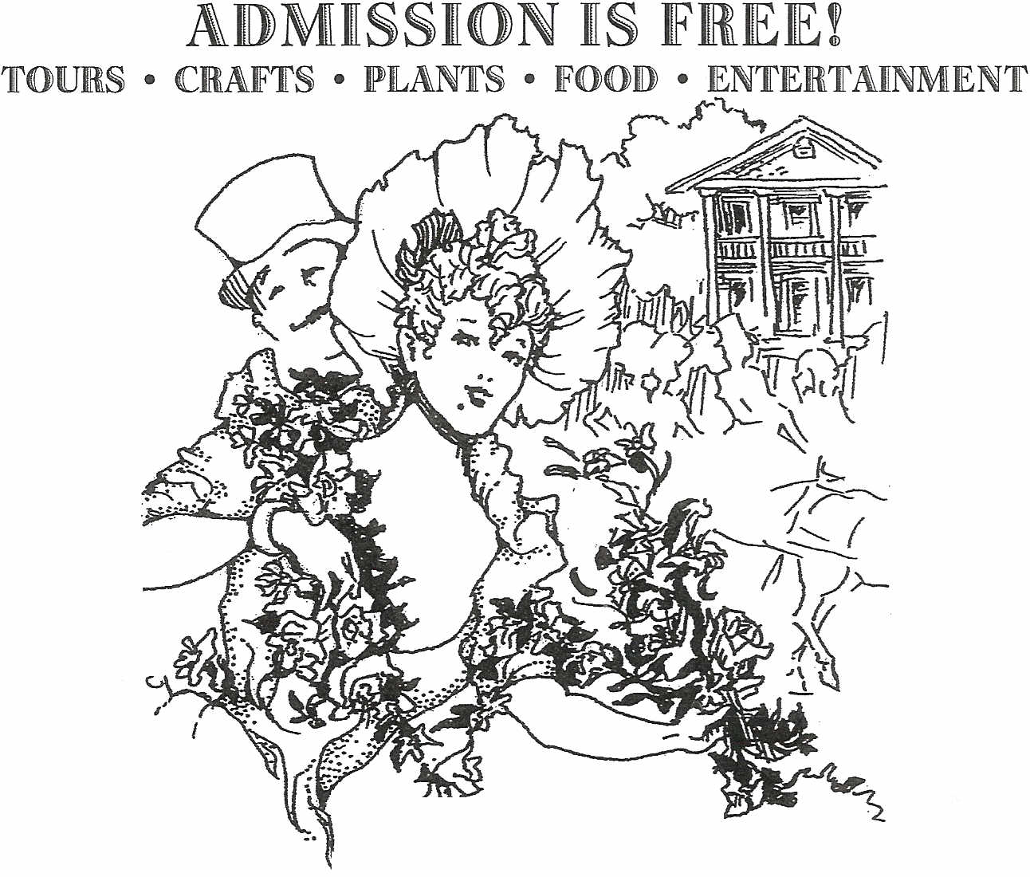
GIBSON HOUSE
512 GIBSON ROAD, WOODLAND
(530) 666-1045
YCHMOFFICE@SBCGLOBAL.NET

