

APRIL 2013
PP 2012

PRESIDENT’S MESSAGE

As President of the Society, I often receive phone calls and/or mail which unfortunately I don't have the opportunity to share with members on a timely basis. Most of what I receive goes to the Yolo County Archives where it (they) rightfully belong. When or if you are "downsizing" don't forget what you may intend to throw away could really go to the Yolo County Archives.

Plans are being made for our summer get together with the Friends of the Archives and the Gibson Museum members. We will be trying something different this year -you will have wait to see what.
Dennis has done his magic and planned a great trip for members and their guess to the City of Folsom which happens to be a place that I have wanted to visit for a long time. There is a group which represents various historic organizations in the Sacramento Valley area which meets on a regular basis. When the representative from Folsom gives her report I always say to myself "one of these days I am going to spend a day in Folsom". I think I stopped there once because I had a low tire. I can't wait for the bus trip as I know Dennis has done his "homework". Come join us. Invite a friend.

Peace,
BJ Ford, YCHS President

Hattie Happenings

March was a great month at the Hattie Weber Museum of Davis. We set new daily and monthly attendance records and closed the patio brick sale with 34 orders.

Pig Day at the Farmers’ Market brought us 219 visitors thanks largely to the display of pigs from Roberta Stevenson’s collection and her greeting skills. Easter Saturday was a good day too, with 102 visitors (not counting Jim Becket’s 3 month old granddaughter – the cutest of them all) and three dozen jelly bean filled eggs found by young visitors. We also featured Easter penny postcards from 1910 -1913.

We closed brick sales for the year with 34 bricks. Dedication and reception are currently scheduled for May 11, assuming the bricks are delivered as promised.

The newest exhibit, which opens April 6th, features Davis religious organizations from 1869 to 2013. Curator Merrily DuPree notes that in 1920 there were only three congregations in Davis: Presbyterian, Methodist and Catholic. In 2013, she counted more than 40. Pictures of historic and current places of worship with origin dates when available, are on display.
The next exhibit will feature 19th century homes surviving in Davis. It will open sometime later in Davis.

Recent Acquisitions

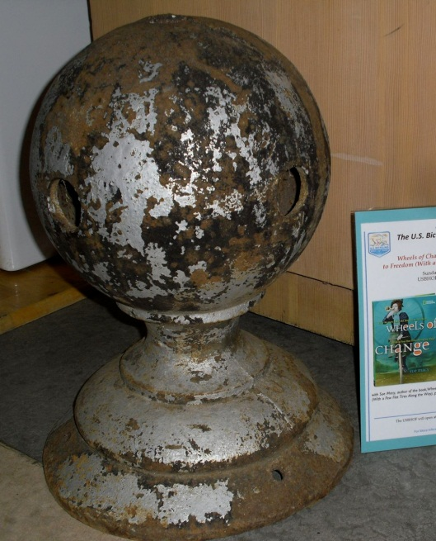

One of the latest donations to the Museum is an 89 pound iron ball which once crowned the City’s first water tower in the 600 block of D Street. The tower is long gone but the well beneath it remains as City Well Number 1. The ball appears to have housed lightning rods.

The ball was donated by long-time Davis resident and PG&E employee Richard Mills. His family recalls his account of how the town Fire Chief would climb the tower and stand on his head on the ball for the amusement of the town’s children. The Museum has yet to obtain independent corroboration of this account.

Another recent acquisition came from the Gibson House Museum in Woodland. It is a double sided banner inscribed “P.S. Chiles Herd Durham’s 7 Herd Davisville” and probably used in agricultural fairs before 1906 when the Davisville Enterprise changed its name to the Davis Enterprise. P.S. Chiles was Phineas Skinner Chiles, the brother of Isaac Skinner Chiles who was one
of the earliest settlers in the area, arriving in 1849. Isaac and Phineas were nephews of Joseph Ballinger Chiles who arrived in 184l. Isaac died in June 1874 at age 44 and Phineas was summoned to help manage the large estate, which included the raising of purebred Durham cattle.

The “7 Herd” on the banner refers to the minimum number of cattle needed for entry in all of the show classes.

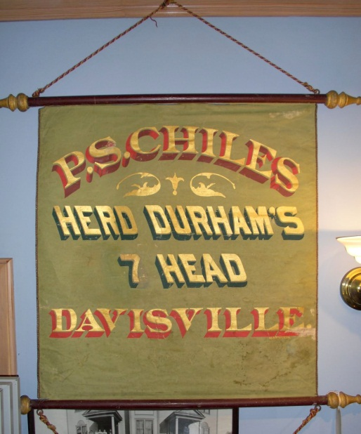

Society members are especially welcome to visit the Museum, which is open to the public on Wednesdays and Saturdays between 10 am and 4 pm. The Museum is located at 445 C Street in Davis’ Central Park.

~

NEWSLETTER ARTICLES DEADLINE: Articles for the newsletter will be accepted until the 20th of each month. Please either email B J Ford at: bjford@pacbell.net or mail to the YCHS at P.O. Box 1447 Woodland, CA 95776
~
If you have a story you would like to share that relates to Yolo County, send it to rbarzo@yahoo.com and we can include it as space is available. Photos are also encouraged!
Spring 2013, YCHS BUS TRIP: HISTORIC FOLSOM

Saturday, April 27th, 8:30 (Woodland) & 8:45 (Davis) [until 4:45]
$35 for YCHS Member, $40 for non-members

Historic Folsom will be our destination this spring. We will visit the thriving (70+ shops) Sutter Street heart of a downtown with roots and relicts from the Gold Rush. Sutter Street was adjacent to a large 1849 placer mining encampment, a terminus of the Pony Express, site of an early (surviving) Wells Fargo office, and subject to wild ambitions as a manufacturing center. The first railroad west of the Mississippi connected Folsom with Sacramento in 1856. The massive granite walls of Folsom Prison date to the 1870s and the 1895 hydroelectric powerhouse was nearby in location and similarly constructed of locally quarried granite blocks. Early viticulture was substantial, taking grapes from one of the world’s largest vineyards. Mining dredges in the 20th century churned square miles of what are now residential Folsom neighborhoods. Downtown recast itself as a “historic and western” town in the 1950s, accentuating its 19th century buildings with false fronts. Folsom has a thriving historical society and four significant museums.
First, our bus will give us an overview of the fine homes and churches of the oldest neighborhoods and of the dramatic river canyon. Then we will spend an hour in the very impressive Folsom Museum. Lunch will be on your own on Sutter Street, with five good restaurants within a block of the Museum, and dozens of antique shops along the street. The afternoon will begin at the Train Museum a block from Sutter Street. We will visit the Powerhouse SHP and the Folsom Prison Museum. The Folsom Zoo and an early “Wild West” shopping center will be noted. On our way home we will stop at Intel’s largest plant – high tech Folsom. This tour is being organized and will be narrated by Dennis Dingemans (753-5959 or djdingemans@ucdavis.edu for more information.

Checks (pay to YCHS) to Dennis Dingemans, 645 C. Street, Davis, 95616

NAME:____________________________________________________________

TELEPHONE/EMAIL_______________________

ADDRESS___________________________________________

Board at Woodland?_____________Davis?______________

8:30 –Woodland: SW corner of County Fair Mall (East street side – Gottschalks)
8:45 – Davis: SE corner of parking lot west for Veteran’s Memorial

Yolo County Historical Society
P.O. Box 1447
Woodland, CA 95776

Address Service Requested

Dated Material

Vision Statement The Yolo County Historical Society strives to preserve, protect and acknowledge
the diverse history of Yolo County through education, communication and advocacy

