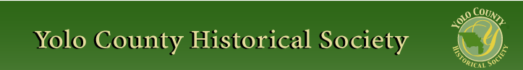

APRIL 2012
PP 2012

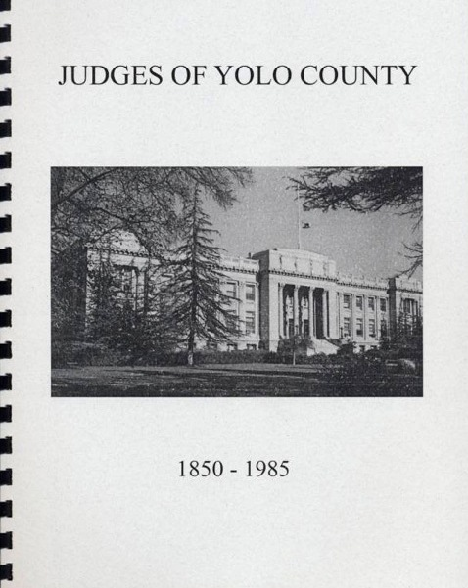

Retired Judge Jim Stevens will give a talk on April 22 at 2 PM on his book, co-authored with Judge Dave Rosenberg, "Judges of Yolo County 1850-1895." Judge Stevens served on the Davis City Council 1974-84 and as Mayor in 1981.
Please join us for this program at the Hattie Weber Museum, 445 C Street, Davis, Ca.

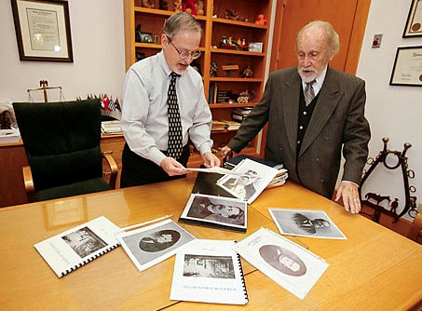

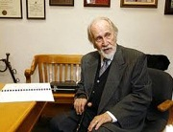

~

NEWSLETTER ARTICLES DEADLINE: Articles for the newsletter will be accepted until the 20th of each month. Please either email B J Ford at: bjford@pacbell.net or mail to the YCHS at P.O. Box 1447 Woodland, CA 95776

PRESIDENT’S MESSAGE

Remembering Nadine Salonites
We would be remiss if we did not note the recent passing of Nadine Salonites, who most people think of as the opera singer. We at the Historical Society remember her also as a former President of the Society. Her efforts in saving the Opera House from demolition is legendary however many people are not aware that she along with Sarah Reynolds were responsible for the substantial donation by the Native Daughters of the Golden West when money

was being raised to fence the Woodland City
Cemetery. Most of the West Street portion of the fence can be attributed to their efforts.

Peace,
B.J. Ford, President
530-662-0952
~

Spring Lake School House
by Kathy Harryman

School is open and the students and teachers will be arriving soon. The bell will ring and the flag will be raised and the shouts of laughter will once again ring out at the
Fairgrounds. We have 3 visits scheduled in April and 17 classes scheduled in May. All the classes have teachers and we are very pleased. We also will have a visit from a PEO ladies group hosted by our own Kathy Cobb. Have a wonderful time ladies!

Gibson House Museum
by Kathy Harryman

The Gibson House will have a grand opening on Saturday March 31 beginning at 1:00 p.m. (Cleaning in the a.m.!!!) celebrating the new display entitled “The Chinese Influence in Yolo County”. I have been the researcher on the project and have filled the museum with the wonderful artifacts that are owned by the museum, supplemented with the generous donations from members of the community and members from the Chinese American Historical Society of Sacramento. The mannequins are all dressed; some in their Chinese finery and others in the dress of the common laborer. The table is set with a celebration of the importance of tea featuring tea pots from the late 1800’s as

well as a lovely tea set and a tea brick, a replica from the time of Marco Polo. Oriental fans in the dining room and lovely Chinese textiles are displayed throughout the museum. The display case in the East
Parlor is filled with items that show the artistry of the Chinese culture.

The Museum Room is where you can take an imaginary ride on the train tracks through the larger towns in Yolo County and read about the Chinese and their influence in the county: first with the building of the railroads and then building levees to hold back the river and then with the laundries and truck farming. Pictures show their lives and maps show where they were located. There is a display using the artifacts found on the dig from Dead Cat Alley. There is also a display showing the archeological strata of the area. You can even pick up an eight pound iron and get a small idea of what it was like to hold one and iron for hours at a time. It truly is a wonderful display and will bring a new appreciation of a culture of individuals who had a deep lasting influence on this county, making it what it is today.

I want to thank the following people who helped with the display: L & S Printing, Lynn Plocher for the railroad, Marilyn Juarez for dressing the mannequins, and Stella Dinger for her discoveries of wonderful ‘things’ to use and of course all the individuals who contributed to the displays. You are all treasured.
~

The Hattie Weber Museum, located at 445 C Street, Davis, Ca. is open to the public on Mon. & Wed. from 10:00 a.m. to 4:00 p.m.

Wanted - Historical Researchers!!!!
by Kathy Harryman

If you like reading about the past and discovering interesting items about Woodland’s history, then you are the person for the job. WE are looking for members who would like to help research information at the Yolo County Archives for our upcoming fundraiser at the Woodland Cemetery on October 27. Our own Chris Drieth, owner of Home Improvement Group, will write the scenarios. As many of you know, she was the author of numerous plays for the Friends of the Woodland Public Library’s Mystery Night. We are thrilled to have Chris on board. The archives are open to the public only on Tuesday mornings and Thursday afternoons. We have to call to let them know we are coming. If you are interested, call me at 662-2189 and we can make arrangements to meet.
~
Our Spring Trip is still in the planning stages – information will follow as it becomes known.
~

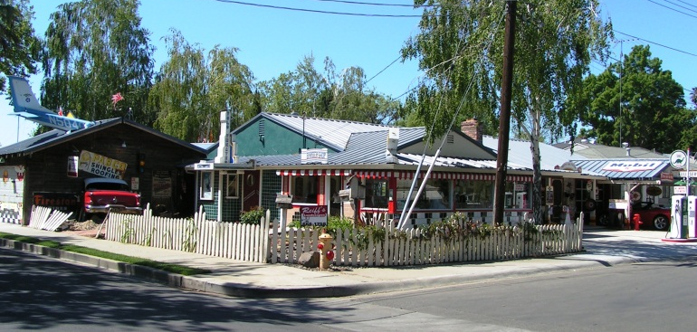

Museum Day in Woodland will be April 14th; 10 A.M. to 4 P.M. The following eleven Museums will be open. The Heidrick Ag History Center, Hays Antique

Truck Museum, the Historic Woodland Railroad Depot, Woodland Opera
House, Woodland Fire Museum, Christian
Church Museum. Gibson House Yolo County Historical Museum, Spring Lake School House, Reiff's Gas Station and the Woodland Museum of Biblical Archeology. Brochures and Maps will be available at all venues.
~

Society publications available for sale at a variety of locations. For more information on book sales, contact Mary Aulman at 666-0743.
~
YOLO COUNTY HISTORICAL
SOCIETY
BOARD OF DIRECTORS
President B. J. Ford 662-0952
Vice Pres. Jeannette Molson 666-7103
Secretary Bob Sommer 756-7553
Treasurer Reva Barzo 867-5800
Directors
Mary Aulman 666-0743
Kathy Harryman 662-2189
Dianne Barsotti 661-1179 Roberta Stevenson 753-5791
Jim Becket 756-1418
Beth Wettergreen 207- 9403
Dennis Dingemans 753-5959

~

Searching for a past article from our newsletter? Go to Yolo County Historical Society web address: http://ychs.org/

Yolo County Historical Society
P.O. Box 1447
Woodland, CA 95776

Address Service Requested

Dated Material

INVITE A FRIEND TO JOIN
Membership in the Yolo County Historical Society is open to all who wish to join in supporting the research, preservation and designation of the county historical resources, maintaining the Springlake Schoolhouse Museum on the Fairgrounds, and publishing mini-histories of Yolo County communities. Please make check payable to Yolo County Historical Society.

Individual $20 NAME _________________________________
Family $25
Senior 65+ $15 ADDRESS ______________________________
Family 65+ $20
Business $50 CITY __________________ ZIP ____________
Patron $100
Life $300 TELEPHONE ___________________________

EMAIL _________________________________

Vision Statement The Yolo County Historical Society strives to preserve, protect and acknowledge the
diverse history of Yolo County through education, communication, and advocacy

Vision Statement The Yolo County Historical Society strives to preserve, protect and acknowledge the
diverse history of Yolo County through education, communication, and advocacy

