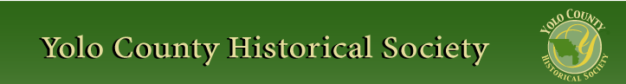

MARCH 2013
PP 2012

PRESIDENT’S MESSAGE

Most of you know by now but for those who have not, Analu Josephides , Yolo County Archivist, has returned to his native Hawaii where he has been appointed the Director of the Native Hawaii Library System over seeing the libraries on the various islands . In talking with Analu he admitted it was not his first choice to leave Woodland, however, in talking with a colleague in Hawaii he learned that the position that he had left to come to Yolo County was open in that a number of the libraries which he had left were now closed and the monies (a substantial amount) was gone. He was offered the position to restore the program he had left and with his family encouraging him to come home the decision was made. We are sending him David Wilkinson’s Crafting a Valley Jewel. We don’t want him to forget us as we will not forget that under his leadership the Yolo County Archives evolved from an archives to an ARCHIVES!

Peace,
BJ Ford, YCHS President

~

Hattie Happenings

Pig Day (March 2) was huge for the Hattie Weber Museum. Thanks to the loan of dozens of pigs (big, small, stuffed, ceramic, wood and fabric) from the collections of Senior Docent Roberta Stevenson and Kathryn Nilsson and Roberta’s efforts as a greeter, the Museum hosted 219 visitors, an all-time one day record!

In honor of Woman’s History Month, the Museum mounted an exhibit honoring women winners of the annual Covell and Brinley awards for outstanding contributions to the Davis community. Material for the exhibit was kindly supplied by Judy Wydick, who is compiling a history of the awards and all of the winners.

On March 30th, the Museum will host its annual Easter egg hunt and mount an exhibit of antique Easter post cards from Yolo County. Another new exhibit will feature the diversity of worship communities in Davis, growing from three in the 1920’s to more than 30 today.

The Museum volunteers are also working on a pictorial display of 19th century structures surviving in Davis which will open sometime in April.

The Museum is located at 445 C Street in Central Park, next to the Farmers’ Market. Hours are 10 to 4 Wednesdays and Saturdays. Admission is free. Come visit!

~

NEWSLETTER ARTICLES DEADLINE: Articles for the newsletter will be accepted until the 20th of each month. Please either email B J Ford at: bjford@pacbell.net or mail to the YCHS at P.O. Box 1447 Woodland, CA 95776
~
If you have a story you would like to share that relates to Yolo County, send it to rbarzo@yahoo.com and we can include it as space is available. Photos are also encouraged!

Our members have enjoying reading about the memories that have been shared in the newsletter of late.

~

Winters History Project

The early settlement of Buckeye will be the topic of the Winters History Project on April 11 at 7:00pm when Park Winters hosts the group. Buckeye descendants will give illustrated stories about the community which was replaced by Winters when the railroad came. Joann Larkey, local historian and chair of the Winters, History project will join the story tellers which include Bill Chapman whos kin George Washington Scott built the historic home at Park Winters on county Road 26 north of Winters where the event will be held. Family members of Buckeye pioneer Henry Fredericks will share some of their history and artifacts also. Reservations may be made by calling Nicki Chapman 795-2676 or Gloria Lopez. Toglo@aol.com. Donations to the history project to help preserve, research and copy important historic documents and artifacts will gratefully be accepted.

~

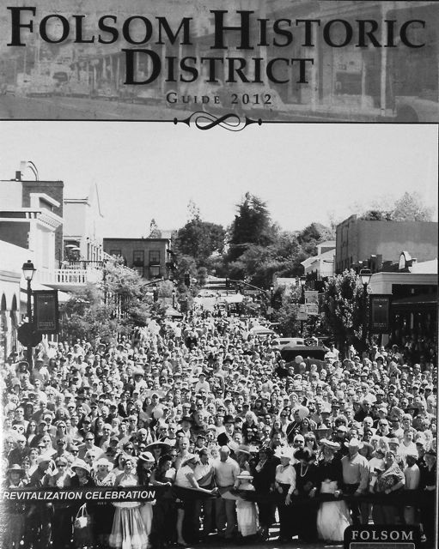

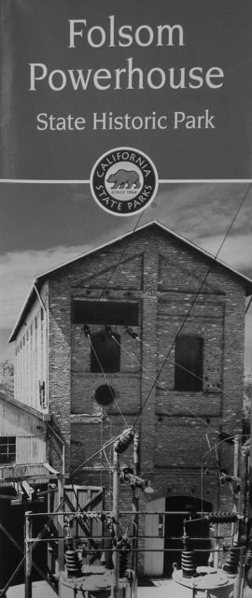

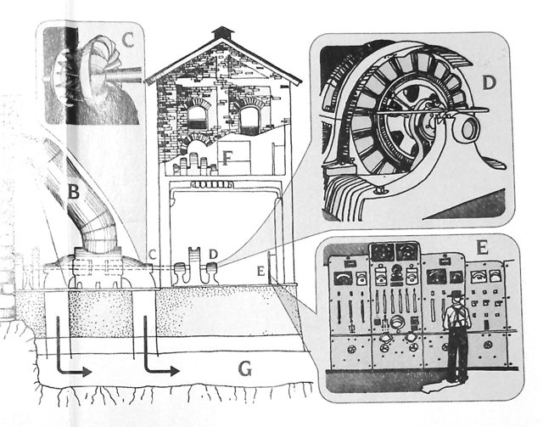

Spring 2013, YCHS BUS TRIP: HISTORIC FOLSOM

Saturday, April 27th, 8:30 (Woodland) & 8:45 (Davis) [until 4:45]
$35 for YCHS Member, $40 for non-members

Historic Folsom will be our destination this spring. We will visit the thriving (70+ shops) Sutter Street heart of a downtown with roots and relicts from the Gold Rush. Sutter Street was adjacent to a large 1849 placer mining encampment, a terminus of the Pony Express, site of an early (surviving) Wells Fargo office, and subject to wild ambitions as a manufacturing center. The first railroad west of the Mississippi connected Folsom with Sacramento in 1856. The massive granite walls of Folsom Prison date to the 1870s and the 1895 hydroelectric powerhouse was nearby in location and similarly constructed of locally quarried granite blocks. Early viticulture was substantial, taking grapes from one of the world’s largest vineyards. Mining dredges in the 20th century churned square miles of what are now residential Folsom neighborhoods. Downtown recast itself as a “historic and western” town in the 1950s, accentuating its 19th century buildings with false fronts. Folsom has a thriving historical society and four significant museums.
First, our bus will give us an overview of the fine homes and churches of the oldest neighborhoods and of the dramatic river canyon. Then we will spend an hour in the very impressive Folsom Museum. Lunch will be on your own on Sutter Street, with five good restaurants within a block of the Museum, and dozens of antique shops along the street. The afternoon will begin at the Train Museum a block from Sutter Street. We will visit the Powerhouse SHP and the Folsom Prison Museum. The Folsom Zoo and an early “Wild West” shopping center will be noted. On our way home we will stop at Intel’s largest plant – high tech Folsom. This tour is being organized and will be narrated by Dennis Dingemans (753-5959 or djdingemans@ucdavis.edu for more information.

Checks (pay to YCHS) to Dennis Dingemans, 645 C. Street, Davis, 95616

NAME:____________________________________________________________

TELEPHONE/EMAIL_______________________

ADDRESS___________________________________________

Board at Woodland?_____________Davis?______________

8:30 –Woodland: SW corner of County Fair Mall (East street side – Gottschalks)
8:45 – Davis: SE corner of parking lot west for Veteran’s Memorial

Yolo County Historical Society
P.O. Box 1447
Woodland, CA 95776

Address Service Requested

Dated Material

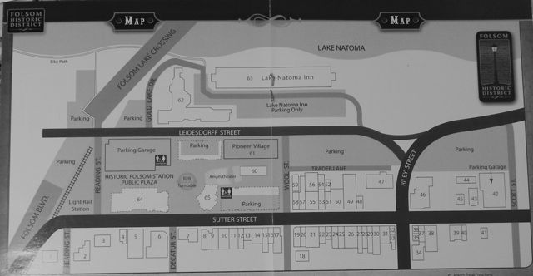

Vision Statement The Yolo County Historical Society strives to preserve, protect and acknowledge
the diverse history of Yolo County through education, communication and advocacy

