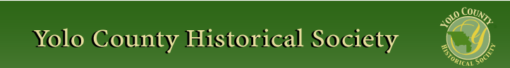

March 2012

Our March program will be a presentation by author, July James Wydick. Please join us Sunday, March 25, 2012, at 2 P.M. at the Hattie Weber Museum, 445 C Street, Davis, Ca.

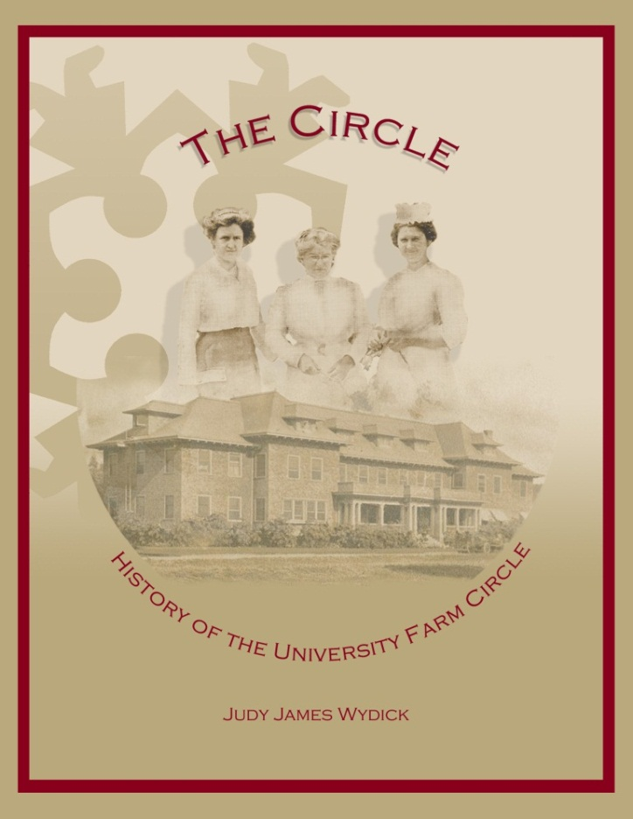

The Circle: The History of University Farm Circle is a book that covers 95 years of an organization supportive of the University of California, Davis. Why did the women choose to belong to Farm Circle? What kinds of problems did they encounter, and what contributions did they make? And how have they managed to keep the organization going for nearly a century?

University Farm Circle was formed in 1914, five years after the University Farm opened, bringing women together in this tiny, isolated community with its unpaved streets.

This book highlights what the campus and the town were like in the years until World War II—first for the faculty wives and other women connected to the school, and later for the very few female faculty and coeds.

Farm Circle’s development parallels that of the school and the town, and the organization reflects what was happening around them—through two world wars, the Depression, the Women’s Movement. UFC focused on helping students and newcomers, but as a women’s group, it represents such organizations everywhere.

Past Presidents include Ruth Painter in 1950 (who is now 102), Lois Wolk 1982 and Ruth Asmundson 1984.

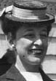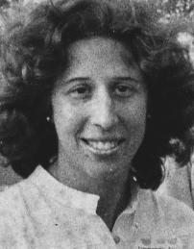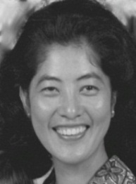

~

NEWSLETTER ARTICLES DEADLINE: Articles for the newsletter will be accepted until the 20th of each month. Please either email B J Ford at: bjford@pacbell.net or mail to the YCHS at P.O. Box 1447 Woodland, CA 95776

PRESIDENT’S MESSAGE

Our monthly program meeting which was held in West Sacramento on February 26th was well attended with at least 50 people enjoying the program presented by Richard Hurley & TJ Meekins who have written a book “Queen of the Northern Mines” - a Novel of the Civil War in California. Our intended program was to be presented by Jeannette L. Molson who attended the Sesquicentennial Celebration of the USCT l861 - 1865 (United States Colored Troops). Instead of having a program about the Civil War on the East Coast we had one about the Civil War on the West Coast. We thank Richard and TJ who stepped in with 3 days’ notice after Jeannette suffered a health problem that made her participation impossible. Jeannette will present the program at a later date. We all wish her a quick recovery.
Peace,
B.J. Ford, President
530-662-0952
~

Hattie Sets Attendance Record

Saturday, March 3rd, was Pig Day at the Davis Farmers Market and also at the Hattie Weber Museum. An all-time one day record was set at the Museum when 161 visitors came to view the exhibits and portions of the pig collections of Senior Docent Roberta Stevenson and community member Kathryn Nilsson. Percy, the dancing/singing pig, led a drove of pigs of all sizes and many different materials. A 24” Piglet was astride the Museum’s pony and a 2” 21st century pig in a bathing suit rested on an inner tube while consulting his laptop and talking on his cell phone. Great fun!

Our celebration of Jim Becket’s 83rd birthday and his becoming Director
Emeritus of the Museum on February 4th was also a very fun day. Jim’s favorite
musical group, the Putah Creek Crawdads,
played for a crowd of about 60; Jim received proclamations of appreciation from the State Senate and the City of Davis and was lauded by multiple speakers. And we had snacks, cake and wine!

In early March we mounted two new exhibits. One displays photographs of public art in Davis taken by David Anderson. The second celebrates 100 years of California woman’s suffrage with materials assembled by the Davis League of Woman Voters. The 1930s Davis exhibit continues.

On another front, the Davis Historical Resources Commission voted unanimously on February 27th to recommend to the Davis City Council that the 1937 WPA restroom building in Central Park be retained and used as an annex to the Hattie Weber Museum! The Council approved demolition of the building last November but the issue will be reviewed before any action is taken. Construction of new restrooms is slated for later this year.

On March 31, the Museum will celebrate twenty years of service to the Davis and Yolo County community. We will have a short ceremony honoring the City Council that approved the project and the architect who oversaw it at 2 pm on the 31st, followed by a reception. Refreshments will be served. All are invited. Please save the date.

The Hattie Weber Museum, located at 445 C Street, Davis, Ca. is open to the public on Mon. & Wed. from 10:00 a.m. to 4:00 p.m.

Check out the website for The Greater Capay Valley Historical Society at greatercapayvalley.org. Editor-writer, Elizabeth Monroe, recently made and posted several short oral history videos: 2 of Capay Valley "old-timers" who recently passed away, Alfred Hayes and Gene Rominger; and 2 of William Petty, local historian, featured at Black History Day (last Saturday, Feb. 11), and talking about what it was like trying to buy property as an African-American in Woodland in the 1950s, and how he created a cultural awareness program for McClellan Air Force Base about the same time. Elizabeth conducted a historic walking tour of Esparto on Feb. 5 for the new owner of the Esparto Depot and her Bay Area art students, who are working on design plans to tie the renovated depot to the rebirth of the town. Elizabeth will be interviewing her soon to explore her plans and publish it in the up-coming March issue to accompany an article on the ClearLake-VacaValley Railroad through the Capay Valley, etc.
~
A Spring Trip is being planned. We will be visiting “historic” Petaluma either late April or early May. The next newsletter will contain information. And, as soon as the “planning team” returns with a definite date and plan, the information will be on the Society website.
~
Plan now to attend Museum Day in Woodland on April 14th; 10 A.M. to 4 P.M. Nine Museum will be open which will
include The Heidrick Ag History Center, Hays Antique Truck Museum, the Historic Woodland Railroad Depot, Woodland Opera
House, Woodland Fire Museum, Christian

Church Museum. Gibson House Yolo County Historical Museum, Spring Lake School House, Reiff's Gas Station and the Woodland Museum of Biblical Archeology. Brochures and Maps will be available at all venues.
~
Society publications available for sale at a variety of locations. For more information on book sales, contact Mary Aulman at 666-0743.
The Circle, with 444 pgs. and over 1,000 photos is underwritten, so anyone who donations $25 to UFC Scholarships may receive a book. To obtain an autographed copy, contact Sandi Redenbach (756-8678) or spopcorn@espp.org.
~

YOLO COUNTY HISTORICAL
SOCIETY
BOARD OF DIRECTORS
President B. J. Ford 662-0952
Vice Pres. Jeannette Molson 666-7103
Secretary Bob Sommer 756-7553
Treasurer Reva Barzo 867-5800
Directors
Mary Aulman 666-0743
Kathy Harryman 662-2189
Dianne Barsotti 661-1179 Roberta Stevenson 753-5791
Jim Becket 756-1418
Beth Wettergreen 207- 9403
Dennis Dingemans 753-5959
~

Searching for a past article from our newsletter? Go to Yolo County Historical Society web address: http://ychs.org/

Yolo County Historical Society
P.O. Box 1447
Woodland, CA 95776

Address Service Requested

Dated Material

INVITE A FRIEND TO JOIN
Membership in the Yolo County Historical Society is open to all who wish to join in supporting the research, preservation and designation of the county historical resources, maintaining the Springlake Schoolhouse Museum on the Fairgrounds, and publishing mini-histories of Yolo County communities. Please make check payable to Yolo County Historical Society.

Individual $20 NAME _________________________________
Family $25
Senior 65+ $15 ADDRESS ______________________________
Family 65+ $20
Business $50 CITY __________________ ZIP ____________
Patron $100
Life $300 TELEPHONE ___________________________

EMAIL _________________________________

Vision Statement The Yolo County Historical Society strives to preserve, protect and acknowledge the
diverse history of Yolo County through education, communication, and advocacy

Vision Statement The Yolo County Historical Society strives to preserve, protect and acknowledge the
diverse history of Yolo County through education, communication, and advocacy

