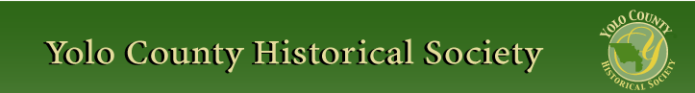

February 2016

PP 2012

Prez Says:

El Nino has finally arrived and we are all thrilled to see the mountains covered in snow and watch the lakes and rivers fill up with water. Now if only we could officially be out of the drought! But we all know that it is going to take time to get back to where we were …Just as I am constantly reminded that it takes time to get things done when you are working with the government and all the levels of its beaucracy. Both projects that we are involved in are slowly moving forward…The WPA building in Davis has been on the city books for 24 months. The Yolo County Courthouse has now been vacant for 6 months and our proposal is about 9-12 months long. Yes, I know that patience is a virtue but ……

We had a wonderful presentation on Sunday, January 31 by Neal Peart and a group of
enthusiasts at the Woodland Fire Museum. We were introduced to the fire trucks that
they have restored and told of the number of countless hours it took to restore each truck.
Yes, in this case patience was a virtue.
The Yolo County Historical Society hosted the Sacramento Area Consortium of History
Organizations at the Woodland Public Library on Thursday, January 21. Over 40 people
representing historical associations throughout Sacramento, Placer, and Yolo counties
attended the meeting. These meetings keep us informed about what is happening
throughout the three counties. After lunch, we were then given a tour by the library
director, Greta Galendo, of the historical Carnegie Library. What an impressive building!
Everyone was pleased.

Our schoolhouse program will begin shortly. I just purchased a broom closet for the schoolhouse. Several years ago, I asked the membership if they could donate a broom closet. The brooms and mops and cleaning stuff are stacked in a corner by the teacher’s desk. One individual responded, but that fell through. I have been looking for four years and finally found one. Jim Scott, our go-to repairman, made some alterations (it was a gun closet) and attached a magnetic strip. It will now be added to the school house as a permanent fixture. Yes, patience does pay off!

Thanks to all of you who donated extra monies for the school house project. We purchased more equipment for the outside. The graces (round wooden rings) especially needed to be replaced.

As you all know, we meet every month at different county library locations throughout the county. This month we met at the county library in Yolo. The Yolo Library is a Carnegie Library and like Woodland is one of the few Carnegies left that is a working library. Most of the Carnegie Libraries have been re-purposed. The library is undergoing
some major changes due to age and neglect. We were pleased to have Meg Sheldon, the
President of the Friends of the Library in Yolo, come to our meeting and update us. You
will be hearing more from us regarding this project. We are always available to assist groups of individuals who wish to preserve history.
Remember, as always….

History Rules!
Kathy Harryman,
President

❖

Business Buddies

The following businesses in town have financially supported the Yolo County Historical Society. We would like you to support them and keep your money local:

L & S Printers, Main St.
The House Dresser, Main St.
The Gifted Penguin, Main St.
Corner Drug, Main St.
Dahlin & Essex Inc.
Chamberlain Farms
Bill Marble
Michele Giguiere
Bernard & Lynn Gough
Larry Shapiro
Tom & Meg Stallard

If you know of any business that would like to join our support list, contact me. Businesses pay $50.00 per year for advertising.

❖

Hattie Happenings

Mid-Winter Highlights at the Hattie Weber Museum
By Dennis Dingemans, Museum Director

January had low attendance, 155 visitors during the 9 Wednesdays and Saturdays we were open. The combination of winter gloom, rain, and holiday distractions cut our numbers by half. However, a high share were out-of-town and out-of-state and foreign visitors — and these tourists are often satisfyingly appreciative of our exhibits and our attentive docents. An above average $335 was accumulated in the donation box.

A wonderful highlight will be the subject of the rest of this report. A new temporary exhibit will be up for February. We call it “Remembering Home: Photographs of Memorable Houses and Beloved Toys.” The exhibit was put together in conjunction with their November meeting by the Davis Genealogy Club. They asked their active and creative membership to submit photographs that reveal something of where they came from, geographically and emotionally. The results are three dozen photographs depicting 14 toys and 18 houses. They are arranged nicely on six 20 x 30 inch poster boards and are given informative captions. We think you will find them entertaining and educational. They show the dispersed places from which come our region’s residents. The toys bespeak the familial affections that parents shower on their offspring and the appreciation that is apparent by the recipients’ even decades later. The architecture of the houses and the nature of the toys reveal popular culture trends of past times.
The houses judged to be memorable and beloved as “our home” by the families of the contributors are arranged here in temporal order (by estimated year of construction).

** 1631 at Blankenau Hess Germany. A 3 story city house with “half-timber” exteriors.
** 1640 at Ipswich, Mass. Another town house with an over-hanging second story.
** 1850s at Roseville, CA. A two story American vernacular with little ornamentation.
** 1860 at Rosevillle, CA. A cottage with porch pillars of twin spaced 2x4s.
** 1870 at Chilton, WI. A Greek Revival.
** 1870s at Tipton, CA. A vernacular split-logs cabin — with the logs mounted vertically.
** 1880 at Newark NJ. A three story Parisian Mansard with a widow’s walk.
** 1890 at Adair, MO. An “upright and wing”.
** 1900 at Joseph, Utah. A rambling Victorian assemblage of towers and porches.
** 1904 at Queens, NY. An unornamented, wooden-siding row house.
** 1905 at Lexington, Mass. A colonial revival with dozens of shuttered windows.
** 1908 at Long Valley, UT. A conventional log cabin — with logs mounted horizontally.
** 1918 at Salina, KS. A square farmhouse with pairs of spaced 2x4 porch pillars.
** 1930s at LaGrange, IL. An early tract house from just before the picture window era.
** 1936 at Wausau, WI. A colonial revival.
** 1949 at Levittown, NY. The simple Cape Cod Levittown tract house.
** 1956 at Sunnyvale, CA. A $15,000 tract house with ranch features.
** 1970 at Clark AFB in the Philippines. A tropical barracks.
The 14 toys shown in the exhibit include a mix of commercial productions (by Playschool, Lionel, and Radio Flyer) and some homemade acts of creativity (a two wheeled wooden trailer; a doll bed). I was especially fond of the depicted “bubbler” Christmas tree ornament. My family was proud of ours and I too had “Hop along Cassidy” and “Zorro” attire as well as a Radio Flyer red wagon.
**1922 A very large homemade doll (of wool?)
**1934 A stick and vegetable can for “hockey” or “cricket” games
**1935 A 4-poster doll bed, homemade with quilt (by dad and mom)
**1937 Playschool Pullman railroad sleeping car
**1937 Lionel Speedboat (wind up)
**1940 A tricycle pulling a homemade wooden trailer
** 1942 A riding locomotive
** 1942 A Radio Flyer red wagon
** 1948 A doll “Sparkle Plenty”
** 1949 Cowboy outfits with vest, holster, and six shooter
** 1955 A Christmas tree’s “bubble lights” and a girl’s proto “go go boots”
** 1955 A “Zorro” outfit with black mask
** 1958 A “Hop along Cassidy” bike
** 1970 A pedal car “Chitty Chitty Bang Bang”

❖

Thanks to the following for generously supporting the Society …………. You too can be a Patron by donating $100.00 to help us run our projects

2015-2016 Patrons

- Robert & Lynn Campbell
- Donald & Pat Campbell
- John & Helen Daniels
- Jonathan & Barbara Durst
- Robert & Judy Simas
- Ron & Marilyn Scholz
- David & Ann Scheuring
- Claire Childers
- Jeff & Starr Barrow
- Michael & Debra Truitt
- Alphe Springer
- Steve & Teri Laugenour
- Richard & Joann Larkey
- Ramon & Karen Urbano
- Thomas Crisp
- Ryan Baum & Alice Wong
- Richard & Evelyne Rominger
- Lynn & Penn Wilen
- Steve & Lydia Venables
- Cleve Baker
- Louis & Jane Niehues
- Charles & Claudia Owens
- Marilyn Kregel
- John & Kathy Harryman
- Roger & Ann Romani
- Patricia Nickell
- Jim & Wilda Shock
- John Hoover
- Dennis Dingemans & Robin Datel
❖

Historical Society Monthly Program

On Sunday, February 28 at 2:00 in the afternoon, Dennis Dingemans and Merrily DuPree will give a talk on postcards entitled “The Postcard Collection of Chris and Jan Cross”. The collection includes over 200 postcards with photographs of historic Davis, UCD, Woodland and other places of interest. Many of the cards are rare.

Merrily is retired faculty in English from The University of Nevada, Reno, and Dennis is retired faculty in Geography from The University of California at Davis. Both are volunteers at the Hatti Weber Museum.

The talk will be at the Hatti Weber Museum in Davis, 445 C St. If you have old postcards that you would like to donate to the museum or you would like some information about them, bring them on Sunday.

❖

Looking for an old article published in the newsletter or upcoming events? Check it out on our website. www.yolo.net/ychs

❖

Yolo County Historical Society Essay Contest
2015-2016

The Yolo County Historical Society would like to offer all students involved in agriculture in Yolo County an opportunity to write a researched essay. It is opened to all students in grades four through twelve. This essay will be judged by the Historical Society and will be awarded a prize. This year’s theme will be “An Important Crop/ or Livestock in Yolo County.” The essay can be either in the past or the present.
Please follow the directions below:

1. 2 page double spaced typed essay – 12 point font Times Roman or an equivalent or
3 page double spaced hand written readable essay

2. A cover page with the title of the essay, the student’s name, school attended, and date

3. A Bibliography page with at least 3 references.

Prizes:

First Place $100.00

Second Place $75.00

Third Place $25.00

Entries are to be sent to :

Yolo County Historical Society
PO Box 1447
Woodland, Ca. 95695

❖

Finding History in Cook Books

If you are a cook you always want to look at new recipes. Even though we all have our favorites, the thrill of trying something new excites us. When we see a book or a magazine, we all want to thumb through it, just in case something wonderful is discovered and can be used for tonight’s meal.

Recently, I had the opportunity to spend some time looking through an old recipe book from 1914 entitled Our Select Recipes put together by the M.E. Church, South in Woodland. I would like to share some of the recipes with you in hopes that you might want to add them to your list….But first I would like to share their editorial…

“In this little volume, gotten out by the ladies of the Woodland M.E. Church South, we have made no effort to increase the numberless recipes already extant; but have simply garnered those that are best, novel and most practical plus the inestimable value of personal touch and experiment. ……To this end we have worked and in this we feel that we have succeeded. The success of our enterprise, however, is due largely to the gracious co-operation of the women throughout Yolo County and elsewhere, to whom we have dedicated this book, also to the local coloring given by pictures and recipes from our own county, and to the ready and generous response of the merchants of Woodland, Winters, Davis and Esparto, as well as citizens throughout the entire County. For this reason, the gratitude of words is but a poor thank-offering for what our hearts contain. So with humility, yet confidence that we have accomplished the object of our endeavors, we present you a volume unique in its conception, design and contents and commend it for your careful study, use and appreciation.”

These ladies certainly had a way with words!

Every good cookbook has a page titled Measurements. I have listed some interesting terms:

A speck = ¼ saltspoon
4 saltspoons = 1 teaspoon
2 gills = 1 cup
1 wine glass = ½ gill

Also did you know that …
1 cup of stemmed raisins = 6 oz.
1 cup of cleaned currants = 6 oz.
1 cup of stale bread crumbs = 2 oz.
10 eggs = 1 pound

Wow! I just assumed that raisins always were stemmed and that you always cleaned your currents.

You also need to know how long to cook your foods. Here are some suggested times:

String beans ….1 to 2 hours
Beets/turnips …..1 to 2 hours
Corn …..20 minutes
Carrots …..3/4 to 1 hour
Cabbage ….1 to 3 hours

My goodness! Can you imagine if we cooked like that today?

Next I looked at the meats that were available for cooking. Here is a list of the more unusual meats:
Veal, Liver, Goose, Duck (tame), Duck (wild), Grouse, Pigeons, Venison.

The recipes were just as fun to read. Here are some of the recipes that you might like to try:

A Refreshing Drink
3 pints of well sweetened lemonade
1 pint root beer
A little vanilla.
Some orange or strawberries
This came from the kitchen of Mrs. C. P. Allen

How about Pickled Nasturtium Seed (Relish)?
Nasturtium seeds
Brine
Vinegar

Collect the seeds while young and tender. Place them in a double boiler; cover with strong brine. Let stand for an hour; then place on the stove and bring to a boil; then drain off this hot brine and put the seeds in a jar, and cover with boiling hot vinegar. This recipe was from Mrs. C. Epperson

Molasses Fudge came from the kitchen of Mrs. J. D. Musgrove
The ingredients were: 3 cups white sugar
1 cup milk
2 tablespoons molasses
Butter size of an egg
½ level teaspoon soda

The cakes were titled Sunshine Cake, Snowdrift Cake, World’s Fair Cake, Mahogany Cake, Honolulu Lady Cake, Pork Cake and the Fireless Cooker Cake which was baked ¾ of an hour between radiators which have been heated 20 minutes. This was from the kitchen of Mrs. W.O. Marders

The pies and the cookies were similar to what we have today. But then there was the Peanut and Olive Sandwich made from ½ box peanut butter, 1 dozen olives, lemon juice and salt. Mix the peanut butter and olives (stoned), season with lemon juice and salt; spread between slices of bread. Finally there was one page entitled Dainties for the Sick. There were recipes entitled Barley Water, Beef Juice, Beef Tea, Gruel Formula, and Egg Jelly. Aren’t you glad you are not sick now?

Books such as these give you a glimpse into the early food life of the people in this county. You can see that there was a real attempt to share their best recipes with other families as well as provide variety in cooking. Many of the meats listed in the book are now considered ‘gourmet’. Back then, they were considered common foods. The vegetables then and now were the same. The cooking times were drastically different. I wonder if they ate ‘raw’ vegetables. And if they didn’t, was it because they felt they were ‘bad’ for you? The cake titles were fun to read. Pork Cake actually used diced pork. And the Fireless Cake…cooking between radiators.

These ladies were determined to share their best with the community and 100 years later, they provide a glimpse into their lives.

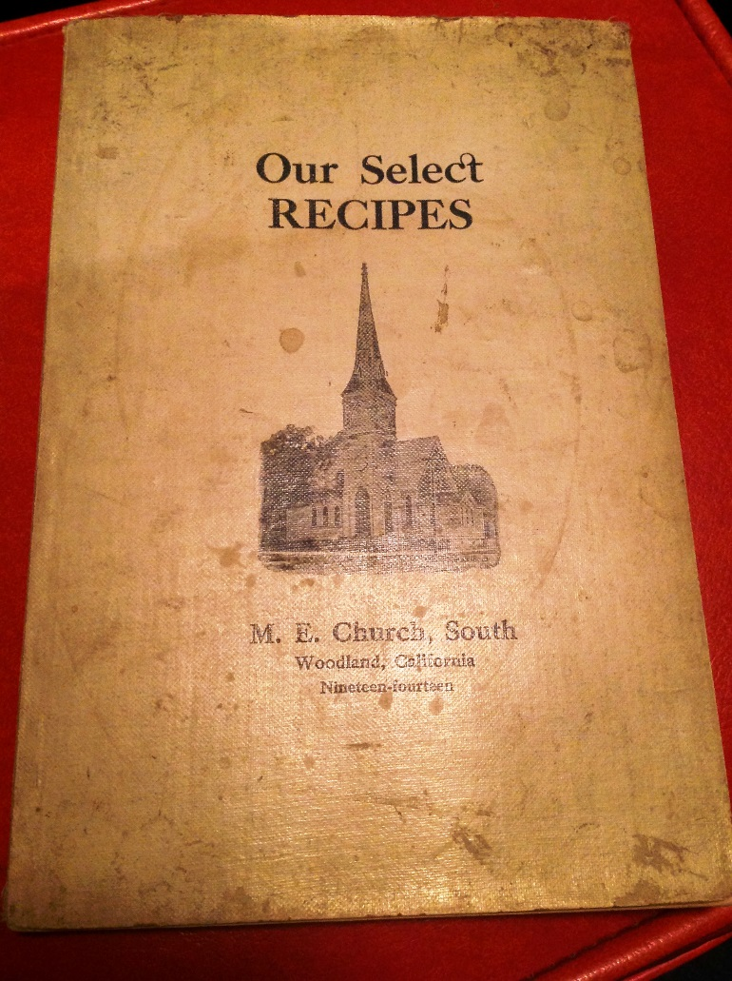

Yolo County Historical Society
P O Box 1447
Woodland, CA 95776

Address Service Requested

Dated Material

Vision Statement The Yolo County Historical Society strives to preserve, protect and acknowledge
the diverse history of Yolo County through education, communication and advocacy

