

FEBRUARY 2014
PP 2012

Pres Says:

What an exciting month this has been! We had a marvelous turnout at Mary’s Chapel to listen to our own Lynne Gough talk about westward expansion and four pioneers of Yolo County. Thank you so much to Lynne and her husband Bernard. Thanks also to the Support Group for Mary’s Chapel and especially to Catherine Overhouse who worked tirelessly with the Goughs covering windows, setting up tables, and attending to many other chores to make the afternoon a rousing success. The Chapel was filled. Many of the attendees were relatives of the Morris, Sharpnack, Riley, and Read families. After the presentation, Catherine invited the entire group to come and see the original Morris home that she and her husband, Van, own. Van has done extensive renovation to the home. What an unexpected treat!
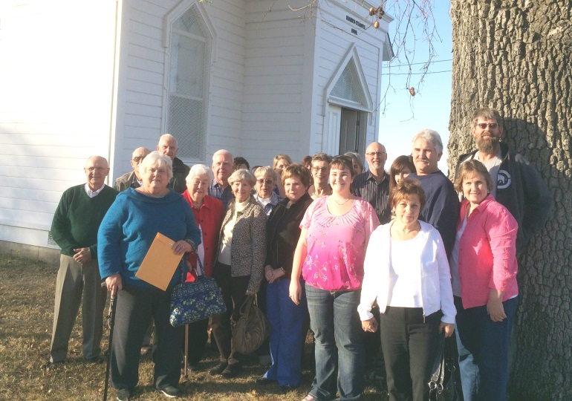
Descendants of the Morris, Shapnack, Riley & Read Family

As many of you know, Catherine Pete Hare died recently in Woodland. She was a longtime resident who ministered to lots of individuals in our community. She listed our society as a recipient of funeral gifts. If you knew “Pete” and would like to contribute to her memory, you can send a donation
to Yolo County Historical Society, P.O. Box 1447, Woodland, Ca. 95766

Our Essay Contest has been extended to February 19. If you know of a sophomore in Yolo County, please go to our website for the information. www.yolo.net/ychs/

Our last Board meeting was in Esparto on Tuesday, Feb. 4 at the Esparto County Library 17065 Yolo Avenue Esparto. All are welcome to join us for the next meeting. We try to carpool. If you are interested, please let me know.

Remember, if you would like to receive this newsletter electronically, via e mail, just let Reva Barzo know. She will place you on the list.

History Rules!
Kathy Harryman

❖

Hattie Happenings
Celebrations!
The Hattie Weber Museum volunteers have had a lot to celebrate recently. On January 28 the Davis City Council voted unanimously to enter into a contract with the Yolo County Historical Society to hire an architect and proceed with plans to renovate the WPA Restroom building in Central Park into a Museum Annex. The City will contribute the $14,106 cost of demolishing the building and the volunteers will raise funds for the remaining costs to be paid to the City through the Society. The current cost estimate by the City is “more than $50,000” but the operative estimate will come from the architect in the spring. Major fundraising will begin at that point. Contributions of more than $12,000 have already been received.
Another occasion for celebration was Jim Becket’s

85th birthday which was marked by a “Becket Bash” at the Museum on February 1st. A crowd of about 60 appeared to wish Jim well, listen to music by the Putah Creek Crawdads and Ken Kemmeling, nibble on refreshments, drink wine and punch and eat cake. Jim was recognized by the City of Davis with a proclamation and a Davis baseball cap delivered by Davis Mayor Joe Krovoza who has consistently backed the Annex project. Councilmember Lucas Frerichs, another Annex supporter, was also in attendance. A good time was had by all.
The Museum will host a Valentine’s Day Second Friday ArtAbout exhibit and reception on February 14. A display of the Museum’s extensive collection of antique valentines as well as artwork by Davis artists will be featured. Refreshments will be served and noted Davis pianist Dick Livingston will play the Museum’s 1908 Schmeiser family piano.
In anticipation of Valentine’s Day, Museum volunteers have created Valentine note cards featuring reproductions of some of the most attractive post cards in the collection. Packets of six cards and seven envelopes are on sale at the Museum for $10.
If you would like to contribute to the Museum’s Annex fund or purchase Valentines, please contact the Museum at 530-758-1332 on Wednesdays or Saturdays between 10 am and 4 pm or stop by at 445 Street on those days.

❖

Speaker Series
Local Author to Speak About Her Family’s Place in History
On Sunday, February 23, Jeannette Molson will present a fascinating lecture about her family. Jeannette has been researching both her maternal and paternal family for the past 35 years. She will share her discoveries with us on Sunday afternoon beginning at 2:00. You will hear of a relative who came to California during the Gold Rush as a slave, others who fought in the Civil War as soldiers in the United States Colored Troops regiment, and one who fought with the NY 107th; she even has a relative who was a stationmaster on the Underground Railroad. Jeannette has also co- authored a book with Eual D. Blansett, Jr. entitled The Torturous Road to Freedom. This promises to be a great talk and just think! It is happening in Yolo County at the Hatti Weber Museum in Davis.

Yolo Rock Chronicles
By Gilbert Gonzalez
Way back in January of 2000, on a sunny day after a big rain storm, I was out in the rolling hills of Hungry Hollow. A desolate and sparsely populated area five miles north of Capay, formerly Langville. Capay was a camping area for the early white trappers that ventured into Yolo County back in the 1800’s from Canada along the Siskiyou Trail. The native American Indians had a trade route from Vancouver to San Francisco that went through Yolo County and was called the Siskiyou Trail.
After checking on how my flock of white face sheep had weathered the storm that had drenched us for three days. Using my Honda three wheel motorcycle, I cruised the fence lines and gullies for any evil coyotes that may have gotten themselves caught in any of the twenty snares that I had guarding my sheep. Everybody was doing fine and everything looked okay.
It was a nice day to go into Goodnow Slough, which ran through the property where my sheep were spending the winter, to look for coyote tracks and beautiful pieces of Yolo petrified wood. The rain always washes out new pieces of petrified wood for me to collect as it erodes away the steep banks of the slough. The agate of the petrified wood is easy to spot after a rain, --- it shines.
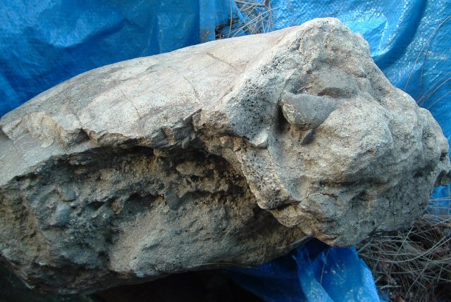
So, I was trudging along the bottom of this enchanted area called Goodnow Slough, a geologic fault line. One side is the floor of a small long flat valley that suddenly drops straight off, down sixty feet to the bottom of the slough. I once witnessed a fully grown cow get to close to the edge, the soil gave way and she went down sixty feet and
impacted the creek bed. She is now part of the creek bed eco system called Goodnow Slough. This subterranean area is about 100 feet wide with a small seasonal creek about ten feet wide, three feet deep, meandering back and forth in a zig zag pattern through the floor of the slough. As you approach the slough from normal ground level you see the tops of huge fully mature trees that are growing in the wide slough bottom.
When you scramble down the steep sides of the slough, you enter a vast eco system sixty feet below ground level. Ancient Valley Oak trees, huge Manzanita bushes, blue Oaks, Holly bushes with their bright red berries, tall Jack Pines, poison Oak (of course), moss, ferns, flowering plants, Quail, Squirrels, Cotton tail and long eared Jack Rabbits, Raccoons, Hawks, Eagles, several species of Owls, hundreds of song birds, lots of insects, Panamint daisies, Fig trees, Salamanders, Lizards, Kangaroo Rats, Deer, and Snakes, all attracted by the moisture oozing from the soil and the cool temperatures.
The north bank of the slough is entirely uplifted to bluffs and eroding hillsides about 150 to 250 feet high. Mr. O.P. Jenkins wrote, “This is a belt of Pliocene non-marine sediments about 10 miles wide that trends northwestward through the north-central part of Yolo County and a strip about four miles wide extends south along the coast range foothills to the southern border of the county”. I believe that this was the coast line 40 to 50 million years ago when the volcanic event occurred that created the geologic conditions to make some of the fossil petrified wood, fossil mammal bones, and marine fossils found in this part of Yolo County. In the western headwaters of Goodnow Slough I have found fossilized ammonites and marine fossils, but no petrified wood and no fossilized mammal bones.
The sides of the slough were too steep for my motorcycle, so it stayed at ground level while I decent into the cool air below. As I was trudging along this beautiful natural area in my rubber boots, I found lots of newly exposed pieces of petrified wood. I set the pieces of petrified wood on top of larger rocks in the creek so that I can grab them on my way back. I stopped for a smoke and a drink from my trusty canteen. As I sat there quenching my thirst, my attention was drawn to this large hunk of gravel and concrete that I had seen many times in the creek. But the storm run-off water that had washed through the slough and exposed those new pieces of petrified wood, had also turned this hunk of rock over, exposing a side that I had not seen before. The part that I thought was concrete, was fossil bone of some ancient animal. I could see the zig zag pattern where parts of the bone had grown together and I realized that this big hunk was a nice specimen of an extinct Yolo County animal. All the gravel that had filled the fossil when it was buried was now solid fossil stone and weighed about 100 pounds.
I could not lift it from the ground, I was ¾ of a mile from my motorcycle, but I really wanted that fine fossil bone. So with great effort, I carefully rolled it up the bank of the small creek, to a spot on the bank about 3 feet high. At this point I could cradle it in my arms, lift it and carry it. The fossil was so heavy that I could only carry it about 100 feet before I have to set it down on the 3 feet high bank. I was able to move the fossil about half way back to my motorcycle before I ran out of energy and went home for the evening.
I returned the next day and started the slow process of moving this beautiful fossil through the ancient oak trees that live in this sub-ground level eco system. At the end of the second day I had moved my precious heavy fossil to a spot just below where I had parked my motorcycle. But it was 60 feet nearly straight up and I was worn out, so I went home for dinner.
The next day I returned with a strong burlap sack and a shovel. I used the shovel to dig foot holes in the side of the slough and holes to rest the fossil in as I moved it up hill. I finally got the 100 pound fossil in the sack and started pulling it up the side of the slough. It took a few hours, lots of inch by inch pulling and colorful language to move it 60 vertical feet . I finally got that fossil next to my motorcycle and it was time to rest. I struggled to get it up on the foot petal and roll it up onto the seat of my three wheel motorcycle. Yahoo!
I started my motorcycle , then climbed aboard and sat on that fat fossil and slowly and carefully ride the two bumpy miles back to my trusty Chevy pickup truck. I then headed home with my 100 pound fossil from Goodnow Slough, Yolo County, California
The fossil made several trips to Snyder's Pow Wow mineral show in Valley Springs, California but has since retired to my rock pile of petrified wood. The described area of Goodnow Slough is on private land and there is no public access.
❖

Our members are enjoying reading stories that have been submitted these past few months – SO….If you have a story you would like to share that relates to Yolo County, send it to rbarzo@yahoo.com we can include it as space is available. Photos are also encouraged!

❖

Save the Date!!
36th Annual May Festival
May 4th 10:00 – 4:00
Free Admission
Yolo County Historical Museum GIBSON HOUSE
512 Gibson Road, Woodland (530) 666-1045
E-Mail Address: ychmoffice@sbcglobal.net
www.gibsonhouse.org

❖

History Rules!
By Kathy Harryman

I have been using the closing, “History Rules” for all my messages to you. I adopted that slogan when I taught history in school. I soon came to the conclusion that there is nothing new…the times change, but people and their reactions to whatever occurs, do not! Many of you I am sure are thinking…..computers and the internet surely has changed history…But I contend that they did not! Think of Alexander Bell and the telephone, the transatlantic cable, the Morse code….All communication devices getting information to and from at remarkable speeds for that time…changing history. History does rule! If we look and study history, we begin to realize that underneath everything that happens, we can find the same event has happened before. Right now, our state is suffering a major drought. We are all wondering when it will end, when rain will come, and if it does come, how much will we get and what will it do to our rivers and streams. We are an agricultural county. Water is very important to us. To support my premise, I went to the internet (previously I would have gone to the library and searched books) and I found a very interesting graph. I am enclosing it in this newsletter. I also discovered some other information that showed the resilience of the farmers of this county:
In the 1840s and 1850s, residents of the County based their livelihood on raising livestock, but as
floods and droughts hampered their operations, farmers increasingly turned to the planting of crops. Soon an acre of land became more valuable for growing crops than for sustaining domestic livestock. www.yolocounty.org/Modules/ShowDocument.aspx?...

Charles E. Byrns was another early pioneer who was affected by the early droughts. Byrns didn’t go to the gold fields; he herded cattle from his Missouri home and began to raise cattle in Sutter County. At first he prospered, but the floods of 1862 forced him to move to northern Yolo County. Then in 1864, the severe drought proved too much for this man. He moved into Woodland and established a livery business. He also began to dabble in real estate and he built a hotel, which bears his name.
http://www.archive.org/stream/historyofyolocou00greg/historyofyolocou00greg_djvu.txt
Then there were the floods…

The Myers and Schaffer families, of Yolo County, put two chests of choice possessions in a boat, already nearly full of goods. The boat was tied to a tree in the farmyard where it turned this way and that with the shifting wind and steep waves. The raging storm made it impossible for them to escape to high ground across the new inland sea. They returned to the house and went upstairs where a fire was lit in the stove. At 9 o’clock in the evening the house toppled over. They were not hurt, and safely reached their boat. In a few minutes the house caught fire from the stove. Between the fire, wind, and water the house was completely destroyed, but they lived to tell the tale.
http://www.redlandsfortnightly.org/papers/Taylor06.htm

If only people would pay more attention to history!!

The following is a chart showing the Chronology of major and other memorable floods and droughts in California from 1827-1989. The information was taken from
http://geochange.er.usgs.gov/sw/impacts/hydrology/state_fd/cawater1.html

Flood or Drought |  | Date |  | Area Affected
Droughts |  | 1827-1916 |  | Variable
 |  | (1827-29,1843-44,1856-57, 1863(extreme)1887-88,1897-1900, 1912-13
Flood |  | Dec 1861-Jan 1862 |  | Statewide
Flood |  | 1863-1936 |  | Variable
Drought |  | 1917-21 |  | Statewide
Drought |  | 1922-26 |  | Statewide
Drought |  | 1928-37 |  | Statewide
Flood |  | Dec. 1937 |  | Northern 2/3 of state
Drought |  | 1943-51 |  | Statewide
Flood |  | Dec. 1955 |  | Northern 2/3 of state
Drought |  | 1959-62 |  | Statewide
Flood |  | Dec. 1964 |  | Northern ½ of state
Drought |  | 1976-77 |  | Statewide
Flood |  | Feb. 1986 |  | Northern ½ of state
Drought |  | 1987-Printing |  | Statewide


Patrons
Thanks to the following for generously supporting the Society for 2013-2014. You too can be a Patron by donating $100.00 to help us run our projects

- John and Helen Daniels
- John and Kathy Harryman
- Pamela Pearl
- Virginia
Schwarzgruber
- Stella Dinger
- Robert and Lynn Campbell
- Leroy & BJ Ford
- Jon & Barbara Durst
- Dennis Dingemans & Robin Datel
- Jeff & Starr Barrow
- Donald & Pat
Campbell
- Albert & Lynn Plocher
- Cecilia Kwan
- John Hoover
- The Laugenour Family
- Phyllis Levers

Yolo County Historical Society
P O Box 1447
Woodland, CA 95776

Address Service Requested

Dated Material

Vision Statement The Yolo County Historical Society strives to preserve, protect and acknowledge
the diverse history of Yolo County through education, communication and advocacy

