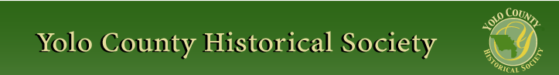

February 2012

PRESIDENT’S MESSAGE

First let me invite any member of the Society to step forward and volunteer to be a board member. While we have an active Board, there are still plans to be made for future programs, trips, fundraising events, etc. that you could be a part of. We meet the 2nd Monday of the month alternating between Davis and Woodland. If you would like more information and I hope you will consider being a part of this active group, give me a call.

One of our pledges as a Board is to reach out to other historical groups in Yolo County. Our newsletter now contains information from around the County. It is our hope that you will take time to read the newsletter in its entirety to keep abreast of all the activities focused on the history of the County.

Peace,
BJ Ford, President
530-662-0952

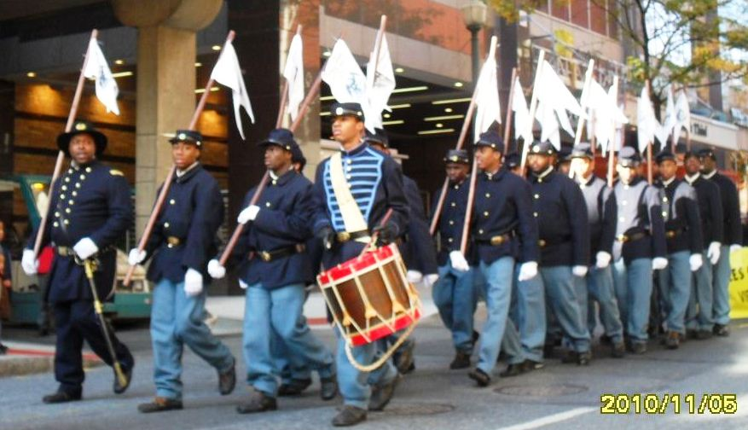

SUSQECENTENNIAL CELEBRATION OF THE USCT
1861 – 1865
The USCT, or United States Colored Troops, began the 150th year celebration of its forming, in Harrisburg PA, November 2010. Harrisburg, the state capitol, would again be the site of the Grand Review. More than 200,000 African American soldiers and sailors were members of this organization. When the call was made by President Lincoln, in 1862, to allow African Americans to enlist in the military, it was prior to the signing of the Emancipation Proclamation. What most people do not realize is that African Americans were members of the military prior to the forming of the USCT. At the close of the War of the Rebellion, there was a Grand Review held
in the nation’s capital, Washington, D. C., to welcome home the survivors and have a celebratory parade in their honor.

Conspicuously absent were the veterans who served with the USCT. When this slight was noticed, members of the ERL, the Equal Rights League, sent out a call to all who had served during the Civil War to notify them that they would be honored at a parade in Harrisburg PA from Nov. 14 – 15, 1865.

On Sunday, February 26th, a presentation will be given by, Jeannette L. Molson, one of the participants in the PA Grand Review that was held in Harrisburg November 4 – 7, 2010. Her great great grandfather, Samuel D. Molson,

was on the organizing committee that arranged
the original celebration in 1865.

The Yolo County Historical Society’s February General Monthly meeting will be a joint program with the West Sacramento Historical Society. The meeting begins at 2 p.m. and will be held at River Bend Manor 644 Cummins Way, West Sacramento, Ca.

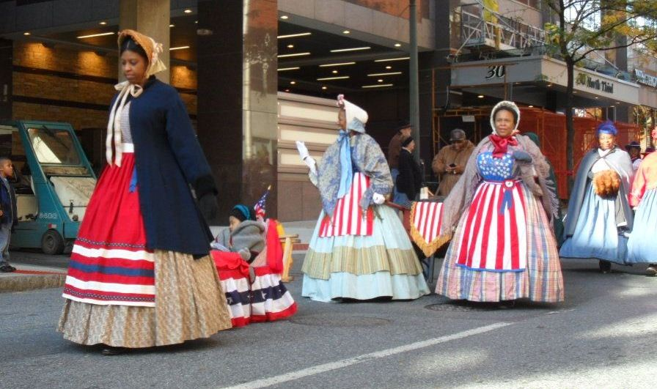
~

NEWSLETTER ARTICLES DEADLINE: Articles for the newsletter will be accepted until the 20th of each month. Please either email B J Ford at: bjford@pacbell.net or mail to the YCHS at P.O. Box 1447 Woodland, CA 95776

HATTIE HAPPENINGS

Visitor counts for 2011 show a record number of almost 2700 visitors.

The Museum mounted an exhibit honoring Martin Luther King, Jr. and the area Freedom Riders who travelled from Davis to Selma to join the marchers in 1965 with an exhibit on January 15.

On January 21, the Museum opened “1930’s Davis” featuring news articles from the Davis Enterprise and artifacts from the era. The articles, collected by Merrily Dupree, feature

accounts of challenges and progress in the community during the decade of the Great Depression. Included in the artifacts part of the exhibit are a collection of depression glass, Japanese china, a wool bathing suit, a smoking jacket made of patchwork, sheet music, a vintage radio and books by Hemmingway,
Steinbeck, Faulkner, Porter and others. Kitchen
tools of the era are also featured.

Also on January 21, the Museum hosted a book signing by Robin Datel, Dennis Dingemans and
Thomas Krabacher for their new Arcadia book, Woodland. The book was well received.

As of this writing, the volunteers at the Hattie are planning a celebration of Jim Becket’s 83rd birthday and his decision to become Director Emeritus. The event is scheduled for Saturday, February 4 at 2 pm. The public is invited. The Putah Creek Crawdads will provide entertainment, honors will be bestowed and refreshments will be served.

Jim’s “team” will remain intact. Dennis Dingemans will become Director, Adrain Gabriel will become Assistant Director, Roberta Stevenson will continue as Senior Docent, Stella Dinger will continue as Collections Manager, Mary Lee Thomson will continue as Exhibit Coordinator, Merrily Dupree will continue as researcher/docent, Mary Ann Harrison will continue as Special Events Director, Margaret Hill will continue as Special Events Assistant and Gerri Adler will continue as History Tour Guide. Jim will, he promises, continue to be a presence at the Museum.

The Hattie Weber Museum, located at 445 C Street, Davis, Ca. is open to the public on
Mondays & Wednesdays from 10:00 a.m. to 4:00 p.m.

YOLO COUNTY ARCHIVES
Highlights of the “Silberstein-Cook” Collection
By: Analu Kameeiamoku Josephides, MLISc

In 2007, the Yolo County Archives received a collection of records compiled by August G.
Silberstein from the Veteran’s Service
Office. Silberstein was honorably discharged from the Navy in 1900 and began placing war department headstones on fallen soldier’s
graves. This work led him to research and compile information on each veteran buried in Yolo County

The Silberstein-Cook collection contains various types of records including biographical information of veterans residing in Yolo County, information on the Yolo County Fire Department inclusive with the Sacramento Fire Department, the history of Yolo County, information on the United States military conflicts that include the Indian Wars, Civil War, Mexican-American War, Spanish-American War, and other wars such as the World War I and II. This collection also includes information about the Freemasonry in the United States.

The Silberstein Collection is divided into eleven series or file groups of records with related materials.
Researchers will discover lots of genealogical information on the various veterans listed e.g. parentage, spouse, children, birth dates and death dates, and often the location of veteran’s family origin. Researchers should also note
that any genealogical information found within the Silberstein-Cook collection are secondary
and not primary records - dates, names, and other information found should be verified with and or against primary sources such as official birth, marriage, and death documents.

The public is invited to visit the Yolo County Archives. Research hours are Tuesday from 9am to 1pm and Thursday from 12pm to 4pm. Please contact the Archives at 530-666-8010 or e mail archives@yolocounty.org to
schedule an appointment. The Yolo County Archives is located at 226 Buckeye Street, Woodland, California 95695.

YOLO COUNTY HISTORICAL SOCIETY
BOARD OF DIRECTORS
President B. J. Ford 662-0952
Vice Pres Jeannette Molson 666-7103
Secretary Bob Sommer 756-7553
Treasurer Reva Barzo 867-5800 Directors
Mary Aulman 666-0743
Kathy Harryman 662-2189
Dianne Barsotti 661-1179 Roberta Stevenson 753-5791
Jim Becket 756-1418
Beth Wettergreen 207- 9403
Dennis Dingemans 753-5959
~

There are a number of Society publications available for sale at a variety of locations. For more information on book sales, contact Mary Aulman at 666-0743
~

Searching for a past article from our newsletter? Go to Yolo County Historical Society web address: http://ychs.org/

Yolo County Historical Society
P.O. Box 1447
Woodland, CA 95776

Address Service Requested

Dated Material

INVITE A FRIEND TO JOIN
Membership in the Yolo County Historical Society is open to all who wish to join in supporting the research, preservation and designation of the county historical resources, maintaining the Springlake Schoolhouse Museum on the Fairgrounds, and publishing mini-histories of Yolo County communities. Please make check payable to Yolo County Historical Society.

Individual $20 NAME _________________________________
Family $25
Senior 65+ $15 ADDRESS ______________________________
Family 65+ $20
Business $50 CITY __________________ ZIP ____________
Patron $100
Life $300 TELEPHONE ___________________________

EMAIL _________________________________

Vision Statement The Yolo County Historical Society strives to preserve, protect and acknowledge the
diverse history of Yolo County through education, communication, and advocacy

