

DECEMBER 2013
PP 2012

Pres Says:

Christmas….such a magical time of the year…filled with memories and laced with dreams of ‘something better’. As we approach the holiday season there are many things for which I am thankful…family, friends, and health to name a few. This issue is devoted to the Christmas season. When I remember my Christmas holidays I remember going through the “Monkey” wards catalogue and circling items that we, my brother and I, wanted for Christmas. My brother would circle in one color and I would circle in another color. It was our “wish” book filled with hundreds of items that we knew we just couldn’t live without. Did we get them all? No, we didn’t, but we knew that we could try again next year! And we did!

I thought it would be fun to see what Christmas was like around the turn of the century. The following information and ads was taken from The Woodland Daily Democrat, December 12, 1900 and December 24, 1909. The information was taken verbatim from the newspaper.

Under “LOCAL ITEMS BRIEFLY TOLD” or Items of More or Less Importance Picked Up Here and There on the Wing

The Woodland Orchestra went to Williams today to furnish music for a ball. (1909)

The cheerful greeting in Huston Bros.’ advertising space will put you in the proper holiday mood. (1909)

A marriage license was issued today to Harry Walker Keith and Miss Henrietta Moore, popular young residents of Knights Landing, who will be married in this city on Christmas morning. (1909)
The sun made an ineffectual effort to break through the clouds this morning. Better luck next time.

And in the FIFTY-CENT COLUMN where 50 cents could buy you advertising space for one week providing you did not exceed 5 lines…

The Capay Social Club will host a grand ball at Capay Hall on the evening, December 24th, after the Christmas tree has been held by the school. Admission to the dance, $1. All are invited to attend and enjoy a social evening.

Christmas Eve Dance – A Christmas Eve dance will be given in Knights Landing Friday evening December 24th. A fine supper will be served at W.A. Bridges’ restaurant. Good music by the Knights Landing orchestra of three pieces.

Send 10 cents for 10 beautiful Xmas or New Year post cards, assorted. Other grades from 5 cents to 75 cents each. No order less than 10 cents.

And what is happening in the local churches in the “Merry Christmas Observance” ?

At the German church Rev J.E. Mangold will preach a sermon Christmas morning at 11 o’clock. Sunday afternoon beginning at 2
O’clock the Christmas tree exercises will be
held. The church blinds will be closed and the interior brilliantly illuminated by electricity. The Christmas tree will be nicely decorated and loaded with beautiful presents. The Sunday school children will render songs and recitations, and the church choir will also render a number of selections.

Unitarian church, N.S.G.W. Hall, Edward G. Spencer, minister – Public worship at 11 a.m. Subject of sermon, “The Poetry of Christmas” All are cordially welcomed.

At the Second Baptist church there will be a Christmas tree and appropriate exercises this evening and Rev. E. E. Reed will preach at 11 o’clock on Christmas day.

And just a few tidbits of information that might be important…

Ladies, souvenirs tonight at the Elite Theater.

And what about advertising……..

There are only 6 more shopping days before Christmas at “The Hub” whose “ Holiday Goods are Beyond Comparison” (1909)

Toy Land is Open!
We shall see more children in this department today (we hope) than any time since dear old Santa’s last visit and they shall not be disappointed. If you want to be young again yourself, come and see their delight over the things which once –Oh dear! Not a word about your money. We are too sure of that to be at all anxious and hardly a word about the toys themselves.
Iron express wagons with steel wheels, sheet iron body, painted a brilliant red – The Rough Rider
Go carts, wooden wheels, strong basket woven seats, decorated with green Japan cane straw,
very substantial, 25 cents
No. 1221, Doll buggy, wooden wheels and axle, body made of woven Japan cane straw 25 cents.

People’s Trade Palace
TRADE MARK – GOOD GOODS (1900)

And they do have Special Diamond Rings at PRAET’S Jeweler for $20.00. Others up to $300.00. Phone 1372. (1909)

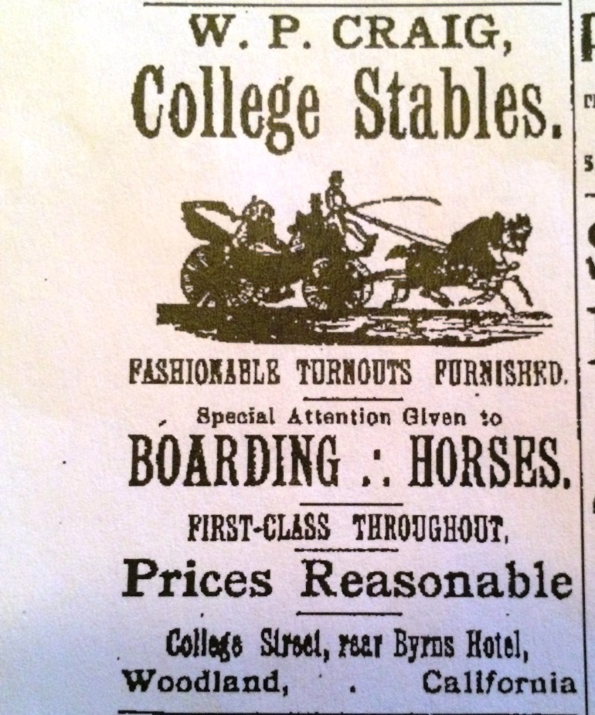

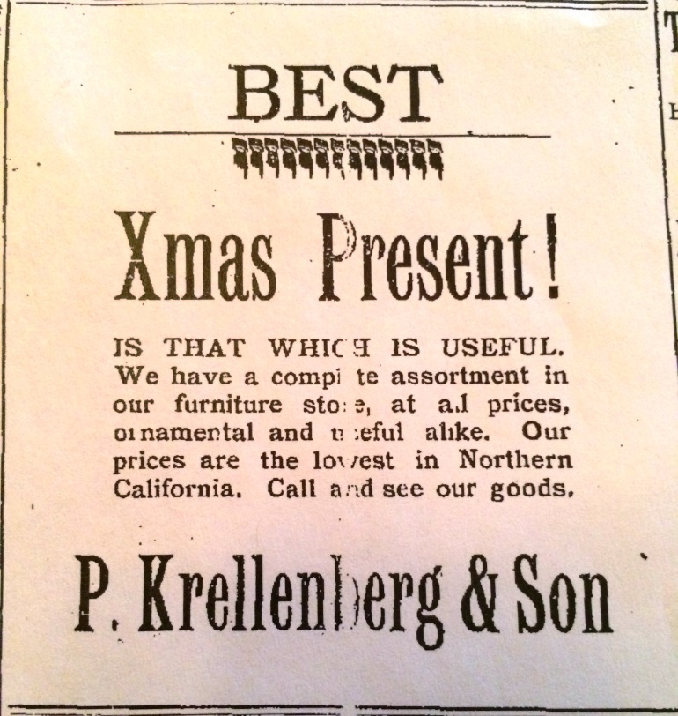

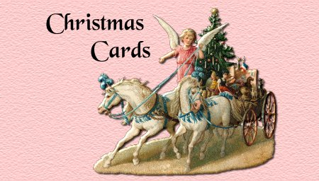

The very first Christmas card was printed in December 1843, at the request of Sir Henry Cole, who was also the instigator of the Great Exhibition of 1851 and founder and first director of the Victoria and Albert Museum in London. Indeed, he was responsible for the whole idea of sending Christmas cards through the post when he decided to surprise his friends with a novel and colorful card at Christmas time instead of the usual Christmas letter. It was designed as a way to offer seasonal greetings without having to write out hundreds of personal messages.

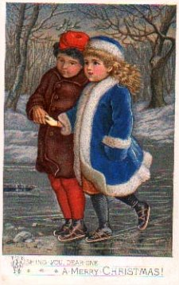

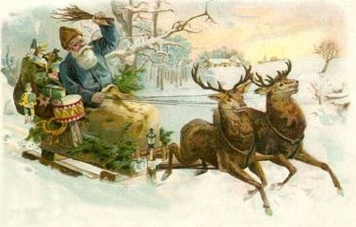

The Christmas season is a wonderful time of the year. All of your Board at the Yolo County Historical Society wish you and yours a Merry Christmas and a Happy New Year.

Remember…..

History Rules!!
Kathy Harryman, President

❖

Hattie Happenings
By MaryLee Thomson

The Hattie Weber Museum of Davis got an early Christmas present this year thanks to the generosity of Carole and Jan Brewer who donated a large collection of photographs, documents and artifacts from the pioneer Schmeiser family.

Gottfried Schmeiser married Sophia Oeste in November 1868; they moved to a ranch about five miles west of present day Davis a few days later. Gottfried and Sophia had a rocky start
when they discovered they did not have clear
title to the land and that “land grabbers” were trying to run them out and take over. Ultimately they prevailed and became quite prosperous. Eight children were born to the couple. Most of the items in the Schmeiser collection relate to two of them: Pauline and Elmine.

The gem of the collection is already on display at the Museum, although it will be a few weeks

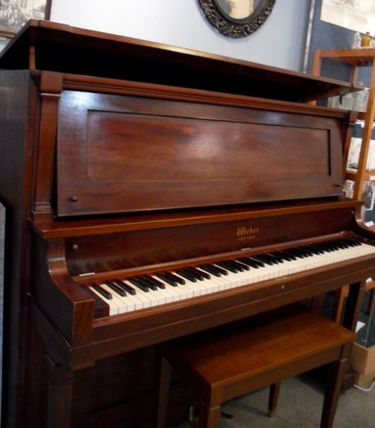

before it is fully functional. It is a Weber modified upright piano manufactured in
Rochester, New York in 1908 which was probably shipped around the horn of South America to the distribution firm of Kohler and Chase in San Francisco. It is a handsome piece in excellent condition but it needs time to acclimate to its new location before it can be tuned.

The piano should be tuned in time for Christmas, when the Museum will celebrate with a tribute to a Davisville celebration in 1898 with a tree and “goodie bags” for children. The bags are reminiscent of those containing fruit,
nuts and candy distributed to the 200 children
living in town that year and are distributed to young visitors to the Museum in December at no charge.

Also in December, the Museum will open the “Purple Circle” exhibit celebrating the era from the 19teens to 1960s when the area around Davis was famous for Grand Champion Live
Stock from prestigious shows around the country. Purple is the color of the Grand Champion award ribbons. Purple ribbons, as
well as blue First Place and red Second Place ones won by the Rowe family’s Innisfail herd were sewn into a coverlet by a family friend in the 1920s. The coverlet is part of the exhibit, as are pictures of local Grand Champion cattle and sheep from the Davis area shown at the Chicago International Live Stock Exposition and a map showing the names and locations of Purple Circle Society members.
The Museum is located at 445 C Street in Davis and is open from 10am to 4pm on Wednesdays and Saturdays. Members are especially welcome. Don’t forget to bring a kid!

Museum Annex Decision Time – Save the Date

Davis City staff now predicts that the issue of retaining the WPA building in Central Park for a Hattie Weber Museum annex will come back before the City Council at its Tuesday, December 10th meeting. This may be a more accurate prediction than previous ones; we know the bids for Central Park improvements were received by the City on Nov. 22. The “add on” proposal for demolishing the building and building a “history plaza” concrete slab with a crude contemporary map of Davis outlined in color was bid at $77,000. Staff has yet to submit a report as to what would be involved in retaining the building, as directed by Council in May of 2012.

Museum volunteers would like to see as many supporters of the Annex Proposal as possible attend the meeting. Those with Hattie tee shirts should wear them and we will have buttons showing the WPA building and the Museum building together to distribute. There are a few tee shirts available for sale at the Museum.
Since this is about the sixth time we have been informed that the issue will be on the agenda and it hasn’t happened yet, it would be a good idea to check the City Council agenda on the
City Council of Davis website a few days ahead. The staff report (if any) should be available on the website by December 5th.

❖

The Christmas Wish
By Kathryn Heinson

Christmas, that wondrous time or children, the time of magical thinking was enshrined in my imagination. Fulfilling the daydream was longed for every year. It would be a time with a giant tree, sparkling in lighted glory, packages arrayed under its branches and, best of all, a houseful of laughing, joyous children and parents. The doorbell would ring and more friends would drop in, welcomed by this happy family. That was the fantasy; that was what I imagined was happening in homes elsewhere. I was an only child and as a child of the Great Depression my reality was a small tree atop a table and under it a few presents, most homemade, and a mother and father, just we three. Influenced by the stories I read from Dickens to Anderson, the Christmas dream, my perfect Christmas, was not accomplished for many years.

But, dreams sometimes do come true, and not in the ways we envision. In 1963 our family of seven moved to Woodland. We needed a house big enough for three generations-two parents, four children and a grandmother. Two months later, we celebrated Christmas in our new home. We were the “new kids” on the block, surrounded by neighbors who were established, longtime residents. Our next door neighbor, Mary Porter, and her two aunts, Myrtle and Gertrude Gable, welcomed us and our children – especially our children, and even more especially our four year old daughter. We knew no-one in town and those three ladies became Woodland’s friendly ambassadors. The bond which took place between our daughter and Gertrude was like that of grandmother and granddaughter. Shortly after moving in, Cheryl ran in the house asking if she could go downtown with Aunt Gertle. Combining
Myrtle and Gertrude into one name was amusing and later, when we felt more comfortable we told ‘Aunt Gertle’ and she
adopted that name for the rest of her life.
I was surprised the following year to discover that the three ladies were not planning to be any place for Christmas day, but next door. With some trepidation I asked if they would like to join us for Christmas breakfast. They said they would be glad to come. We got a call on Christmas morning asking if our son and his dad could help them come from next door. When they arrived, the male contingent was laden with shopping bags of brightly wrapped gifts, so much that I was taken aback. This started our celebrating holidays, birthdays, and always Christmas. Even though on every occasion I asked, in deed pleaded, that they come sans gifts, it was in vain. Every Christmas morning, in their remaining years, we gathered around our dining room table and afterward at the tree for the gift time.

It was as if the Christmas spirit arranged fairy godmothers for us, and our family filled their lives too. Fifty years later, those times, when the house was filled with the beauty of the season, a giant tree, happy children, adoring adults, and visits from friends, I look back, knowing that my Christmas wish did come true, that my family of birth and my family of choice merged into a family of love.

❖

Plaque Presentation

Many thanks to the Yolo County Archives for the presentation of a plaque for the Society’s Golden Anniversary. The plaque reads:
In recognition of exemplary service to the citizens of Yolo County for half a century, we, the Directors of the Friends of the Yolo County Archives, do hereby acknowledge and commend the Yolo County Historical Society and Its Membership on this occasion of their Golden Anniversary for not only preserving the
history of Yolo County but also for dedicating their time, their energy, and their funds in sharing that history with their fellow citizens.”
Conferred by a unanimous vote of the Board of Directors Friends of the Yolo County Archives on the first of August 2013.

This plaque is recognition of all that each of us does for the Society. It will be hung at the Spring Lake Schoolhouse. You can see it during the Fair.

❖

The Danish Cookie Grinder
By Marge Hansen

Christmas is coming – time to get out the Danish cookie grinder. The red cast-iron grinder lined with porcelain is at least one-hundred years old. It was brought to America in 1913 when my late husband’s parents Jens and Katherine Hansen emigrated from Denmark with their six-month old daughter Carla, now my one-hundred year old sister-in-law. Perhaps the cookie grinder is more than one-hundred. I never thought to ask my mother-in-law.
How many cookies has the old grinder turned out? It’s hard to say, but in a century it has to be hundreds of thousands….a million? The old recipe calls for eight cups of flour, a pound of margarine (butter was dear and saved for export), three eggs, 1/3 cup of canned milk and 1 ½ teaspoons of vanilla. (We add a little almond extract.) After mixing and chilling, the dough is formed into balls the size of grapefruit to push through the grinder. Then the fun begins. There are different templates for the grinder. My favorite is a flat one with ridges which produces endless strips right onto the cookie sheet. All one has to do is score them so they break apart easily after baking. Fast. The other template makes a ridged strand which can be cut in different lengths to shape into holiday designs. More creative and more work.
My mother-in-law Katherine was the only person I’ve known who could make Danish
cookies single-handedly and besides that, she had to bake them in a wood stove when I first knew her. It’s hard to press down on the dough, turn the handle and run the cookie dough out on the sheet by yourself. Much better for one person to push down on the dough (watch your fingers!) and turn the handle. Another guides the dough onto the cookie sheet, and hopefully there’s another person to watch the oven.
Katherine, widowed young was a frugal person, to protect her Christmas cookies from being devoured quickly by her five children, stored a good supply away out of their reach. She forgot about one big cracker tin full of cookies. It was discovered the next July. I remember the day it was discovered. The cookies were still delicious! What a treat in July!
In early years I mailed the grinder to my sister-in-law in Berkeley, Charlie’s younger brother and his family would come for a cookie bake. Then those of the family near Live Oak would take our turns. Finally other grinders were ordered from Denmark, but they’re mundane gray steel like our meat grinders, not red with porcelain lining. It’s rather puzzling that the old grinder has “Amerikan System” in raised letter on one side.

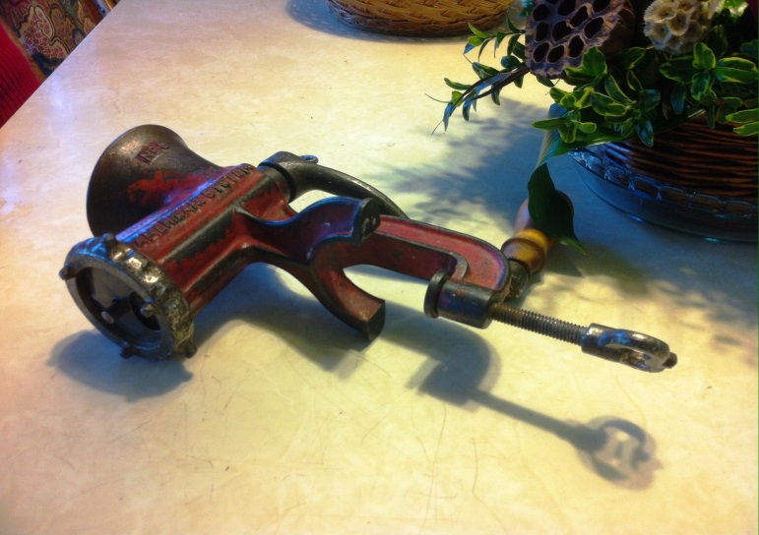

Countless numbers of relatives, friends, neighbors and their children have helped with cranking the grinder, shaping the dough, sometimes eating quite large amounts of it. Most kids insist on spelling out their names in dough, often forgetting to do so in cursive. The
first year Chris left the Bay Area for New York, Carolyn constructed an exact replica of San Francisco’s City Hall in cookie dough for him, and it arrived intact, amazingly. I hope my great grandchildren will be coming to help before long, and I have a new neighbor who is part Danish to share the production.
Feeling its age, no doubt, a few years ago the poor old grinder began to have trouble turning out the perfect strand of dough. Another pesky strand would ooze out where it shouldn’t, causing consternation among the bakers. I took the template to a machine shop, but they really didn’t help it much. Next, David’s friend spent hours repairing the template. It’s better now and we just put up with the “oozing”, poor old thing. On to the next century of the Danish cookie grinder’s holiday service!

❖

CHRISTMAS GIFTS!!!

If you are buying gifts for someone who has everything, then you might want to consider giving a gift that lasts forever. We have many history books that are for sale. They make a great gift for someone who is new to Yolo County, someone who has returned to the county, or someone that you might want to say ‘Than kYou”. The prices range from $15.00-$25.00. We have books for all of the major towns in the county. If you are interested in purchasing books for gifts, please give Mary Aulman a call. 666-0743

❖

Our members are enjoying reading stories that have been submitted these past few months – SO….If you have a story you would like to share that relates to Yolo County, send it to rbarzo@yahoo.com we can include it as space is available. Photos are also encouraged!

Patrons
Thanks to the following for generously supporting the Society for 2013-2014. You too can be a Patron by donating $100.00 to help us run our projects

- John and Helen Daniels
- John and Kathy Harryman
- Pamela Pearl
- Virginia
Schwarzgruber
- Stella Dinger
- Robert and Lynn Campbell
- Leroy & BJ Ford
- Jon & Barbara Durst
- Dennis Dingemans & Robin Datel
- Jeff & Starr Barrow
- Donald & Pat
Campbell
- Albert & Lynn Plocher

Yolo County Historical Society
P O Box 1447
Woodland, CA 95776

Address Service Requested

Dated Material

Vision Statement The Yolo County Historical Society strives to preserve, protect and acknowledge
the diverse history of Yolo County through education, communication and advocacy

