

NOVEMBRER 2014
PP 2012

Pres Says:

Thanks to all of you who have rejoined. We now have approximately 160 members. That is terrific. If you know of anyone who would appreciate our newsletter and be part of a dynamic group, please let me know. I will send them an application.

This is a quiet time for the Society. The 3rd grade program at the Spring Lake Schoolhouse has finished. It will begin again in the spring. We have new teachers who will join the school marms. So we are in good shape.

We have started the lecture series and thanks to Bob Dunn, we had a great presentation at St. Luke’s Church. We now know all about the Tiffany stained glass windows. Wow! We are so lucky.

On a sad note, we are saddened at the loss of Ann Scheuring, a member and a great historian. She will be missed. Remember, History Rules!

Kathy Harryman

❖

Business Buddies

The following businesses in town have financially supported the Yolo County Historical Society. We would like you to support them and keep your money local:

L & S Printers, Main St.
The House Dresser, Main St.
The Gifted Penguin, Main St.
Corner Drug, Main St.
Dennis Dahlin
Zamora Hills Ranch
Richard Berteaux

Historic Woodland Downtown
Business Association
The Home Improvement Group

If you know of any business that would like to join our support list, contact me. Businesses pay $50.00 per year for advertising.

❖
Hattie Happenings: Ups and Downs
Unexpected but very welcome progress was made late last August on the WPA Museum Annex. The City had agreed to the removal of the ugly gray shade structure from the front and side of the building and lo and behold, it happened! It was expensive ($5300 from our Annex Fund) but the building looks so much more attractive.
On the downside, we have still not been able to meet with City staff to discuss the architect selection process. We have not yet had an architect plan proposal acceptable to both us and the City. But we’re not giving up! This month we’re going back to the Davis Historical Resources Management Committee with a slightly different proposal we hope they will endorse and get us back in front of the City Council. Fingers crossed.
After a long delay due to the construction of the new playground in Central Park, we were able to dedicate the 2014 bricks in the Hattie Weber Rose Garden on September 6th. Director Dingemans and Assistant Director Gabriel presided over a ceremony which included tributes to those honored on the bricks by the brick donors. The heartwarming comments were followed by a reception in the Museum where a special exhibit honored mothers, grandmothers and other exceptional women remembered on the bricks.
As the school year began, we invited Davis third grade teachers to bring their classes to tour the Museum to enrich social studies lessons on our community. We are also happy to provide Museum tours to scouts, seniors and other groups on Wednesdays. Pease feel free to contact Dennis Dingemans or Mary Lee Thomson at the Museum (530-758-5637) to arrange a tour. Of course individual Society members are welcome to visit us any Wednesday or Saturday between 10am and 4pm.
❖

Spotlighting ……..Knights Landing

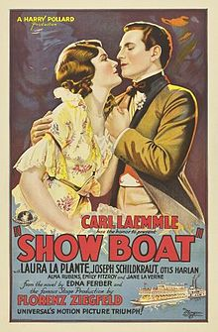
This year, I would like to highlight in each of our newsletters the communities that make up Yolo County. This article is from Knights Landing. It is entitled “Babe’s Roots”* and was written by Z. Maxine Bristow Freeman in 1989. The information is also found in the Knights Landing history book entitled Knights Landing, The River, The Land and The People by Shipley Walters and Tom Anderson.

In the summer of 1928, Knights Landing became the town of ‘Westport’ during the filming of ‘Showboat’. It stared the famous actress Laura LaPlante. Imagine that! What an exciting event.

When Show Boat was being filmed in Knights Landing, Dad sold the movie company the filigree mirror, the billiard table and many of the bottles and other items. (He refused to sell the bar.)

One little funny happened during that filming (that) I shall always remember.
After the older ones had gone to high school, and could not stay a few minutes in the pool hall (Bristow’s), Dad went to the butcher shop for our day’s meat. My duty was to preside while he was gone. This particular day, one of the big film moguls bounced in and grabbed Dad’s morning paper and headed out to the privy. I yelled to him “That’s this morning’s paper. He reached in his pocket and threw .10 cents up on the bar. When Dad came back, I gave him my tale of woe. Dad went out to the toilet and came back with the paper and said, It’s OK kid, he just used some of the advertising sheets.”

The filming of ‘Showboat’ had the whole town very excited. Almost everyone was hired as extras. I remember my job. In the morning I was to sit on the horse trough in front of the old Hershey Hotel. In the afternoon my job was to run down the bank to the river and wave to the boat’s arrival coming into the river bend. Harriet and Ramona, my sisters, of course being older than myself, had more lady-like costumes and more sedate acts. I thought they were two beautiful ladies. We were provided with a nice box lunch.
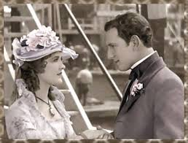

One thing that really fascinated me was the movie company washing down all the buildings on Front Street and putting a touch of paint or some

decorations to meet their needs. One addition the crew made to Dad’s place was a scalloped edging on the porch which covered the entrance to the pool hall. When the filming was completed and it was time for it to be removed, Dad told them to leave it, as he kind of liked the trim. I received $1.25 for my services, but Harriet and Ramona got $2.50. * *Thanks to Pat Campbell for finding this information.

❖

Dingle Elementary School History Club
By Rachael Zur

This year the Dingle Elementary History Club had the privilege of participating in the Yolo County Historical Society's Cemetery Tour. This is the third Cemetery Tour that Dingle Elementary has participated in, and students were very excited because this year they were given the opportunity to lead the tours! Not only was this a great source of pride for the students (and their parents), for the kids to have such a prominent role in the event, but through memorization, repetition, and teaching, it allowed the students to gain a deeper understanding of the History of the Yolo County Veterans by getting to hear all the information that was at each stop on the tour.
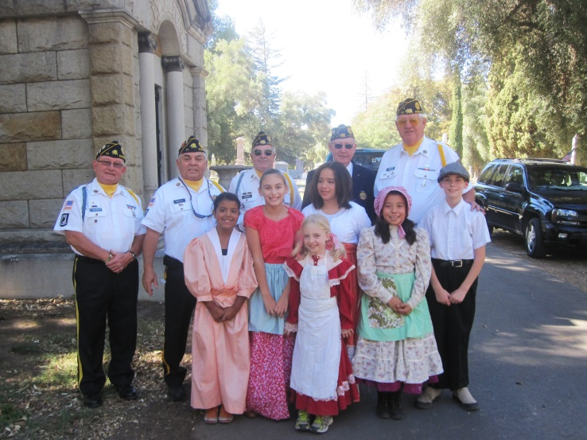

Last year, History Club students learned about several of the epidemics that affected Woodland’s and Yolo County’s population during the late 1800s and early 1900s. The information that they gained from last years event was often brought up by students in our History Club meetings through out the remainder of the school year. This year, with a focus on wartime in Woodland, History Club

students had the opportunity to learn about major historic wars, looking closely at how wars impacted

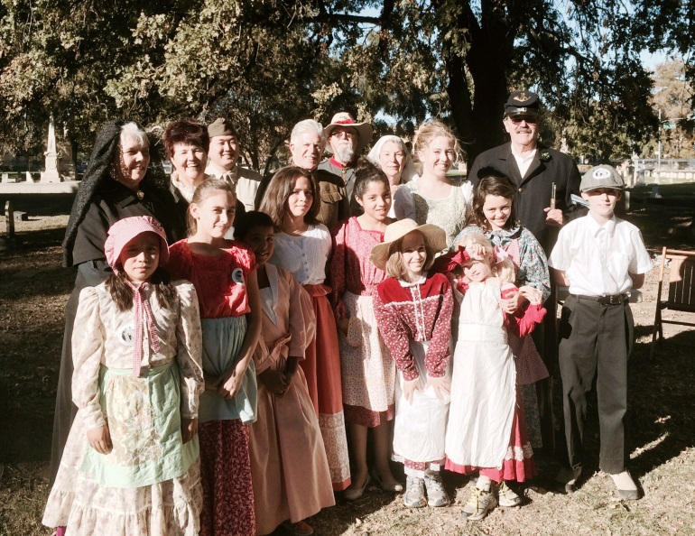

the lives of Woodland’s children. Students worked hard to prepare for the event, as they have in past years, but this shift from students being in a stationary position to leading the tours allowed the children to continue to learn at the event whereas in years past the majority of the educating was taking place before the event.

Cemetery Tour continues to provide an incredible opportunity for these students to gain breadth of knowledge about our town. I also believe that it provides them with a deeply-rooted interest in our community, which with continued nurturing will help them to develop into community-oriented adults who feel a strong desire to inquire and dig deeper into their community’s history. Participating History Club students worked hard to prepare their lines and practice reciting and leading tours. The knowledge that they gained through their preparation and participation in the event, combined with the feedback they received and day-of learning from other Cemetery Tour participants was not only a good history lesson for the students but a good life lesson as well. As adults we understand that no matter how well educated we are, there is always more that we can learn. Children don't often look at life this way; they often think that there is a point that a person gets to where they "know everything they need to know." For the students to come into the event feeling like they had a solid understanding about how different wars impacted Yolo County and the lives of children was great; but it was really

fantastic for them to see that there are even more stories about other lives impacted by these wars.

Learning about history is not about arriving at a destination of answers, but embarking on a life long journey of answering questions that lead to new questions and a very exciting adventure-- this was one of the many things that the students learned that day and perhaps the most important lesson of all.

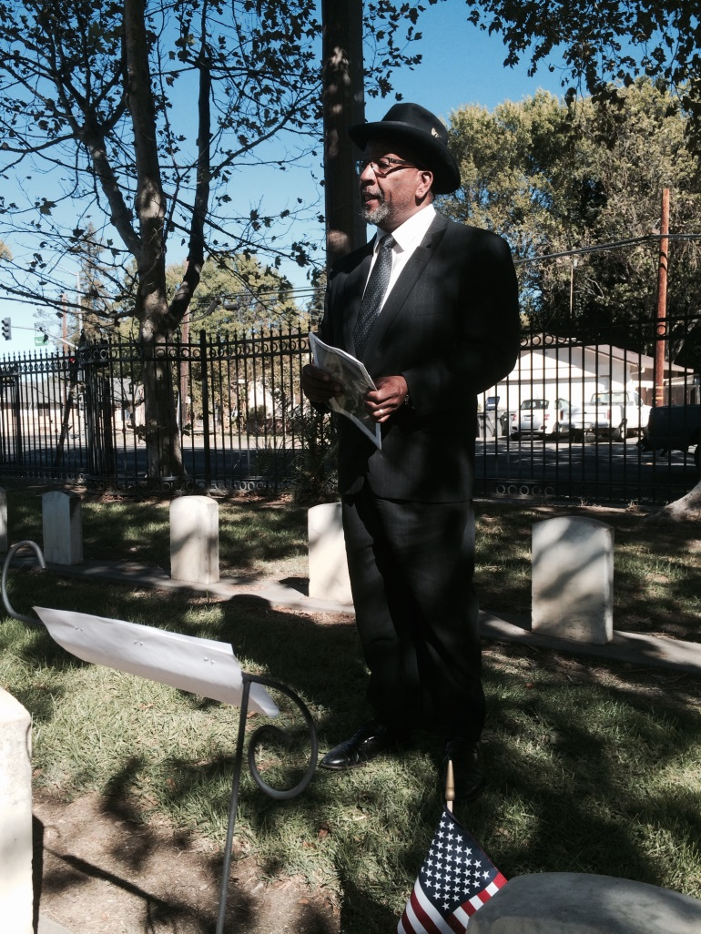

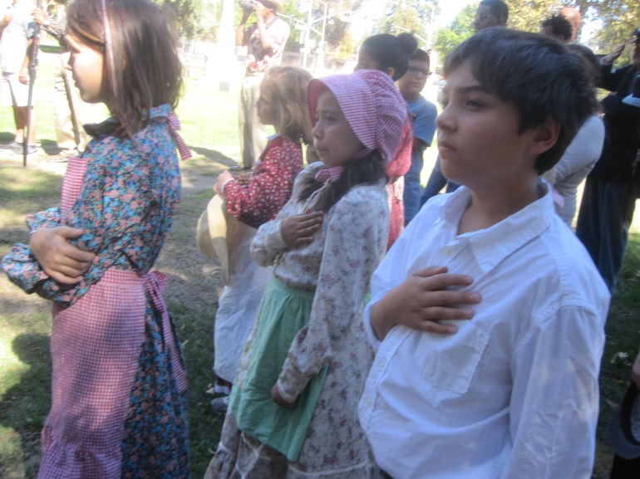

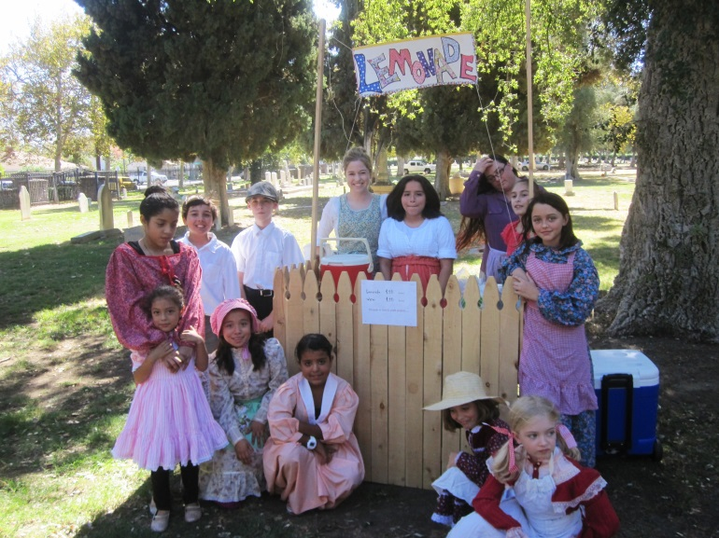

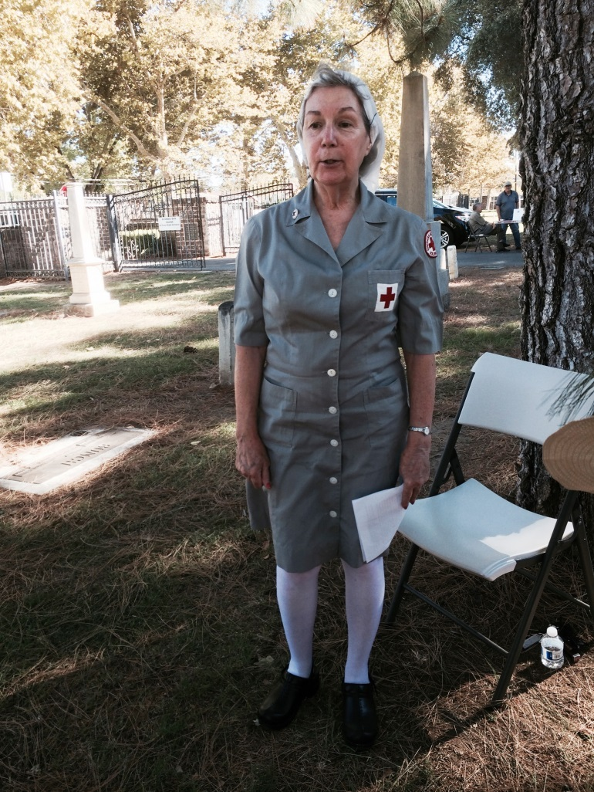

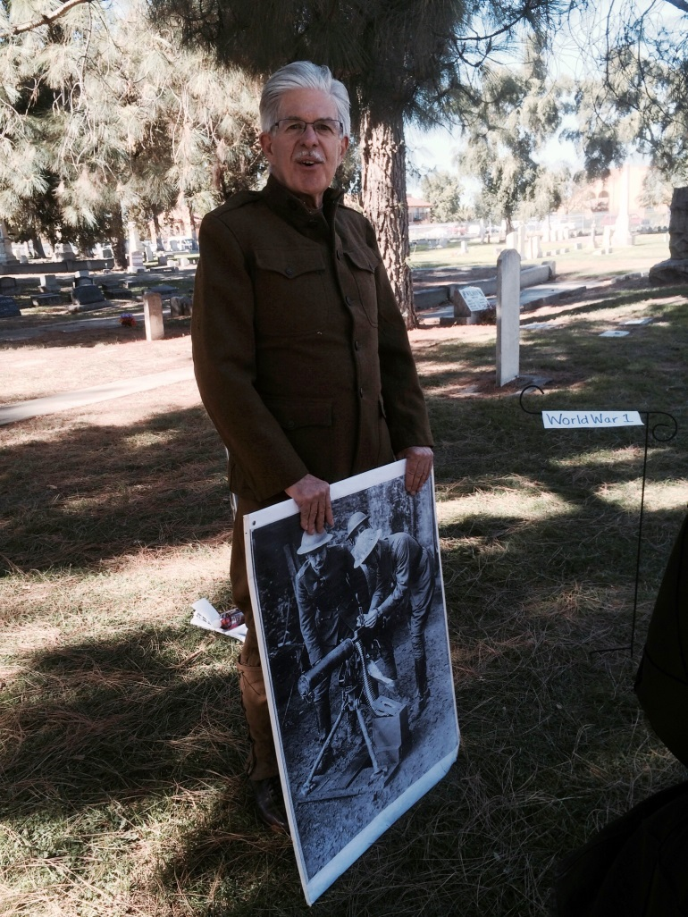

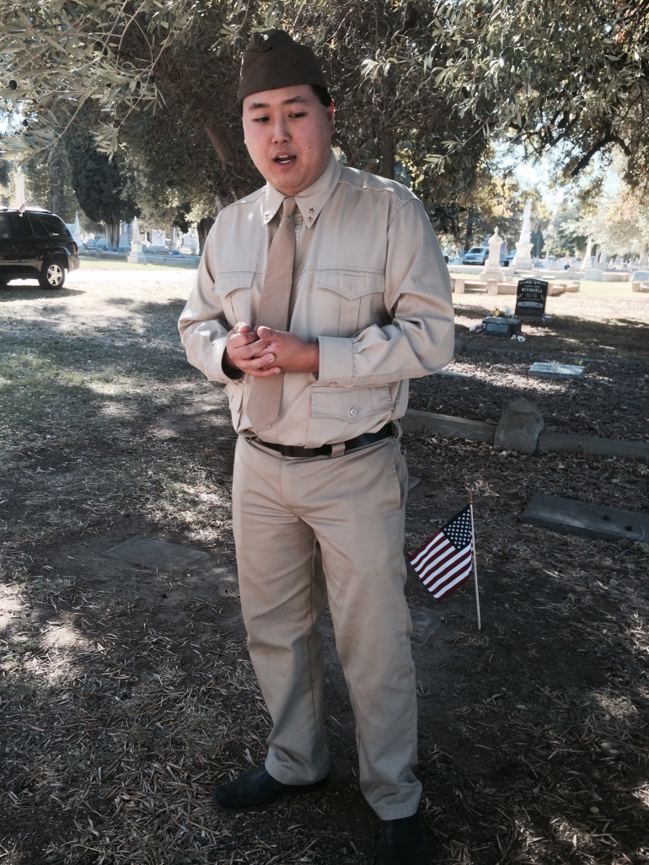

Thanks to the following for generously supporting the Society…………. You too can be a Patron by donating $100.00 to help us run our projects

2014-2015 Patrons

- Jeff & Starr Barrow
- Alice Wong & Ryan Baum
- Donald & Pat Campbell
- Michele Giguiere
- Bernard & Lynne Gough
- Betty Van Lew Haines
- John & Kathy Harryman
- Joan Hogan
- Jim & Donna Peoples
- Roger & Ann Romani
- Lon Springer
- Tom & Meg Stallard
- Valerie Vann
- Steve & Lydia Venables
- Marilyn Kregal
- Clair Childers
- Michael King
- Jeanie Sherwood
- Virginia Schwarzgruber
- Albert & Lynn Plocher
- Richard & Evelyne Rominger
- Robert & Judy Simas
- Richard & Joann Larkey
- Bobby Jo Ford
- Dennis Dingemans & Robin Datel
- Steve & Teri Laugenour
- Johnathan & Barbara Durst
UPCOMING LECTURE – save the date: November 23rd @ 2:00 PM, our own Dennis Dahlin will speak at the Davis Community Church at 412 C Street across from the Hatti Weber Museum. We will meet in the sanctuary where he will talk about four families in Davis who have had a profound impact on the community.

Yolo County Historical Society
P O Box 1447
Woodland, CA 95776

Address Service Requested

Dated Material

Vision Statement The Yolo County Historical Society strives to preserve, protect and acknowledge
the diverse history of Yolo County through education, communication and advocacy

