VISION STATEMENT
The Yolo County Historical Society
strives to preserve, protect, and
acknowledge the diverse history of
Yolo County through education,
communication and advocacy.

November 2005

”Those Wild and Lusty Gold Camps”

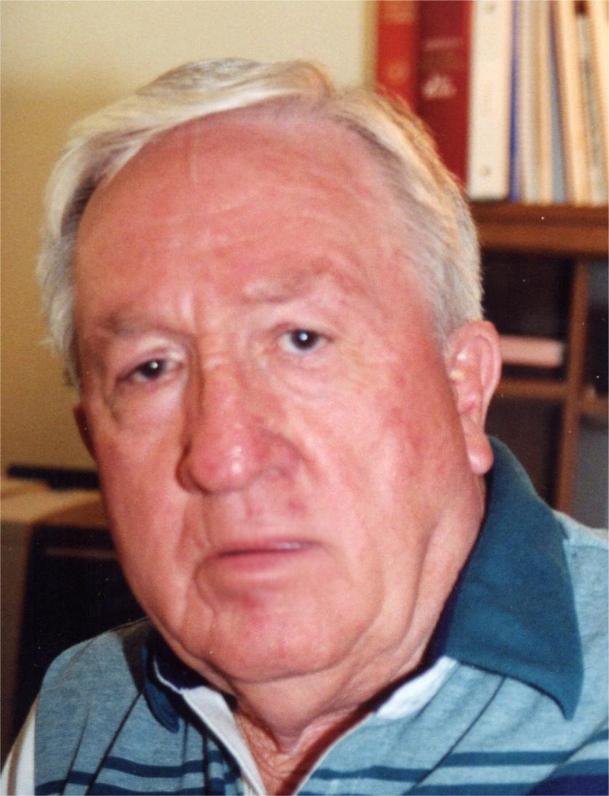

Alton Pryor, a writer for magazines, newspapers, and wire services for fifty years, will be presenting his program on the Gold Camps in California. He is the author of twelve books, some of which are titled, “Historic California, It’s Colorful Names and How It Got Them,” “Classic Tales in California History,” “California’s Hidden Gold,” “Outlaws and Gunslingers,” to name a few.

He began collecting both facts and ideas as he researched, and finally turned them into his first book, “Little Known Tales in California History.”

Alton is a graduate of California State Polytechnic University, San Luis Obispo, where he earned a Bachelor of Science degree in journalism.

This program will take place in the Blanchard Room at the Davis Branch of Yolo County Library, 315 E. 14th Street, Davis on Sunday, November 27th from 2 – 4 p.m. Parking is free. Refreshments will be available after the program.

