

OCTOBER 2014
PP 2012

Pres Says:

This is a special issue for all of us. We are honoring the recent awards that our members have received this past year, all relating to the preservation of history. It is always a great joy and a sign of the dedication to an ideal when an organization has members that represent the goals of our society. On behalf of all of you, I would like to thank you for being part of us. We are proud of you.

The Spring Lake Schoolhouse opened this past week to begin our fall season of 3rd grade visitations. Yes, the patter of little feet was heard in the school house once again. This year, the students had a small surprise. Thanks to The Church of Latter Day Saints, Camille Haley and the quilters in our area, we were able to provide the girls with aprons and the boys with kerchefs. We know that their experience will be enhanced when they ‘dress up’. Here is a picture showing the aprons.

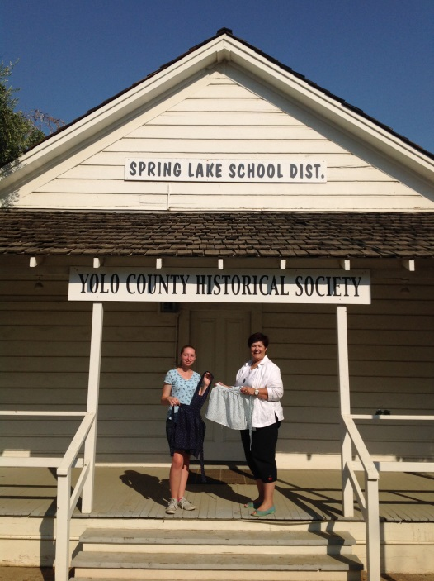

This month on October 7th, the Board are meeting at Home Improvements Group building at 440 Main Street in Woodland at 7:00 p.m. Everyone is welcome to attend. Come meet us! We really are nice people!

Remember,
History Rules!

Kathy Harryman

❖

Business Buddies

The following businesses in town have financially supported the Yolo County Historical Society. We would like you to support them and keep your money local:

L & S Printers, Main St.
The House Dresser, Main St.
The Gifted Penguin, Main St.
Corner Drug, Main St.
Dahlin & Essex, Inc., Davis
Zamora Hills Ranch
Richard Berteaux
Historic Woodland Downtown
Business Association

If you know of any business that would like to join our support list, contact me. Businesses pay $50.00 per year for advertising.

❖

Cemetery Tour to Honor Woodland’s Military Dead

Did you know that the Woodland Cemetery has graves of soldiers from the Mexican War in 1846 to the present day! What a remarkable place filled with men who lived history.

On Sunday, October 12, beginning at 1:00 P.M., the Yolo County Historical Society will hold its annual Cemetery Tour fundraiser with the focus on our military dead from 1846 to World War II. The Legion of Honor will begin the afternoon with a ceremony honoring these veterans.

Come and spend an afternoon learning about these remarkable men and women of our community. The cost is $10.00 per person, $2.00 for children under 12. The location is at the Woodland City Cemetery, corner of West and Cross Streets.

❖

Thanks to the following for generously supporting the Society…………. You too can be a Patron by donating $100.00 to help us run our projects

2014-2015 Patrons
- Jeff & Starr Barrow
- Alice Wong & Ryan Baum
- Donald & Pat Campbell
- Michele Giguiere
- Bernard & Lynne Gough
- Betty Van Lew Haines
- John & Kathy Harryman
- Joan Hogan
- Jim & Donna Peoples
- Roger & Ann Romani
- Lon Springer
- Tom & Meg Stallard
- Valerie Vann
- Steve & Lydia Venables
- Marilyn Kregal
- Clair Childers
- Michael King
- Jeanie Sherwood
- Virginia Schwarzgruber
- Albert & Lynn Plocher
- Richard & Evelyne Rominger
- Robert & Judy Simas
- Richard & Joann Larkey
Steve and Reva Barzo
Heritage Home Award Recipient
Hickey – Barzo 1927

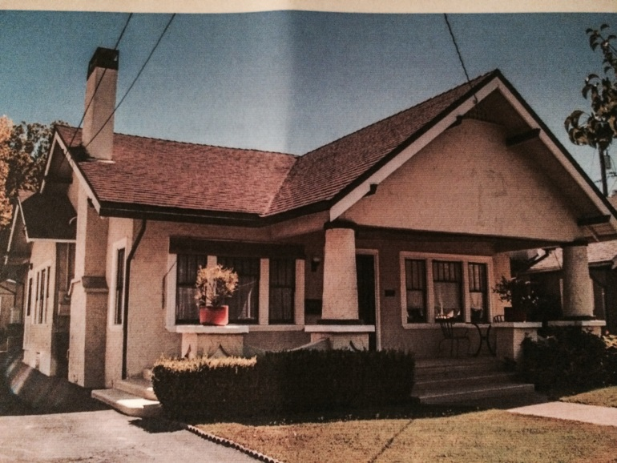

This Craftsman bungalow, built in 1927 for Joseph and Rowena Hickey, has been owned and cared for by Steve and Reva Barzo since 1995.
All the windows in the house are original. Most windows are double-hung, with geometric Craftsman detailing. The large front porch has a smooth concrete floor, travertine steps and impressive rounded columns that flare at the base. The rusticated stucco exterior was at one time painted dark gold and brown, earning the house the nickname of the “giraffe house”.
The large front door opens into the living room, in typical Craftsman style. The living room has its original brick fireplace and mantel.
The living and dining areas are dramatically separated by one of the home’s most noticeable features, a decorative archway of unpainted redwood. The arch spans the width of the room. On one side this strong Craftsman design element expands to a glass-front display case, and the opposite side features a built-in drop-leaf desk. Like the redwood arch, the other original woodwork in the house is unpainted.
The dining room has a beautiful built-in hutch with all original glass and hardware. The kitchen was expanded to include the back porch and a small addition for a relaxed sitting area that leads to the back yard. The kitchen cabinets and natural wood finish were selected to harmonize with the simple and warm style found throughout the home.
The picture railings original to the bedrooms were removed some time in the home’s history, and the Barzos have had custom milled railings made to replace them. The Douglas fir and pine wooden floors are original to each room, as is the seven-inch high floor molding.
The quality in craftsmanship, functionality in design, as well as the warm atmosphere created through the use of woodwork is what attracted the Barzos to this home. Twenty years later the original integrity remains, as these homeowners prefer preservation and restoration.

B J Ford
Historic Preservation Award Recipient

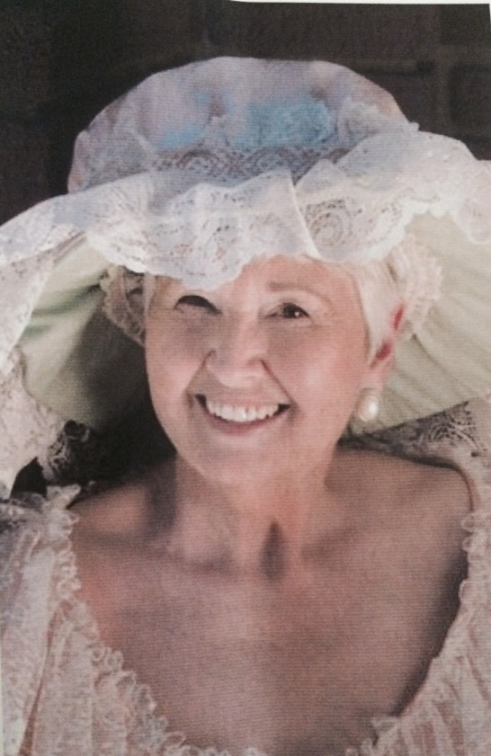

In recognition of her commitment to preserving and celebrating Woodland’s history and heritage, B. J. Ford has demonstrated a tireless commitment to historic preservation through her active participation as the Downtown Coordinator, Co-organizer of the first “Stroll Through History” and Stroll board member since its inception. Chairperson for the City Cemetery Fence fund-raiser, President of the Yolo County Historical Society, Chairperson of the Yolo County Women’s History Month and Vice-chairperson of the Historic Preservation Commission. Her name is synonymous with historic preservation throughout the Woodland community.

Tom and Meg Stallard
Historic Preservation Award Recipient

Since starting their first renovation project in 1981, Tom and Meg Stallard have devoted thousands of hours and substantial funds renovating buildings on Woodland’s Main Street. Working in conjunction with architect Duane Thompson, Tom did much of the labor himself, while Meg kept an eye on the finances. Starting with 712 Main Street, they went on to purchase and renovate 610, 612, 614, 616, 618, 620, 622, 626, 630, 706, 708, 710, 714, 716, 720, 722, 724, and 726 Main Street as well as 400 Second Street.
Interior details were kept or repaired when possible; when not they were recreated. Consistent standards, attention to detail, and preservation of good architecture are the hallmark of Tom and Meg’s work. Artifacts found during renovation are kept on display in several of the buildings and create a strong connection to the history of the spaces. This is reinforced by the use of historical photos in many of the common areas. Upgrades to modern HVAC, electrical and plumbing systems ensure that these buildings will be in use for many years to come.

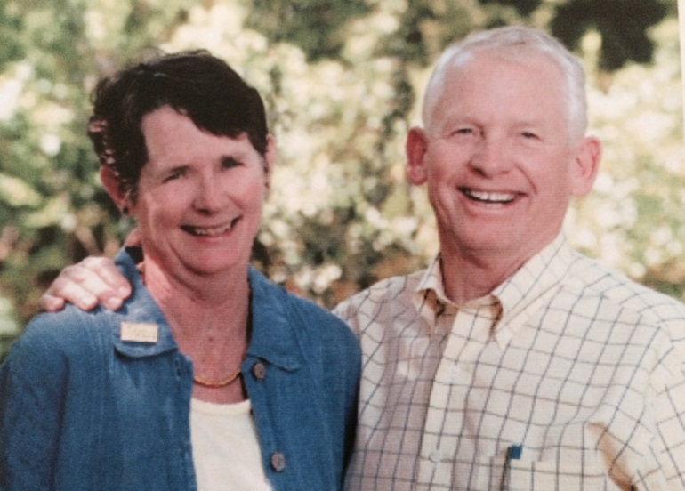

❖

Searching for a past article from our newsletter? Go to Yolo County Historical Society web address: http://ychs.org/

Yolo County Historical Society
P O Box 1447
Woodland, CA 95776

Address Service Requested

Dated Material

Vision Statement The Yolo County Historical Society strives to preserve, protect and acknowledge
the diverse history of Yolo County through education, communication and advocacy

