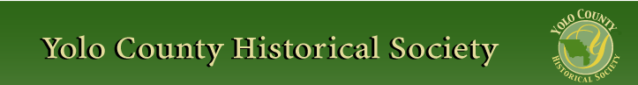

OCTOBER 2013
PP 2012

Pres Says:

Chris Dreith has done it again!! Yes, our very own member extraordinaire has created the scenes for our upcoming Cemetery Tour on Sunday, October 20 from 1-3:30 ish… It will be a real treat to meet Dr. Fred Fairchild, founder of the Woodland Clinic, “Babe” and “Doll”, two women who…you will have to come and visit to find out what they did, Kathleen O’Connell and Mary Gaddis, two nurses fresh from college in San Francisco, Mrs. T.B. Gibson, who lived at the Gibson Mansion on Gibson Road, and Mrs. Sarah Huston, who you have met before as a suffragette, and now will see another side of this remarkable women. You might even be able to purchase Dr. Goerss’s “Chaulmoogra, The East India Cure” that is guaranteed to cure all your woes! Chris has also thrown in a few zingers, as only our Chris can. In addition to all this you will learn about some of the epidemics that devastated the populations of this small town. And working with the Yolo County Health Department, they will have a table set up for giving flu shots. Flu shots are $10, but no one will be turned away for lack of funds. What a deal!!
Bring your friends and join us for an exciting stroll through the Woodland City Cemetery. Cost for this fundraiser is $10 per adult, $20 for family of 4, and $5 for child 10 & over.

On another note, our first community meeting will be held in Winters, on Tuesday, October 8, at 10:00. We will be at the Winters Library. Please come and join us. All are welcome.

Remember, History Rules!!
Kathy Harryman, President
YOLO COUNTY HISTORICAL SOCIETY
BOARD OF DIRECTORS 2013-2014
President Kathy Harryman 662-2189
Vice Pres Dennis Dingemans 753-5959
Secretary Bob Sommer 756-7553
Treasurer Reva Barzo 867-5800
Directors
Mary Aulman BJ Ford
Roberta Stevenson Enid Williams
Beth Wettergreen Joann Larkey
Jeannette Molson Al Plocher
Pat Campbell Dennis Dahlin

❖

Winters History Project

Learn how to preserve your family's old photographs and documents at a special workshop being planned by the Winters History Project Committee for Thursday, November 6 from 6-8 p.m. in the Community Room of the Winters Community Library, 708 Railroad Avenue. Current preservation techniques will be given by Meredith Sarmento,Yolo County's new Archivist.

❖

‘volunteer’ 133,000,000 in .34 seconds
First Installment
By Kathy Harryman & Reva Barzo
What a strange title! And what does it have to do with the word ‘volunteer’. When I Googled the word ‘volunteer’, there were 133,000,000 hits in .34 seconds. I was awestruck. I didn’t realize there was so much interest in ‘volunteers.’ Then I looked up the definition of volunteerism and again, was pleasantly surprised to discover that it not only means a person who performs a job willingly and without pay, in agriculture volunteer means something that comes up without being planted and finally volunteer means a native or inhabitant of Tennessee (the Volunteer State) There are a total of 13 definitions of that word and the word can be a noun, verb, and adjective.

When I think of volunteering, I think of passion. For me passion and volunteering are one and the same word. We volunteer because we are passionate about what we are doing. Passion gives us the impetus to make the world a better place for ourselves and the future generations. Passion is what has driven the American psyche since the first pilgrims landed on the North American continent. They left their homeland because they were passionate about the right to practice their religion of choice.

Volunteerism is what defines the American character. It is the story of American patriots who volunteered to fight and die for ideals that reflect our democracy; men who fought in the French and Indian Wars, the Revolutionary War, the Cherokee Wars, the Franco American Naval War, the Barbary Wars, the War of 1812, the Creek War, the War of Texas Independence, and the Mexican American War.

During World War I, the United States fought a war of ideas with unprecedented ingenuity and organization. President Woodrow Wilson established the Committee on Public Information (CPI) to manage news and solicit widespread support for the war at home and abroad. Under the energetic direction of Mississippi newspaper editor George Creel, who organized the “Four Minute Men,” a virtual army of volunteers gave brief speeches wherever they could get an audience—in movie theaters, churches, synagogues, labor unions, lodges, and grange halls. Creel claimed that his 75,000 amateur orators had delivered over 7.5 million speeches to more than 314 million people. They also recognized diverse audiences, with reports of Yiddish speakers in theaters and workplaces, a Sioux Four Minute Man, and a speech called “The Meaning of America” delivered in seven languages.

It's also the story of women who left their homes and marched for the right to vote, and for equal representation before the law. It’s the story of ordinary individuals who stood up, and sat in, and marched for justice for all. It's the story of people who rushed to the aid of flooded American cities and gave their money to countries hit by disasters. That's always been the story of this nation -- the story of those who stepped forward to serve, the ‘common man’ who helped their neighbors build a barn, the landowners who gave land to build schools and of people today, who give of themselves so that they could make their place a better place for their families and their communities. We are a nation of volunteers.

Volunteers are the glue that holds an organization together. Without volunteers, most organizations would not exist. Their dedication and work ethic hold an example FOR ALL.
I would like to acknowledge an individual who has certainly epitomized the above characterizes. She was born in 1918, and lives in Woodland. Although she was not a native of Yolo County, she has touched the area at various times during her early years. Miriam Miller’s first memories of Woodland start in 1922 when her brother was ill and her mother drove back and forth for 8 weeks between their home in Glenn County and Woodland Clinic to see Dr. Fairchild.
Her next memory of Woodland occurred when Miriam returned to Woodland and from 1940 to 1941 worked as a nurse at the Woodland Clinic located at Cross and Third Streets. At this time nurses were given room and board in two Victorian homes located next to the Clinic. One house was for the day shift, the second for night shift nurses. In addition to room and board, she earned $90 a month for a six day work week. Gibson Road was a dirt path and the mode of transportation was a bicycle. She married Richard Miller in 1942 and it wasn’t until 1974 that Marian returned to Woodland once more. Richard decided that he wanted a Victorian. As he said, “Historians like Victorians” and that precipitated the move to purchase their current home in Woodland in 1974. Miriam remembers that when they bought their home, Woodland pretty much ended at Gibson Road although plans were under way for the development south of Gibson. With these expansion efforts continuing by Stanley Davis Homes to develop this area, it was the Historical Society that talked the County into purchasing the Gibson family home along with two adjoining acres. These events lead to the creation of the Yolo County Historical Museum Association which focused on raising funds for the restoration of the home that we now know as the Gibson House Museum. Miriam was part of that group and continued to give her time to the museum until a few years ago.
Replacing her deceased husband as Treasurer of the Yolo County Historical Society in 1977, Miriam continued to work diligently for the Society. For many years she helped in running the famous Lemonade Stand that sold cupcakes and cookies at the Yolo County Fair as a way to raise funds for the organization. Through the Historical Society, Miriam has been part of the purchase, restoration and turning over of the Woodland Opera House to the State of California.
From 1978 through 1984, as a member of a five church coalition, Miriam opened her home to the relocation effort of refugees from Vietnam, Cambodia and Iran. Many of these refugees are still a part of her life.
Of her past years, Miriam says these efforts were never a burden but were fun years in her life. Quoting her, she says, “There are so many things to do – don’t just sit home and clean house!”
At 95 years of age, Miriam continues to volunteer. Every month she folds, stamps, seals, and sends out your newsletter. Thank you Miriam for all you have done and continue to do for this organization. We are the lucky ones!
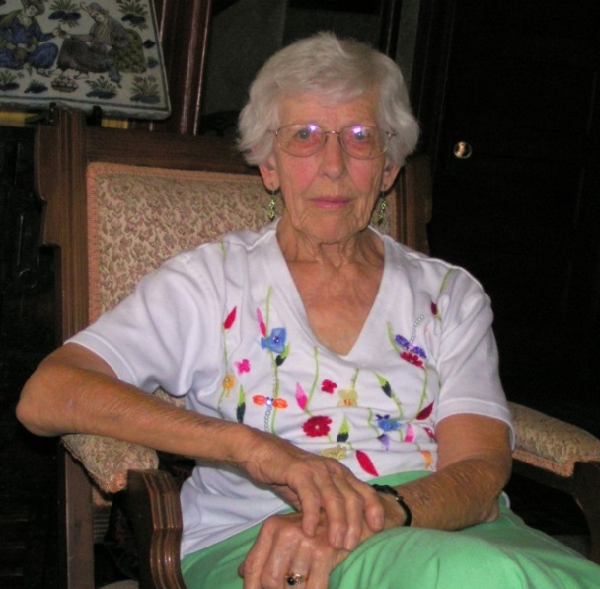
Miriam Miller

❖

Hattie Happenings

“The Purple Circle: A Previous Davis Identity”
By Dennis Dingemans and Kate Morss

What a different town we used to be.

Davis and its nearby farmers and ranchers once took such pride in raising high-quality cattle, sheep, horses, and pigs that Davis emerged as the heart of “The Purple Circle.” In fairs and other livestock-judging competitions, purple is the color of ribbons awarded for the very best – and our town brought home the purple.

The December Enterprise in 1916 used banner headlines to announce that Grand Champion ribbons had been won by Davisites at Chicago’s International Exposition, the premier event of the time. Two years later, winning a World War wouldn’t get much more front-page ink.

The 1916 winners were from the University Farm, and recognition of the Purple Circle pattern came from Gordon True in the Animal Husbandry Department. A service award in his name still is given each year to a DHS senior. True was vocal about the centrality of Davis in the state’s most significant concentration of prize-winning livestock, and he often used the “Purple Circle” phrase. Students at the college started the “Purple Circle Club.” A “Golden Hoof Club” on campus for 40 years staged a “Little International” version of the great Chicago competition.

The University’s herd won the state fair’s Grand Championship for the first time in 1916. Victories subsequently were achieved by local herds on all the major stages of livestock judging.

The Purple Circle was given wider recognition in the 1920s by Fred Shafer of the Woodland Chamber of Commerce and by the Yolo County Farm Bureau. They published a map called “The Purple Circle: Home of Superior Livestock” that listed 46 purebred herds within 10 miles of the Davis-to-Woodland axis. Closest to Davis were 12 herds -- owned by Schmeiser, Roby, Irwin, Pierce, Hopkins, Anderson, Davis Horse and Cattle Co., U.C., Swingle, Dolcini, Briggs, and Rowe.

An annual Purple Circle Dinner was launched to celebrate the winning results at competitions in Chicago, Portland, Lewiston, Los Angeles, and San Francisco as well as at fairs. Sacramento’s prestigious Senator Hotel hosted the first of these in 1925, and into the 1960s they were held in venues such as Sacramento’s elegant Elks Club Ballroom.

Two of the participants, and sometimes organizers of the banquets, were the Rowe brothers, Stuart and Charley. These Davis natives and DHS graduates reminisced with us last week about Davis as a livestock town. There was a small corral/stockyard downtown between 3rd and 4th Streets from which animals were shipped for sale and to fairs. They related the family legend of an infamous day in the 1910s when some bulls being shipped by their neighbors, the Hamels, got away and roamed downtown for hours. One woman, forced to take refuge in an outhouse, was not amused to be holed up by a herd.

The Rowe brothers and Val Dolcini told us how strong were their memories of the drives that sent herds of cattle, and sometimes sheep, through Davis on their way from seasonal pastures in the hills north of Winters to the Tule Wetlands east of Davis.

Especially impressive was the initiative shown by the Rowe Family – headed by John “Johnnie Shorthorn” Rowe – in attending county fairs to advertise their purebred “Innisfail Herd” Shorthorns and to win cash prizes. Stuart remembers that in the1940s he helped tend their cattle at 27 fairs in one year -- from which his family earned $25,000 in prizes. Especially rich county fair prizes during the 1930s, a state stimulus measure funded by increased horse racing, had helped the Rowe ranch survive the Great Depression.

Charles Rowe speculated that breeding fine animals was an important source of pride and prestige as well as income. The results of the Chicago Exposition were published in illustrated hardback books, several which are now family heirlooms. Purple Circle dinners are remembered more for their bragging opportunities than for their food.

Stuart Rowe said that he moved from Davis to Orland because “Orland today has a lot of similarities with Davis of the 1940s.” Charlie lives in rural Capay and helps care for a herd of prize-winning milk goats. Both brothers wryly observed that the ethos that brings PETA activists to Davis is strong. Despite a butcher, Cal Covell, serving 20 years on the City Council, Davis lacks a true steakhouse restaurant.

The Hattie Weber Museum exhibit on The Purple Circle opens next month at 445 C Street in Central Park.

❖

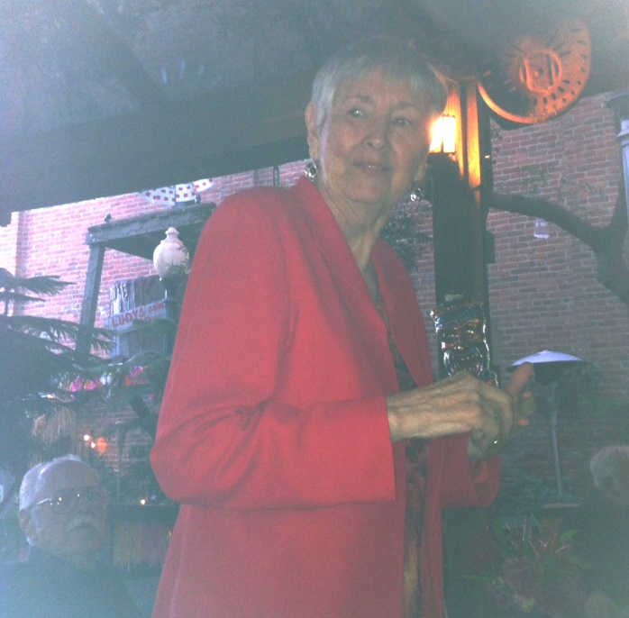
Bobby Jo Ford

The dinner held in my honor on September 26th was a real surprise. I thought it was going to be the Board of Directors from the Historical Society but present were people whom I have worked with in many different areas. I am humbled by the praise I received. But, as I said at the dinner I appreciate the recognition but I'm not going away, I will continue to be involved in various activities in our communities. For now I will be a worker instead of a leader. Can I call that retirement? Probably not.
My only regret is that I was not able to thank all those in attendance individually. But hugs to you all.
Peace, BJ Ford

❖

UPCOMING LECTURE
Sunday, October 27 2:00 p.m.
Gibson Museum, Gibson Road

Join us for the October Lecture entitled “The Amazing Women of Yolo County”. We will tour the Gibson Museum and learn about the groups of women who have been meeting in this county continuously for 100 plus years. You will see a timeline of fashion from 1900 to 2000 as well as a display of hats and undergarments. Finally you will also learn about the bird population that was killed to provide feathers for the millinery industry. Come and spend an afternoon with history folks. Bring a picnic and use the grounds.

❖

Meet your Board of Directors

Dennis Dingemans retired from UCD after 33 years and now directs the Hattie Weber Museum of Davis, where Kate Morss serves as a docent, using her experience at several East Coast museums.

My name is Beth Wettergreen, and I live in Woodland. I have lived in Yolo County for thirty years. I teach part time, online, for the University of Maryland; my class is upper division Advanced Academic Research Writing. In addition, I work freelance as a developmental editor and writer in many subject areas. My previous 18-year career was as a scientific writer and editor for the University of California, Davis. I’ve been on the YCHS board for seven years. One of my long-time passions is history, from the time I was a child and my father took me on amateur archeological expeditions in the Ohio Valley. Here in Yolo County, I like the history of architecture, the history of local ranches and commerce, and Native American History. I also enjoy teaching others writing, as in the YCHS essay contest currently being offered to Yolo County high school sophomores.

❖

“If you don’t know history, then you din’t know anything. You are a leaf that doesn’t know it is part of a tree” Michael Crichton

Impact of Law on Local Life in Yolo County
By Rajeev Sachdev, LLM – Guest Writer

It is often overlooked how much the law has to do with local history. Yolo County is no exception. Some of the key legal events and happening around the county’s initial years shaped local life in the area.

The organization of local government in the Yolo County area occurred shortly after California received her statehood in 1850. Yolo County was one of the twenty seven counties created at the first meeting of the State Legislature. An act of legislature provided for the first election of county officials - a sheriff to enforce the laws, an assessor to compile tax rolls and collect taxes, a judge, and a county clerk were elected. With officials in place, the County was in a position to enforce laws which can lead to a better living standard for locals. Records indicate that the county owned no property and for years made no effort to construct either a courthouse or a jail.
The first court session was reportedly convened under the shade of a spreading oak near the original county seat of Fremont. A June 1850, three man Court of Sessions divided Yolo County into three townships: Fremont, Washington Cache Creek. These political activities did little to improve Woodlands flood damaged economy and in the summer, people began moving away and by October fewer than 250 residents were left. However, areas around the County then began to develop further.
Local law enforcement was characterized by inefficiency and weakness. Crime, needing a more organized government and effective law enforcement, increased. Groups of ranchers and local towns people formed “vigilante committees” to protect property and apprehend those creating disorder and committing acts of cruelty. The Sheriff and his posse drew thieves into gun battles through rough and ready justice which was harsh and uncertain but won respect for law and order. “The stealing of a calf—value being less than $50—generally won the convicted offender fifty lashes on the bare back, and after receiving this donation he usually quit the business of selling veal in Sacramento for elk meat”. This order was important to a County recently organized because early respect for the law can influence life of the local people in later years. Nevertheless, informality characterized many of the early courts of law.
In order to discern what local residents of Yolo County were complaining of by way of crime in the early 1850s and how that impacted the lives, a review of some of the Court records in the Yolo County Archives seemed appropriate. This research, albeit brief, revealed some of the types of crimes that were being charged (not necessarily convictions) in 1850-1855. These archive records were found to be handwritten. Some files were very lean, likely missing documents while others included detailed depositions, witness statements and summons documentation. Some of the charges included grand larceny (money, stealing and running away with head of cattle etc.), nuisance, rape, assault with intent to kill/commit murder, assault with deadly weapon, shoot and injure a certain horse, feloniously failing to pay and refusing to pay over money belonging to the County of Yolo (or the State of California). Failing to attend as a grand juror when summonsed got some people charged $25 (plus fees) for disobeying the summons served upon them. The Court records show marks of the charges/fees being paid in at least one instance. Although the records were not complete and only a sample, this review gives us a flavor of the types of alleged crimes locals were dealing with in the community. We see that crimes relating to animals were being charged as local farming communities would demand as were different types of crimes against persons.
On June 24, 1856, reportedly, during a Court session taking place under five giant sycamore trees in Knights Landing, a minor case was being heard, when a party let slip a slur on the character of his opponent causing the brandishing of guns and knives. Justice Patrick ran for safety and told the jury to do likewise until things calmed down when the Justice addressed the gathering as if he had just arrived. More than a century later, in 1963, a beautiful courthouse was built.
In 1869, there being no jail in Davis, “public offenders” were incarcerated in the American hotel by Judge Brown. The “Great Yolo Train Robbery” (no local Davis newspapers were published in 1894) was like a great western drama including elements of robbery, murder, county sheriffs, investigators, buried treasure, sudden wealth and eventual apprehension of the suspects.
As local government developed and became more stable, and as the laws were more strictly enforced, things began to change. Overall, local life in the initial years of Yolo, were impacted by a mixture of legal events such as initial appointing of officials, rough justice and sometimes primitive early Court proceedings. As time progressed, the building of a Courthouse, jails, expansion of local governance local life began to change further. A garnered early respect for the law, at times, created at least some degree of enforcement atmosphere to set the stage for future decades to come.
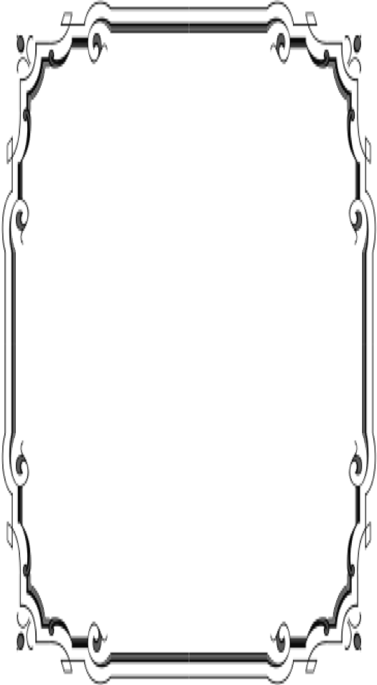
Patrons
Thanks to the following for generously supporting the Society for 2013-2014. You too can be a Patron by donating $100.00 to help us run our projects
- John and Helen Daniels
- John and Kathy Harryman
- Pamela Pearl
- Frank and Virginia
Schwarzgruber
- Stella Dinger
- Robert and Lynn Campbell
- Leroy & BJ Ford
- Jon & Barbara Durst
- Dennis Dingemans & Robin Datel

Yolo County Historical Society
P O Box 1447
Woodland, CA 95776

Address Service Requested

Dated Material

Vision Statement The Yolo County Historical Society strives to preserve, protect and acknowledge
the diverse history of Yolo County through education, communication and advocacy

Cabalzar, Martin A., History of Yolo County a Teacher’s Guide, County Board of Education, approved June 1964
Adapted from Cabalzar, Martin A., History of Yolo County a Teacher’s Guide, County Board of Education, approved June 1964
ibid
ibid
Compiled by Joann Leach Larkey, Davisville ’68 The History and Heritage of the City of Davis, The Davis Historical and Landmarks Commission, The Printer, Douglas A Galbreath, 1969
Adapted from Walters, Shipley, Woodland City of Trees A History, Yolo County Historical Society, 1995
ibid
Cabalzar, Martin A., History of Yolo County a Teacher’s Guide, County Board of Education, approved June 1964
Adapted from Cabalzar, Martin A., History of Yolo County a Teacher’s Guide, County Board of Education, approved June 1964
Cabalzar, Martin A., History of Yolo County a Teacher’s Guide, County Board of Education, approved June 1964
Adapted from Cabalzar, Martin A., History of Yolo County a Teacher’s Guide, County Board of Education, approved June 1964
Gregory, Thomas Jefferson, History of Yolo County, California, with biographical sketches of the leading men and women of the county, who have been identified with its growth and development from the early days to the present, Historic Record Company, 1913 available at http://archive.org/details/historyofyolocou00greg visited September 2013
Cabalzar, Martin A., History of Yolo County a Teacher’s Guide, County Board of Education, approved June 1964
Some of the records from Court of Sessions 1850-1871, Yolo County, Courtesy of Yolo County Archives ---- of course, this does not represent all official or comprehensive records that existed, nor all records that would have been in the files. This does not include convictions, just accusations/charges - whether or not the accused was actually convicted.
Adapted from Cabalzar, Martin A., History of Yolo County a Teacher’s Guide, County Board of Education, approved June 1964
ibid
Adapted from Walters, Shipley, Woodland City of Trees A History, Yolo County Historical Society, 1995
Adapted from the source: Compiled by Joann Leach Larkey, Davisville ’68 The History and Heritage of the City of Davis, The Davis Historical and Landmarks Commission, The Printer, Douglas A Galbreath, 1969
ibid
Adapted from Cabalzar, Martin A., History of Yolo County a Teacher’s Guide, County Board of Education, approved June 1964

