PRESIDENT’S MESSAGE

October means it is time to begin our regular membership meetings on the 4th Sunday of the month. Although they are called membership meetings they are always open to the general public who we hope will become members because of their interest in the history of our county, state, and sometimes world. Mark the 4th Sunday on your calendar “Yolo County Historical Society Sunday” and check out the monthly newsletter as to when, where, and what you will be enjoying.

The Stroll Through History Committee welcomes new members who are interested in participating in the organization of the event. Chairperson Reva Barzo, (530) 867-5800, will welcome your phone call and advise you of the deadline to get the information to our newsletter editor, Jeannette Molson. (Contact information on the back page).

The Board of Directors of the Society meets on the 2nd Monday of each month at 7 P. M. alternating between Davis and Woodland. If you would like to attend a meeting to share suggestions, or just to listen, you are always welcome. The next meeting will be Monday, October 11th, 7 P. M. at the Hattie Weber Museum, 445 C Street, in Davis. The November 8th meeting, 7 P. M. will be at the Home Improvement Group “conference room” located in the Hotel Woodland. Call B. J. Ford at (530) 662-0952 for further information.

Peace,

BJ Ford,
President

SPRING LAKE SCHOOLHOUSE

The schoolhouse has been a busy place since the fair closed. The Board contracted with James Harriman (no relation) to paint the floor. It was in dire need of refreshing. James and his crew did a superb job. They painted the floor as well as the front and back porch. They repaired some dry rot. Thank you, James. During the painting, Jim Scott took home one of the teacher’s desks and repaired the drawers. Now we won’t lose the drawers in the desk. Thank you, Jim. Jackie Scott and I spent a morning returning the school house to its usual prime condition, making it ready for the students in the latter part of October. Thank you, Jackie. Thank you, also, to all of those who volunteered to work at the Yolo County Fair.

Kathy Harryman

GIBSON HOUSE

New Patio at Gibson House

Volunteers and construction workers are busy building a patio between the museum garage and new kitchen building. The patio will have planter boxes as well as an area for flowers.

The cobble stone patio will be available for picnics and weddings.

Yolo County to assist with Saving Heritage Oak Tree

The Museum board has been soliciting donations to save the Heritage Oak Tree in front of the Gibson House. The County of Yolo has offered to assist in this project. With the combined generous donations from our Museum supporters, our goal will be accomplished.

WINTERS HISTORY PROJECT REPORT

Members of the Winters History Project Committee are very grateful to the Board of Directors of the Yolo County Historical Society for sponsoring its recent affiliation with the county-wide society. Most importantly, the Society offered its tax-deductible status to the committee when the City of Winters could no longer provide that benefit to the all volunteer funded Winters History Project, which is an expanding, interactive model for a “museum without walls” with a long term goal of a permanent museum location.

The project’s primary goals, and mission are to provide historic context and a profound Sense of Place for all residents and visitors through celebration of the historic legacy of Winters. During the past year the WHP has presented three major photographic exhibits: “Winters: A Taste of History”, “Farm Workers of Winters” with photos by Francisco Dominguez, “Winters Wheels of History”, and it sponsored a Horticultural Symposium in conjunction with faculty and staff associated with the Wolfskill Experimental Orchards which celebrated the legacy of John R. Wolfskill who started the fruit industry in the Sacramento Valley in 1842. Smaller exhibits celebrated the opening of the new Winters Community Library in November 2009 and one is currently being shown at the Yolo County Historical Museum.

The “Wheels of History” exhibit depicting changing modes of transportation be be hosted by the Winters Center for the Arts at 14 Main Street, Winters from October 1 to November 15. Hours are 5 to 8 p.m. Fridays and Saturdays or by appointment by calling (530) 795-0608.

A colorful collection of Winters fruit crate labels dating from 1906 to 1976 will also be shown from October 1 to December 31 at Lester Farms Bakery, 606 Railroad Avenue, Winters. Bakery hours are 5:30 a.m. – 2 p.m. Mon.-Fri., 6 a.m. – 2 p.m. on Saturdays and 7 a.m. to 1 p.m. on Sundays.

Additional historic photographs from the Winters History Project collected are also being shown at four other downtown businesses: the Winters Visitors Center; Berryessa Gap Vineyards; Pacific Ace Hardware, and VeloCity Bicycle Center, located respectively at 11, 15, 35 and 41 Main Street.

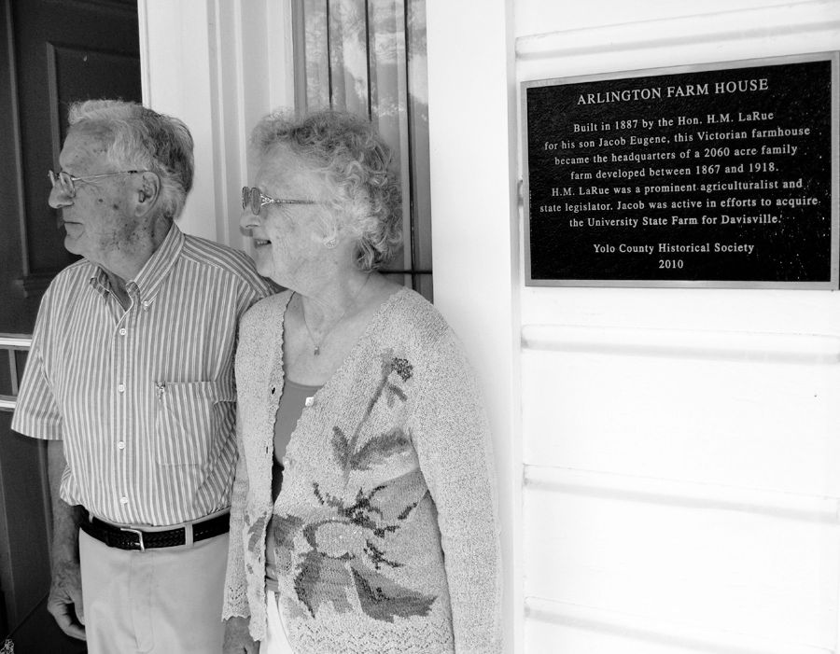
YCHS plaque presented to Roger and Ann Romani, on Sept. 14, at their home located at 2727 Russell Blvd., Davis.

Plaque inscription:

Arlington Farm House

Built in 1887 by the Hon. H. M. LaRue for his son Jacob Eugene, this Victorian farmhouse became the headquarters of a 2060 acre family farm developed between 1867 and 1918. H. M. LaRue was a prominent agriculturalist and state legislator. Jacob was active in efforts to acquire the University State Farm for Davisville.

Yolo County Historical Society
2010

TTTTT

October 2010

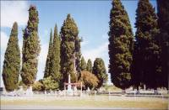
(Photo courtesy of Peggy Perazzo)

COTTONWOOD CEMETERY

Sunday, Oct. 24th, 2 – 3:30 p.m.

Dennis Dingemans will continue his tours and talks of Yolo County Cemeteries with a visit to the Cottonwood Cemetery which is located on Road 25, 1/10th mile east of Road 89 (2 miles south of Madison and 7 miles north of Winters. In the September newsletter, Dennis wrote extensively about the history of the Congregational Church which was attached to the Cemetery and its struggle for a decade before dissolving around 1879.

One stone that will be of particular interest is that of Rev. Tyler Thacher (1801 – 1869). Dennis has researched Rev. Thacher’s history and will impart that very interesting history to those who attend.

Look for the grove of Cypress trees which are a distinctive landscaping feature, visible miles from the 4 acre site.

Refreshments will be served following the presentation.

